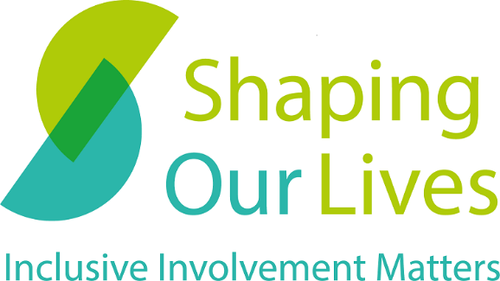

Inclusive Involvement Pledge
I am delighted to be taking part in an involvement activity with (name of organisation). I hope my knowledge of using health and care services, living with impairments and/or health conditions and other experience of marginalisation will be helpful to your work. So I am able to reach my potential in the involvement activities, I am hoping you can meet these 12 simple steps to inclusively involve me and others:
- Meet my communication, access and support requirements.
- Keep a record of my communication, access and support requirements and use these for all activities.
- Provide background information about the topic to help me prepare.
- Provide plenty of notice about meetings and events and circulate papers two weeks in advance.
- Make meetings accessible to me through my preferred access method.
- Arrange meetings at a time that is manageable for me with my health, impairment, responsibilities and travel requirements.
- Give the same priority to issues raised by people sharing their experiences as you do to colleagues and other people in your field of work.
- Provide any training or support I may need to be able to offer an informed response to your work.
- Value my contribution and tell me how it impacts your decisions in the future.
- Provide me with a reference or testimonial of my involvement and the difference it made.
- Process my expense and involvement payment claims quickly.
- Have a single person I can contact if I have any questions and provide their contact details.
Space for additional information:

In return, I will do my best to complete the activities you need unless there is something that happens which means I cannot take part as and when required.
Please note that the priority of the points above may vary for each person. Shaping Our Lives offers a form for people to complete their communication, access and support requirements. This can be found as a free download at https://shapingourlives.org.uk/my-involvement-profile/ or by emailing hello@shapingourlives.org.uk, or calling us on 0345 241 0383.

Shaping Our Lives

www.shapingourlives.org.uk

Email: hello@shapingourlives.org.uk

Telephone: 0345 241 0383

Facebook: @shapingourlives

Twitter: @Solnetwork1

Linked In: @shaping-our-lives-national-user-network

Instagram: @shapingourlivesnetwork

© 2021, Shaping Our Lives
Shaping Our Lives National User Network Community Interest Company.
Company limited by guarantee registered in England and Wales.
Company No. 04382606
Registered office: 30 St Giles' Oxford OX1 3LE30

