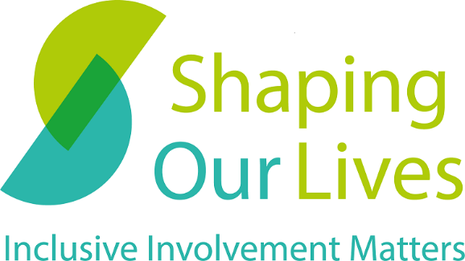

How we can help you
2023

Contents
Contents 2
Who we are 3
What we offer 4
What’s next? 6

Who we are
Shaping Our Lives is a user-led Community Interest Company with a national user group of Disabled people, people with health conditions, and service users. We have over two decades of experience in making sure the voices of people from marginalised groups are heard when it comes to designing and delivering vital services such as health and social care.
Listening to the valuable lived experience of diverse groups will make services better for everyone. Shaping Our Lives has built trusted relationships with user groups across the UK through pioneering user-led approaches and developing working approaches that enable people from many marginalised and often excluded groups to take part equally and have a say. With our excellent links with a wide network of other user-led groups, we are in a unique position to help you ensure your involvement and co-production is inclusive, meaningful, and effective.
All our work is led by experienced professionals in the field of inclusive involvement, who utilise their knowledge, experience, and expertise to ensure that your organisation’s needs and expectations are successfully met. Below, you will be able to find a list of ways that we could assist or partner with you.
Where applicable, our work is bespoke and specifically tailored to your organisational needs, however we have provided examples of previous collaborations which we hope will provide you with additional information.
If you are interested in working with us, we are able to discuss timelines and costs depending on the type of support, resources, and delivery your organisation requires.

What we offer

Description: The below table has 3 columns and 9 rows. The column headings, which are repeated at the top of each page, are: Service, Description, Previous Clients.
Service | Description | Previous clients
Training | We offer a wide range of training courses from How to do Co-production to Disability Equality Training. Please contact us for more details. | Oldham Borough Council, Hampshire County Council, Mind
Lunch and learn sessions | An efficient and dynamic way to increase knowledge is to provide people with the opportunity to attend interactive and problem-solving lunch and learn sessions. We can offer short events which provide an opportunity to ask detailed questions about aspects of involvement. | King’s College London Cicely Saunders Institute
Resources | Everything from role descriptions, terms of reference, accessible recruitment papers, budget templates, to access and support needs questionnaires – let us share our best practice approach by providing template resources for your involvement activities. | King’s College London Cicely Saunders Institute, University of Worcester
Inclusive facilitation | We have many years of experience facilitating focus groups and discussions in an inclusive way. We can support part of your project or conduct a range of interactive activities to gather evidence. | London School of Economics and Political Science,  London School of Hygiene and Tropical Medicine
Research partnerships | With our range of skills, we can manage the service user involvement and participation in research studies for you. We are able to manage the recruitment, administration and involvement payments in an inclusive and professional way. | University of Hertfordshire, London School of Hygiene and Tropical Medicine,  University of Worcester
Advice and support | Our door is always open to provide some advice and support, whether you are starting off in involvement or planning a large research study. | A large range of organisations, universities and researchers
Representation on advisory and expert boards | We can be part of an advisory board or expert group to provide expertise on involvement and participation. | London South Bank,  University of Birmingham
Involvement strategies | We can help you develop an involvement strategy for your organisation and provide a step-by-step action plan to implement it. | British Association of Social Workers, University of Essex
Implementation of involvement-related structures and processes | Inclusive involvement requires good structures and processes to enable it to flourish in an organisation, research study or service planning and policy processes. We can identify where to make changes and implement new ways of working to enable this to happen. | Camden Disability Action, Women's Aid Refuge Services
Evaluation and problem-solving | Sometimes things go wrong, and you need some help to get them back on track. Or, you may need an expert partner to evaluate your involvement activities. Let us help you resolve and report on your activities. | Trust for London,  Southend-on-Sea City Council
Mentoring | Learning to do meaningful and effective involvement takes time and is learnt through experience of doing. Our experienced facilitators and involvement experts can mentor people to gain knowledge quickly. | Southend-on-Sea City Council and various universities
Research | User-led and user-controlled research is one of our key services. | Visit our reports section.
Learning and skill gap audits | Before investing in training or other support activities, it is helpful to understand the learning requirements of your colleagues. We can design a learning and skills gap survey tailored to the work you do and provide an overview of the areas people need more development in. | East of England Applied Research Collaboration, Hampshire County Council,  King's College London
Workshops | In-person and remote workshops are great ways to develop knowledge and understanding or to solve barriers to doing involvement in your organisation. We can design and deliver workshops for any audience including bringing service users and practitioners together. | University of Hertfordshire, Health and Care Professions Council, Liverpool Hope University

What’s next?

Shaping Our Lives is committed to increasing the inclusive involvement of people experiencing exclusion and unequal service provision, we have lots of knowledge and we would love to talk to you about how we can work together. You can find our contact details on the next page.
Shaping Our Lives

www.shapingourlives.org.uk

Email: hello@shapingourlives.org.uk

Telephone: 0345 241 0383

Facebook: @shapingourlives

Twitter: @Solnetwork1

Linked In: @shaping-our-lives-national-user-network

Instagram: @shapingourlivesnetwork

© 2021, Shaping Our Lives
Shaping Our Lives National User Network Community Interest Company.
Company limited by guarantee registered in England and Wales.
Company No. 04382606
Registered office: 30 St Giles' Oxford OX1 3LE30

