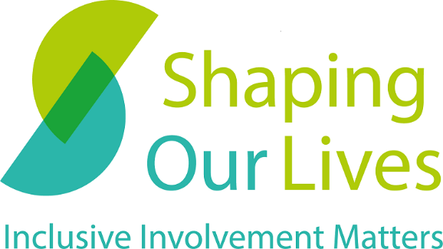

Intersectionality and Involvement

  - Contributions from the Thinking Outside the (Tick)box conference

November 2022

Contents

Contents 2
About Us 3
Acknowledgements 3
Introduction 4
What is intersectionality? 4
Intersectionality and disability 6
Why should we take an intersectional approach to involvement? What are we losing when we don’t? 7
How can organisers of involvement take a more intersectional approach? 8
Sources and further information 11

About Us

Shaping Our Lives is a user-led non-profit organisation, specialising in inclusive involvement. We have over two decades of experience in service user involvement. To find out more about us and what we do, visit our website: https://shapingourlives.org.uk/

Every month, we share news and resources relating to co-production, involvement and participation via our newsletter.

Acknowledgements

We would like to thank the conference attendees who took part in this conversation for their useful insights and contributions. We also thank Sarah O’Brien and Peter Beresford for reviewing this article.

Introduction

The concept of intersectionality was a central topic of our Outside the Tick(box) conference on 1st November 2022. It was woven into the speakers’ talks, in our co-chair’s plenary and it was one of the themes for our afternoon discussions. However, intersectionality is sometimes a buzzword and is often misunderstood. Academics also continue to debate how to understand and apply intersectionality as it is often diluted and abstracted from its original meaning and its ties to race.

In this article, we explore what this concept means. We also delve into contributions from our afternoon discussion during which attendees reflected on how we can take a more intersectional approach to involvement.

What is intersectionality?
“Intersectionality is a lens through which you can see where power comes and collides, where it interlocks and intersects. It’s not simply that there’s a race problem here, a gender problem here, and a class or LBGTQ problem there.” – Kimberlé Crenshaw

Intersectionality is a concept that originated from Black feminist theory and writings. It is widely used to refer to the way different systems of oppression and privilege (i.e., gender, race, disability, class, sexuality, etc.) overlap and intersect with one another to shape people’s experiences.

The term was coined in 1989 by Kimberlé Crenshaw, an American Professor of Law, scholar and writer on civil rights, critical race theory, Black feminist legal theory, and race, racism, and the law. She developed the notion of intersectionality to highlight how the intersection of race and gender shaped the experiences and discrimination faced by Black women in the United States. She argued that they were let down by the criminal justice system as it viewed “women’s experience” as white women’s experience and the “black experience” as “black men’s experience”. She also argued that they were similarly marginalised within both feminist theory and anti-racist movements as they systematically generalised or overlooked the issues and experiences within a given group (“women”, for example) and fail to appreciate the nuances of their members’ experiences. For example, Black women’s experiences of domestic violence would neither be seen as a women’s rights issue nor an anti-racist issue, consequently marginalising them within both movements.
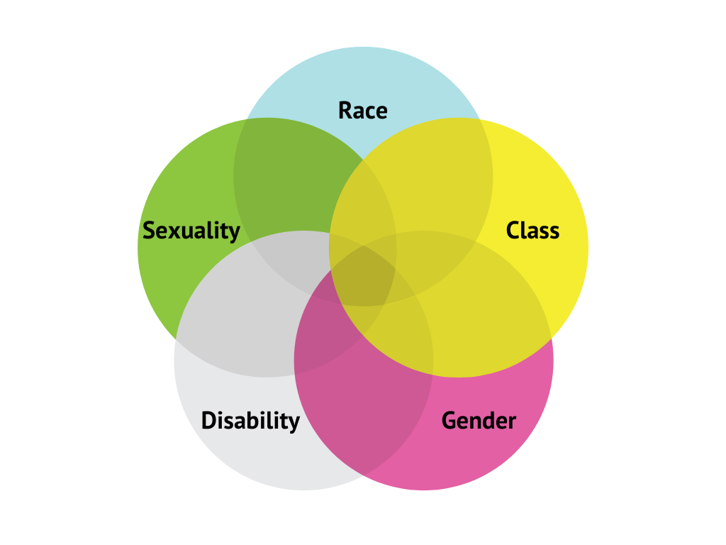
The notion of intersectionality highlights the nuanced and multifaceted character of oppression and identity. It helps us understand that people’s experience(s) can and will vary depending on the forms of oppression/marginalisation they face and the privileges they enjoy. A common analogy used to explain intersectionality is colours and how they mix: if you mix blue and red, the result will not be blue + red but purple. For example, a Disabled Black person’s experience of disability will be racialised. Similarly, Black women experience unequal maternal health outcomes compared to their white counterparts. In 2021, a report from MBRRACE-UK found that Black women are 3.7 times more likely to die in childbirth than white women. The report only focused on ethnic inequalities so does not provide any figures regarding the intersection of disability and race.

Intersectionality and disability
The inclusion (or exclusion) of disability in conversations about intersectionality was also discussed at our conference. Disability and Disabled people often remain an afterthought, even in conversations about intersectionality or in projects and movements claiming to take an intersectional lens. Some felt that if we challenged this and take disability as a starting point, then involvement and services will inevitably be more inclusive for everyone.

One attendee, for example, shared their experience struggling to support a Disabled domestic abuse survivor as they couldn’t find an accessible refuge. Disabled women are more than twice as likely to experience domestic abuse compared to non-Disabled women (Refuge, 2021). Moreover, Disabled women’s experience of domestic abuse may be shaped by disability and ableism. The perpetuator of the abuse may for example take advantage of the environment’s inaccessibility to isolate them, deny care as a tool to abuse them or restrict access to the person’s mobility aid or access technology (Public Health England, 2015). Meanwhile, Disabled women face additional barriers to accessing support services. As of 2018, only one in ten domestic violence refuge spaces in the United Kingdom was accessible to people with physical impairments (BBC, 2018). There is only one refuge for survivors of domestic abuse with learning disabilities (L&Q). Many refuges also operate ‘no visitors’ policies, often preventing BSL interpreters to support Deaf survivors (Frances Ryan, 2020). Disabled women experiencing domestic abuse are systematically failed by a system that doesn’t provide the urgent support they need. If domestic abuse support services were designed taking a more intersectional approach and involving Disabled women, they would be more inclusive and accessible to all.

Why should we take an intersectional approach to involvement? What are we losing when we don’t?

Taking an intersectional lens to involvement brings our attention to the way in which different systems of oppression (i.e., racism, ableism, sexism, classism, transphobia etc.) and privilege intersect and shape service users’ experiences of services and the barriers we face. It allows us to look at those factors together rather than in isolation and invites us to bring different perspectives.
Attendees at our conference shared that they are often put in boxes when accessing services or taking part in involvement. Often, service providers and organisers of involvement only want to discuss part of service users’ experience, not all of it. We may hear things like “we are not here to discuss racism, we’re here to talk about disability”. Yet a service user’s experience of disablement and of accessing health and care services may be crucially shaped by race. As such, service providers fail to appreciate how various systems of oppression may combine and shape that person’s experience.
By failing to take an intersectional approach to involvement and service design, organisers and providers will fail to design services that include and meet the needs of everyone, particularly those who are often the most marginalised in our society. Inclusion without intersectionality is not true inclusion.

How can organisers of involvement take a more intersectional approach?

An intersectional lens considers a collection of factors affecting an individual or service users in combination, rather than considering each factor in isolation. Participants discussed ways organisers of involvement and service providers can take a more intersectional lens. These include:
- Involving lots of different people, not just one token person to tick a box: It’s about having people with different experiences in the room and not only having them in the room but actively listening to them, their experiences and perspectives without creating a hierarchy of experiences. One person cannot and should not be expected to represent the experience(s) of an entire identity, condition, or marginalised group.
- Recognising the value of (intersectional) lived experience: Intersectional experiences bring different perspectives which are extremely valuable. However, we must also consider the additional barriers and struggles that come with this lived experience and provide tailored support to ensure people’s needs are met and their experience isn’t exploited. For example, one attendee shared their experience working for a mental health peer support service. The service actively recruited people with lived experience into peer support roles. However, they weren’t supported properly, leading to them really struggling in the role and having a negative impact on their mental health.
- Reflecting on who is and who isn’t in the room (physically or virtually) when organising involvement activities: We should pay attention to who is and who isn’t represented and think about how we can bring those missing into the room. We shouldn’t expect people and communities to come to us. It’s our responsibility to reach out and meet them where they are. Consider how you may be able to use your position (i.e., job role, experience and reputation as an involved service user) to bring people in.
- Identifying barriers to involvement and actively removing them: for example, recognition and pay were brought up as one of the biggest barriers. Too often, we are asked to share our experiences and trauma for free. This inevitably excludes people who are often the most marginalised to share their experience.
- Recognising our own privilege: Organisers of involvement and service users must all recognise our own privileges and reflect on how this might impact on involvement. Service users often end up being asked to speak as representatives of a whole group or community, erasing the nuances of peoples’ experiences within that community. We need to ask ourselves whether we are the right person to talk about certain subjects. For example, as Disabled people, we might be asked to speak for the entire Disability community even though we all have different needs and other factors such as race, gender or class intersect in our experience. If possible, tell organisers when you feel they are asking you to speak on behalf of others or recommend other people they could speak to about a specific experience.

To conclude, involvement and services designed without an intersectional approach are not truly inclusive and will fail to meet the diverse needs of people, including those who need them the most. Now more than ever, it is also crucial that we embrace intersectionality and consider the nuances of people’s experiences instead of compartmentalising people into separate and narrow groups or categories pitted against one another. Intersectionality brings our attention to the intersections of people’s experiences within groups or communities that have traditionally been seen as separate and that led them to work in silos. Embracing an intersectional lens can highlight the links between our experiences and struggles and be the basis for solidarity and better collaboration.

Sources and further information
BBC (2018) ‘Why disabled women can’t access all refuges’
Crenshaw, K. (1989) ‘Demarginalizing the Intersection of Race and Sex: A Black Feminist Critique of Antidiscrimination Doctrine, Feminist Theory and Antiracist Politics’, University of Chicago Legal Forum, Iss.1, Article 8
Crenshaw, K. (1991) ‘Mapping the Margins: Intersectionality, Identity Politics, and Violence against Women of Color’, Stanford Law Review, 43(6), pp.1241-1299.
Columbia Law School - Kimberlé W. Crenshaw
Frances Ryan (2020) Crippled: Austerity and the Demonization of Disabled People.
Intersectionality Matters podcast – available on most streaming platforms including Spotify, Apple Music and Soundcloud
Kimberlé Crenshaw – The urgency of intersectionality (Youtube TED talk)
MBRRACE-UK – MBRRACE-UK Saving Lives Improving Mothers’ Care – Lessons from maternity care from the UK and Ireland Confidential Enquiries into Maternal Deaths and Morbidity 2018-20 (2022)
Public Health England – Disability and domestic abuse: Risk, impacts and response (2015)
Refuge – Refuge launches critical accessibility features on its National Domestic Abuse Helpline Website (2021)

Shaping Our Lives

www.shapingourlives.org.uk

Email: hello@shapingourlives.org.uk

Telephone: 0345 241 0383

Facebook: @shapingourlives

Twitter: @Solnetwork1

YouTube: shapingourlives1

© 2021, Shaping Our Lives
Shaping Our Lives National User Network Community Interest Company.
Company limited by guarantee registered in England and Wales.
Company No. 04382606
Registered office: 30 St Giles' Oxford OX1 3LE30

