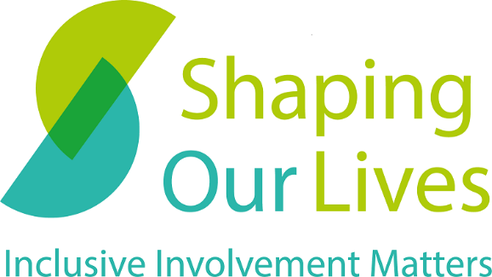

Match Making in Research:
  - Practical reflections on partnerships between user-led organisations and universities

February 2023
Authors:
Becki Meakin – Shaping Our Lives
Bella Wheeler – King’s College London
Eleni Chambers – Shaping Our Lives
Glenn Robert – King’s College London
Oli Williams – King’s College London
Raj Mehta – Shaping Our Lives
Sarah O’Brien – King’s College London
Other contributors:
Ann Nutt – Shaping Our Lives
Graham Price – Shaping Our Lives
Jeremy Browne (in memory, he died before publication) – Shaping Our Lives
Peter Beresford – Shaping Our Lives

Contents
Foreword 3
1. Introduction 5
2. Where to start 9
The chicken and the egg, which comes first? 9
There is never a stupid question 9
Capacity issues 11
Kick-off stage 12
Not just anyone will do 13
Tips: 14
3. Starting as you mean to go on 15
Culture clash 15
Make sure everyone is on the bus 16
Money talks 16
Tips: 17
4. The ups and downs on the way 19
Relationships do not happen overnight 19
Keep looking over your shoulder 20
Let’s talk it over 20
Tips: 21
5. What makes us different? 22
6. Reflections and learning 22
What would we/I do differently if we get involved again? 23
7. Conclusions 25
Summary of Tips by section 27

Foreword

This publication is based on our shared experiences of working together over a 16-month period on a study funded by the Economic & Social Research Council (ESRC).

It has been written by members of a user-led organisation and by academic researchers who collaborated to investigate new ways of partnership working between researchers, Disabled people and health and social care organisations.

You can read more about the basis for our collaboration here: https://www.kcl.ac.uk/news/two-funding-awards-to-test-and-model-effective-research-partnerships-from-a-user-led-perspective

We hope that readers find our joint reflections of interest and practical value when thinking about and engaging in future collaborations between user-led organisations and universities.

Peter Beresford, Shaping Our Lives:
This report has two main aims. First, to help researchers who want to carry out helpful research which can be effective, work on more equal terms with disabled people and other service users. Second, to help disabled people and service users do the same with researchers. This is a practical report. It is to help everyone do things better and it is based on first-hand experience, so it is likely to be a real help in trying to do that. But it is also based on important ideas and theory. Perhaps most important, we hope we will get better research if we involve everyone who has a stake in such work and try to do so as inclusively as possible. Also, that research is more likely to have some force behind it, if the people who are the subjects of it are also able to join forces to help make its findings happen.

I have enjoyed being involved in this research, although sometimes I wasn’t quite sure what was happening and how well we would be able to do it. But I think it came together really well, mainly because we grew to understand and know each other and build trust and be part of a shared enterprise. As so often, the other human beings were what made this project good to be part of. Sadly, during the course of it, one of those people, always conspicuous by his helpfulness and wisdom, Jeremy Browne, tragically died. We all miss him, his generosity, warmth and helpfulness. We would like to dedicate this report to Jeremy and his family in remembrance of the valuable part he played in bringing the work to fruition. Thank you, Jeremy.

1. Introduction

This publication is based on the experiences of a 16-month research study completed by Shaping Our Lives and King’s College London. It shares the learnings about partnership working between Shaping Our Lives and King’s College London. The guide focuses on the challenges of this type of partnership and how to capitalise on the opportunity of bringing a user-led organisation and university research team together to complete a research study. The main study that this guide has been drawn from was funded by the ESRC’s methodological innovations funding stream. This guide does not comprehensively cover the findings from the main research study. We hope the transparent and reflective nature of this document will prove useful to other user-led groups and universities embarking on a collaboration.

The collaboration between Shaping Our Lives and King’s College London began in February 2020, as initial discussions about how the work of Shaping Our Lives and the Methodologies Research Division of King’s College London’s Faculty of Nursing, Midwifery and Palliative Care could potentially develop a joint application for funding. At the same time, Shaping Our Lives was awaiting the outcome of a four-year grant application from the National Lottery Community Fund (NLCF) for the ‘Inclusive Involvement Movement’ project. The NLCF grant was awarded in March 2020 to enable Shaping Our Lives to develop new services and to help support organisational development and self-sustainability but was deferred because of the COVID-19 pandemic and instead started on 1st October 2020.

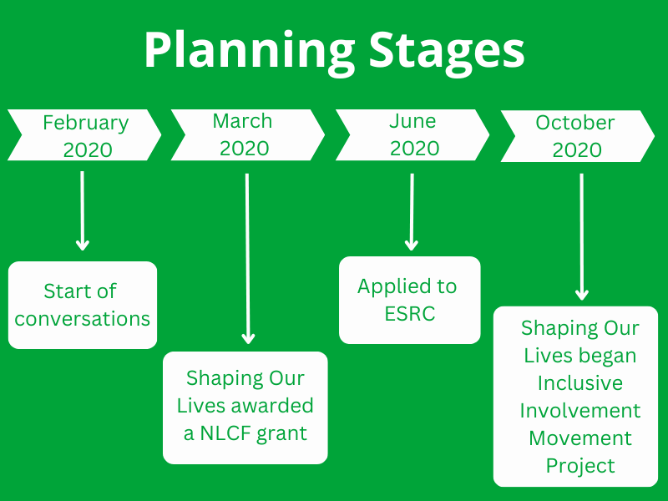

These initial conversations looked at a joint application for funding to support both Shaping Our Lives’ broader aims regarding highlighting user-led approaches, as well as King’s College London’s aims in exploring Elinor Ostrom’s principles regarding collaborative group working in the context of the collective management of resources (Ostrom, 1990). The ESRC funding was an opportunity to look at how the NLCF Inclusive Involvement Movement project group could offer a potentially innovative case study to apply Ostrom’s principles. In June 2020, Shaping Our Lives and King’s College London co-wrote and submitted a proposal to the ESRC’s methodological innovations funding stream.

The stated aims of the ESRC proposal were:
1. To work in partnership to develop new services that will support Disabled people and service users to become more involved in research.
2. To test a new approach to partnership working to help researchers and service users work together more fairly and effectively.

The Inclusive Involvement Movement project formed a working group of six service users from Shaping Our Lives’ National User Group. The working group was set up following several service user discussions with a wider group of service users as a way to plan and oversee the project. This group was formed before King’s College London were able to appoint a Research Associate as part of the ESRC grant.

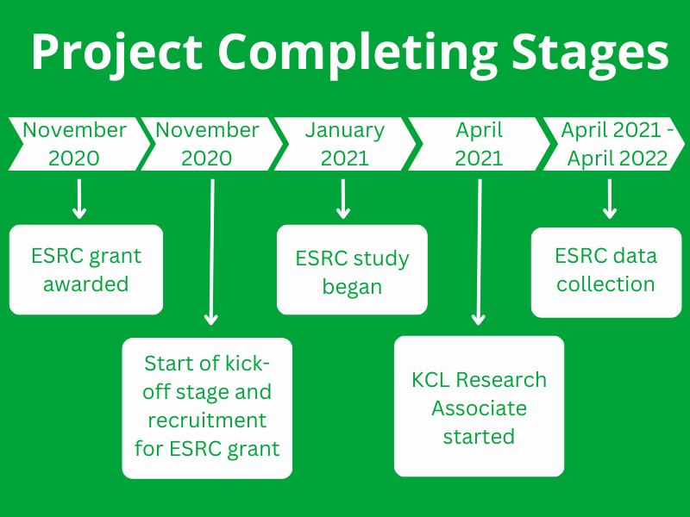

Our reflections on partnership working have been compiled from an ambitious research study that Shaping Our Lives and King’s College London embarked on to examine how Elinor Ostrom’s principles of Common Pool Resources management may be relevant to the working approach of a user-led organisation in developing services for Disabled people. It is acknowledged that the original aims of the funding were changed during the study.

2. Where to start

The chicken and the egg, which comes first?
The partnership with King’s College London and Shaping Our Lives began five months before we applied for the ESRC grant. This was extremely helpful as it allowed time for general mutual discussions about our work and a chance to collaborate on a research idea and then search for an appropriate funding source. This meant we were not trying to squeeze a square research idea into a round hole of a funding call; or arriving late into a research application for funding and trying to fit into a process and approach which was not suitable for a user-led partner. It cannot be overstated that building a partnership early is important to build shared ideas before entering into shared work. These conversations were limited to staff from Shaping Our Lives and senior researchers from King’s College London. With hindsight, involving other service users at this stage may have been helpful, but difficult to do without funding for involvement.

However, in this case, although the conversations started before the joint application for funding, there was mis-alignment of the start of Shaping Our Lives Inclusive Involvement Movement project and the start of the ESRC funded study. This was compounded by failing to recruit a Research Associate in the first recruitment round and consequently the Research Associate was not in post until after the start of meetings of the Inclusive Involvement Movement working group.

There is never a stupid question
The early collaboration and getting to know each other allowed the partners to find potential areas of common interest. The early collaboration and the entire study was conducted remotely because of the pandemic. Although there were several mechanisms for communicating and bringing all parties involved in the collaboration together, the informal opportunities for building relationships did not happen as freely or often as would be expected in face-to-face meetings.

Despite the early collaboration and discussions, later it became apparent that we had interpreted the project and its aims slightly differently which led to some stumbling blocks. These perhaps came from the user-led partner and the University using familiar language to their sector and not asking enough questions about what each party meant in practise.

It may also have been partly due to the capacity restrictions of a user-led organisation to commit time to an application process when there is little or no funding to support it; and as a consequence accepting the generosity and commitment of time King’s College London gave to formulating the application. The creation of a working group between two members of Shaping Our Lives and King’s College London (which met monthly) provided a useful opportunity to explore this issue, but the Inclusive Involvement Movement working group was not involved in the monthly meetings and did not benefit from addressing the approach of the study in the same way.

In this case the first aim of the research should have been further explored by Shaping Our Lives staff involved in developing the proposal for funding; and later when the Inclusive Involvement Movement working group became part of the study. The aim stated:
1. To work in partnership to develop new services that will support Disabled people and service users to become more involved in research.

Shaping Our Lives’ project lead did not question this research aim as the methodology of the ESRC application funding appeared to be based on observational techniques, but it was questioned later by members of the Inclusive Involvement Movement working group. The Inclusive Involvement Movement project was described throughout the NLCF application as a user-led project and that the working group of service users would be responsible for co-producing the main deliverables of the study; while the understanding of the King’s College London research team was that they would be actively involved in the user-led working group and influencing outcomes of the NLCF funded project. This led to some conflicts at about six months into the work which required extra meetings and actions to resolve. The funding stream allowed for flexibility to accept that this aim may not be met as planned. A learning from our partnership is that in a collaboration between a service user organisation and researchers it is important to discuss what is meant by user-led.

Through productive discussions amongst all involved in both projects, the roles of each individual were understood through asking rather than assuming. In this case, moving beyond assumptions and towards shared understanding was something that happened further into the project.

Capacity issues
User-led organisations have always experienced capacity issues because of barriers to securing core funding. The ‘hand-to-mouth’ existence of many user-led groups is mainly because of the culture of funding and an assumed hierarchy from the largest charities to the much smaller user-led sector. Increasingly, charitable funding also excludes or only allows small amounts of overhead costs. One of Shaping Our Lives’ aims of the Inclusive Involvement Movement is to build more sustainable funding streams to create more capacity for developing collaboration opportunities.

It is also fair to say that universities are experiencing capacity issues in the current pressured and under-resourced environment. Staff and volunteers in user-led groups are usually committed to delivering current grant and commissioned funding leaving no time to work ‘unfunded’ on development of potential research ideas. Similarly, in recent times university staff have many competing demands and rarely sufficient paid hours for this type of work. It is important to ensure that the user-led group is resourced sufficiently to contribute to the application process, for the involvement in the project should the funding be awarded and for the pre-work described next in this section as ‘Kick-off stage’. Longer application windows and capacity funding would help alleviate some of this pressure.

Kick-off stage
The kick-off stage is the stage that is inevitable between receiving a grant award and the funding grant starting. This often involves planning meetings, recruitment of staff, ethics applications which include production of project materials, recruiting and setting-up working groups, advisory groups etc., and communications to promote the award. For user-led organisations it is particularly important to consider the timing of not just when the project will formally begin, but also how you will manage the three months or so before the project (and funding) start. Some funders provide a small pot of money to support this stage.

There are a number of soft tasks and practical arrangements that need to happen prior to day one of a funded study. There needs to be time dedicated to getting to know each other’s working approaches, what people can do, what they cannot do and what they want to do. For example, in this partnership the service user group were given a choice of ways they could take part in the analysis of data and how they wanted to contribute to the final outputs, but they were not engaged in the planning of the project in the same way which led to some frustrations in the early stages.

Some of the tasks completed in the kick-off stage were:
- Planning meetings
- Communicating the project to members of the Inclusive Involvement Movement working group
- Agreeing a recruitment advert which was inclusive of service users and people with relevant lived experience
- Advising on accessible recruitment processes and negotiating this with the university HR department
- Advertising the Research Associate position to service users who we wanted to have an opportunity to apply for this role
- Shortlisting and interviewing (not relevant in this case as the first recruitment round was unsuccessful)
- Getting set-up as a supplier on a university finance system
- Establishing invoicing and payment processes
- Producing study materials

Not just anyone will do
In this study the funder notified us of the successful application on 4th November 2020. The timing was particularly challenging to organise an accessible and wider reaching recruitment process to find a Research Associate who would have the ideal combination of research skills and understanding of user-led organisations. The impending Christmas holidays led to a rushed recruitment drive which was unsuccessful first time around. We were then able to spend more time changing the recruitment job description, specification, and advert to make it inclusive of people who were service users, Disabled people and those who may not have had a traditional pathway into academic research. Shaping Our Lives shared the opportunity through their own networks in addition to the University advertising. At the interview stage, we organised an interview with members of the University research team and members of Shaping Our Lives. This interview was then supplemented with a service user panel discussion as a separate part of the selection. The scores of the service user panel were then combined with those of the interview panel to identify the preferred candidate. This type of approach requires more time and a sound scoring matrix to equally value the views of both panels.

It takes time and careful consideration to recruit the right people to work in a research project, particularly when the partnership is between a university and a user-led organisation. Universities have established mechanisms to recruit research staff and these approaches may not attract the most compatible researchers to work in a partnership of this type. Consider how the recruitment of university research staff can be broadened to include applicants who are service users or people who may have not become researchers through traditional pathways. Work with your university partner to ensure there are accessible ways to apply, reduce the formal academic requirements that may be a barrier, advertise widely through your user-led networks, take part in the interviewing process and have a service user panel who meet each applicant in a separate process. Similarly, seek out the right lay researchers and participants to join your study. Create a clear role description and identify the skills and knowledge required to take part, the commitment in time and the methods that people will be involved by.

Tips:
- Look for compatible university partnerships and build relationships before applying for funding.
- Ask questions and find time to ensure the partnership application meets the ambitions of both parties.
- Carefully consider the resourcing of the set-up and delivery of a collaborative project and cost accordingly.
- Allow a couple of months in work schedules prior to the start of a grant to complete pre-work.
- Be mindful of time points that become constrained or pinch, such as winter breaks, summer holidays and dates with public or religious holidays.
- Invest time and user-led principles in the recruitment of research staff and other working groups and advisory boards.
- Partnerships that truly listen to people take time and that might mean planning more buffer time. Buffer time allows for getting to know each other, fully reviewing ideas, actioning amongst reduced capacity teams and those things that always take longer than intended.
- Build in time and processes for regular reviews of the project objectives.
- Be flexible and change structures and processes if they are not delivering what is needed.

3. Starting as you mean to go on

Culture clash
It is important to invest time in understanding the different ways of working in the very different environments of a university and a user-led organisation. This is not so much about the people, who we were able to develop good relationships with, but more about the environments and practices that the different settings engender.

It is worth noting that what is inclusive practice for some might not be inclusive enough for others as they may have higher expectations or positive experiences to draw upon. Some people and/or organisations might work in ways that are more inclusive than others as this is something they have built into how they work, others might be stuck in ways of working which might not be inclusive. There is always room for learning, changing, and working to best support all involved to achieve together.

For example, at Shaping Our Lives we have developed working principles that enable people to take part equally. These dictate how we produce materials, how long we allow for people to read and comment on things, and the length and language of documents. It also shapes our behaviours and the way we organise meetings and the ground rules for participation in these meetings. Equally, university staff are used to academic research language and a more hierarchical structure. It can be difficult for either party to understand these boundaries unless you invest time in explaining why certain things are important. This is particularly relevant for user-led organisations which have developed from shared values of inclusive involvement.

At Shaping Our Lives, we are committed to circulating meeting papers two weeks in advance of a meeting but our partners were initially comfortable with circulating papers the day before. Once explained, King’s College London did adopt these user-led working norms most of the time.

Make sure everyone is on the bus
The analogy of a bus with many people riding in it, all heading for the same destination and taking it in turns to drive is a metaphor for how ideally a partnership may work between a user-led organisation and a university. However, in order for the bus to successfully reach its destination, it needs to make sure everyone has got on and is in agreement about where it is going and the protocols of riding on the bus. This can be particularly difficult if a smaller number of people are involved in applying for the funding than the number who then participate in the study; although this is often the norm – a reactionary approach to funding calls. So, the bus may need to make several stops at the start for people to get on and come to a common understanding of where they are going. It is important to build these relationships across organisations before funding calls so that “everyone is on the bus” and you don’t have to rush the familiarisation in the squeezed time of writing a funding application.

Tools developed collaboratively, such as Terms of Reference, role descriptions and shared working principles are important to help understanding. However, regular communications and discussions are also essential, particularly when processes need to adapt during the partnership. Joint Interpretive Forums were used to bring all the parties together quarterly and give an opportunity for open discussion, challenge and resolution.

Money talks
Relationships and the ability to work collaboratively can be difficult for any party who is not appropriately funded. It is usual for universities to allocate part of the funding for overheads and staffing at the university. This should be comparative for the university and the user-led partner. If the project is going to be truly collaborative then user-led organisations need to have an appropriate allocation for staffing and also meeting their overheads. Underfunded organisations may feel like a lesser part of the study both in terms of commitment and status or importance.

In this partnership, there was a positive move towards Shaping Our Lives being funded appropriately for our role. In this application Shaping Our Lives was able to charge a day rate for the worker on the study which included a contribution to overheads. King’s College London also committed a fair proportion of the funding to paying for involvement payments, support and access costs.

However, the funding split was still approximately two-thirds in favour of the University because of university practises of charging a percentage of overheads to a study. There is also often a disparity between salaries of senior workers in user-led organisations versus senior researchers in universities which can be highlighted when salary information is shared for the budget. Part way into the study the University transferred additional funding towards service user involvement which was helpful to increase the involvement of the Inclusive Involvement Movement working group members. Perhaps what we did not consider was the split of staff hours between the partners and how this may reduce the involvement and potentially influence of Shaping Our Lives worker. It was also difficult to find the time to involve the Inclusive Involvement Movement working group members in meetings relating to the study and data collection activities on top of their time commitment to the lottery project. In this instance, there were four days per week allocated to the research associate at King’s College London and one day for the project worker at Shaping Our Lives. The research associate was involved in collecting considerable data through observations and interviews so required more time dedicated to the project. Shaping Our Lives was hosting the working group and project which was the subject of the research study and it would have been helpful for the project worker to have more funded time to integrate the two projects.

Tips:
- Invest in understanding how each partner works and why this is important.
- Take time to make sure all parties have a common understanding and shared goal.
- Ensure that funding for staff and overheads is comparable and sufficient to enable collaboration where wanted or needed.

4. The ups and downs on the way

Relationships do not happen overnight
Relationships between people and their organisations take time to develop, and even longer for there to be a transparent, honest and trusted working partnership. Trust comes from experiencing how others work out issues, how problems and opportunities are dealt with and realising the flexibility and expectations of partners. In our experience, this trusted relationship will probably take about one year to develop; so successful collaborations need to be open and flexible in the early months while each party gains confidence and understanding of their expected role.

Shaping Our Lives and King’s College London had only just begun talking when the Covid19 pandemic began. Consequently, the entire study was moved to online and we did not meet any of the partners in-person until after the study had finished. Only working remotely in this way impacted on building relationships, trust and rapport which were done without ‘coat and coffee’ interactions.

The adoption of remote working created some advantages in that it was more accessible for some of our Disabled participants and allowed several people to attend a meeting when a telephone call may only have happened between two people in the past. It also created many challenges for people, but often additional challenges for Disabled people who had to learn to use remote meeting software with access technology, or people with limited digital skills and no access to modern technology. This was true for the worker at Shaping Our Lives and several members of the Inclusive Involvement Movement working group. One Disabled participant withdrew from the working group, and eventually all work with Shaping Our Lives, because of their very poor internet signal and barriers to working in this way. The change in working approaches also challenged Shaping Our Lives working practices which had primarily relied on face-to-face meetings. During the early months of the study, we had to create new ground rules for effectively working inclusively online.

Keep looking over your shoulder
It is usual to include evaluation as an aspect of a research study to gather data that helps validate results. It is less common to evaluate the partnership and how it is progressing at stages in the study, but this is a useful way to identify and predict issues that may arise and which also helps prevent barriers to success.

Evaluation does not need to be formal, for example, it can be time allocated in every meeting for people to say how they are finding things. It is not about finding faults, but identifying things that people need to change to be able to take part and agreeing goalposts together. However, it does need to be included in the plan of project activities. In this instance we created the working group between Shaping Our Lives project worker, a member of Shaping Our Lives management board and three researchers from the University. All participants, staff and researchers also came together in the quarterly Joint Interpretative Forum meetings. The latter would have been ideally organised in person over a whole day if the pandemic had not happened.

Let’s talk it over
If there are different groups working within one project such as a working group, an advisory group and individual researchers and staff, it is important that the outcomes from each area are shared and discussed regularly. We did have some time challenges initially with ensuring the Inclusive Involvement Movement working group had sufficient time to get on with their own work, but also to understand the progress of the collaboration and understand how their work was being understood by the University research team. Flexibility is very important and so is the willingness of all parties to adjust the processes if there are issues in the sharing of information and insufficient opportunities to share ideas and thoughts.

We adapted the structures and introduced a weekly call in addition to the monthly working group meetings between Shaping Our Lives and King’s College London. These meetings and calls proved invaluable to the progress of the study. For the members of the Inclusive Involvement Movement working group, four Joint Interpretative Forums were organised which provided a separate space for these people to work solely on the collaboration study and not their lottery funded work. One-to-one interviews with the Research Associate at two points provided further two-way communication.

Tips:
- Invest in the relationships of your partnership and recognise it will take time to develop. Be open to addressing issues and work together to find solutions.
- Evaluate not just the research project, but also the partnership between the user-led organisation and the university throughout the study.
- Map the different groups and elements of the partnership and agree how outcomes from each will be shared and discussed regularly with everyone.
- Be flexible and change structures and processes if they are not delivering what is needed.

5. What makes us different?

It is fair to say that the study had its ups and downs and the members of the user-group developing the services were split in their opinions of the usefulness of the proposed study. The focus of the joint project was intended to be the application/usefulness or not of Ostrom’s principles in the development of Shaping Our Lives Inclusive Involvement Movement services for Disabled people. However, what we actually found was that a refocusing on the collaboration itself and establishing trust and working practices prior to any possible application of the principles was more important.

Ostrom was considered an ‘outsider’ and some people struggled to find the relevance of the principles, while others felt some were important in defining the values and ethos of a user-led approach. The academic team were not Disabled people and/or service users and this also impacted the dynamics in the early stages of the collaboration and emphasised the need for time and space to reach joint understanding of one another’s roles.

Most people had positive comments about the process, knowledge and understanding gained, and skills learnt. All participants expressed the view that there was a bumpy start to the project but most reflected that positive steps were taken which led to a better working relationship between the King’s College London academic team and the user group. Views on most points discussed were on a spectrum from negative to very positive. There were sometimes as many different perspectives as participants. Questions were raised and pondered, but conclusions not always reached. However, the group felt able to disagree and express their different opinions. Lessons have been learnt about both what not to do, and what works, in future projects which bring teams from different disciplines together.

6. Reflections and learning

These reflections and learnings are from individual participants of Shaping Our Lives Inclusive Involvement Movement working group:

- Some valued the opportunity to consider and read about different theoretical approaches to co-production, in this case Elinor Ostrom’s 8 principles of Common Pool Resources.
- Despite some of the early issues, it was positive to work with a good team from King’s College London.
- Being able to meet as a Shaping Our Lives group to discuss issues in a good humoured way, with the luxury of being funded to do it.
- A new way of working [for me] so I enjoyed getting to know the principles and the types of research involved. Been good to put practical and research together.
- A great opportunity to work with other service users in Shaping Our Lives of, having been a member of it for a while. Even though they were remote meetings, getting to know, understand, and learn together.
- Really proud that we brought this group together, challenged each other, and we are still talking to each other. Co-production is bringing different people with different views together.
- Previously thought [Shaping Our Lives members] had lesser status when interacting with academics but in this project felt recognised and valued, so now will approach other university partnerships with the confidence of being an equal partner.
- Reinforced being friends and colleagues in this user group. Doesn’t feel like that in academic work contexts.
- Understanding the value of what the King’s College London team have acknowledged they have learnt. This must not be underestimated.

What would we/I do differently if we get involved again?

- I would want to start the project with recognition we come from different places.
- More discussion at the start, clarify all elements from the outset.
- For remote meetings sorting out technical issues to enable me to contribute more.
- In a collaboration need to get difference of perspectives ironed out and keep an eye on that over time too.
- I have always been better at looking at key questions, but now understand the detail is important too.
- Always start meeting with a reminder of the project objectives, have it written on the agenda.
- Personally, for me to be more patient. I am doer, so feels like things not moving fast enough.
- Co-production means different things to different people, so have clarity at the outset about what principles are being used.
- Get to know the people involved in the project.

7. Conclusions

Building a successful research partnership between a university and a user-led organisation cannot be achieved overnight or through a few conversations. It takes time, around 12 months or more, to build the necessary trust and working practices that are compatible for everyone. However, from our (Shaping Our Lives) experience the time and effort has been entirely worthwhile as we have learned a considerable amount, had the benefit of constructive input from skilled and knowledgeable people while also reflecting on our work and improving our own approach.

Time is a consistent area covered in this report. Time to make contact with potential university partners before the rush to complete a funding application. Time to get to know each other and how each partner needs to work, and their principles and core ethos. Time to integrate user-led practices into the processes such as recruitment and in the project methodology. Time to reflect together and if need be, flexibility to change those aspects that are not working well.

Equity is another important theme. There is likely to be an imbalance of financial and people resources between a user-led organisation and a university. There may also be a perceived power imbalance. Working to establish equity in these partnerships is essential. This takes understanding, flexible attitudes and fair financial resourcing.

Difficulty within partnerships can be overcome by adapting how people work together and the central aspects which facilitate that - building of that shared understanding, not being afraid to change from the initial plan and creating a space for continued dialogue, reflection and partnership evaluation.

Investing in the partnership will pay rewards in the long term and has already led to a further successful joint ESRC PhD. fellowship where the student is embedded within the user-led organisation and adding value to Shaping Our Lives ongoing work of the Inclusive Involvement Movement project.

Summary of Tips by section

2. Where to start
- Look for compatible university partnerships and build relationships before applying for funding.
- Ask questions and find time to ensure the partnership application meets the ambitions of both parties.
- Carefully consider the resourcing of the set-up and delivery of a collaborative project and cost accordingly.
- Allow a couple of months in work schedules prior to the start of a grant to complete pre-work.
- Be mindful of time points that become constrained or pinch, such as winter breaks, summer holidays and dates with public or religious holidays.
- Invest time and user-led principles in the recruitment of research staff and other working groups and advisory boards.
- Partnerships that truly listen to people take time and that might mean planning more buffer time. Buffer time allows for getting to know each other, fully reviewing ideas, actioning amongst reduced capacity teams and those things that always take longer than intended.
- Build in time and processes for regular reviews of the project objectives.
- Be flexible and change structures and processes if they are not delivering what is needed.

3. Starting as you mean to go on
- Invest in understanding how each partner works and why this is important.
- Take time to make sure all parties have a common understanding and shared goal.
- Ensure that funding for staff and overheads is comparable and sufficient to enable collaboration where wanted or needed.

4. The ups and downs on the way
- Invest in the relationships of your partnership and recognise it will take time to develop. Be open to addressing issues and work together to find solutions.
- Evaluate not just the research project, but also the partnership between the user-led organisation and the university throughout the study.
- Map the different groups and elements of the partnership and agree how outcomes from each will be shared and discussed regularly with everyone.
- Be flexible and change structures and processes if they are not delivering what is needed.

Shaping Our Lives

www.shapingourlives.org.uk

Email: hello@shapingourlives.org.uk

Telephone: 0345 241 0383

Facebook: @shapingourlives

Twitter: @Solnetwork1

Instagram: @shapingourlivesnetwork

LinkedIn: @shaping-our-lives-national-user-network

© 2023, Shaping Our Lives
Shaping Our Lives National User Network Community Interest Company.
Company limited by guarantee registered in England and Wales.
Company No. 04382606
Registered office: 30 St Giles' Oxford OX1 3LE30

Common Pool Resources are a resource that is made available to all but the access to the resource is managed and regulated. Common pool resources are often used to describe environmental resources such as fisheries and forests but can also apply to group resources.

