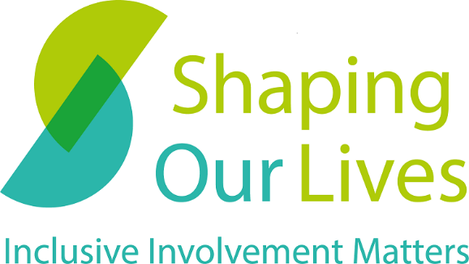

Who we are and what we do
2023

Contents
Contents 2
Who we are 3
How we can help 3
Recent and current partners and clients 4
Our work in 2022 – some examples 4
Making services more inclusive 6
Shaping Our Lives in numbers 7
Connect with us 7

Who we are

Shaping Our Lives is a user-led Community Interest Company with a national user group of Disabled people and service users. We have over two decades of experience in making sure the voices of people from marginalised groups are heard when it comes to designing and delivering vital services such as health and social care. Listening to the valuable lived experience of marginalised and often excluded groups will make services better for everyone.

Our Vision
A society in which everyone has equal life chances and support for independent living; a society which prioritises inclusion.

Our Mission
We work with people, especially those facing the biggest barriers, to build better, more inclusive services and support.

How we can help

Shaping Our Lives has built a trusted relationship with user-groups across the UK through pioneering user-led approaches and developing working approaches that enable people from seldom asked communities to take part equally and have a say. With our excellent links with a wide network of other user-led groups, we are in a unique position to help you ensure your involvement is inclusive, meaningful, and effective.

We offer:
- Consultancy and training in inclusive involvement practice
- Review and evaluation of user-led projects
- Enabling participation in research and other studies
- A trusted partner to reach out to seldom asked groups

Recent and current partners and clients

- University of Worcester
- Kings’ College London
- Southend City Borough Council
- Liverpool Hope University
- Trust for London
- University of Hertfordshire
- London School of Hygiene and Tropical Medicine

Check out our recommendations page

Our work in 2022 – some examples

Consultancy and training – Kings’ College London
We worked with the KCL Cicely Saunders Institute for Palliative Care. We were asked to support a range of research and clinical staff to develop their knowledge, understanding and confidence to involve people from marginalised and often excluded communities in their work. We started by completing a training needs analysis using an anonymous survey to gather honest reflections about what people felt they would benefit from. From this we were able to design two ‘dynamic’ lunch and learn interactive sessions and an in-person longer workshop.
Feedback: 100% of those who filled in the feedback forms said they were very or quite satisfied with the content of the workshop.
“I have done a fair amount of PPI [public and patient involvement] but still learnt loads today”

Enabling and facilitating participation
We ran a workshop for Liverpool Hope University involving the Service User Group at Hope (SUGaH+) alongside academic staff from the Social Work team and wider School of Social Sciences. The aim of the workshop was to talk about what would make a great research team, gathering ideas from service users/people with lived experience (PLE), researchers, and academic staff. This has developed into a series of events building a framework for the equal inclusion of service users in academic research teams.
Read about the workshop on our blog
Feedback: 100% of the participants that filled in feedback forms found the day enjoyable and worthwhile.
“Great opportunity for academics to work with people with lived experience.”

Reaching out to seldom asked groups
We ran the UK’s first service user-led inclusive involvement conference – with service users and individuals from diverse and seldom asked groups coming together both online and in person to talk about inclusive involvement and how to engage with marginalised communities. Speaker topics included:
- Inclusion and co-production of Autistic people
- Food insecurity, poverty and social work
- Breaking barriers for deaf people
- Mental health in the Showmen, Gypsy, Roma and Traveller community
- The intersection of race and disability and being Disabled in the South Asian community
- The experience of being a Queer Muslim woman and the overlap between Queer and Disabled experiences
- The barriers faced by Disabled trans people
Read more about the conference and the outputs
Feedback: “The speakers were important voices to hear. I admired the way that you had worked with speakers and protected their identities too. The write up was valuable and I look forward to seeing more work which models inclusion across diverse communities.”

Making services more inclusive

We have completed several action research projects where we have been able to influence services to become more inclusive in their approach.

Here are two examples:

Mutual Benefits – the potential of Disabled people as foster carers We worked with four foster agencies (two local authorities, one charity and one private provider) to remove the evident barriers to Disabled people becoming foster parents in a sector that has a disproportionate number of Disabled children needing support. Working with staff teams to audit processes, up date marketing materials and build confidence to work with Disabled people effectively our research and outcomes have led to a change in the Ofsted inspection process and an industry practice note.

Read more about the project

The Missing Voices of Disabled people in Traveller communities
We researched why these communities are largely not considered in the provision of health and social care services. Through our user-led network we formed partnerships with Traveller connectors and were able to visit people in a range of traveller sites and brick housing.

Read our report

Shaping Our Lives in numbers

20 years’ of experience

75+ free resources and guides

327 user-led groups in our network

5000+ followers and subscribers

9000+ website visitors in 2022

Connect with us

Shaping Our Lives is committed to increasing the inclusive involvement of people experiencing exclusion and unequal service provision, we have lots of knowledge and we would love to talk to you about how we can work together.
- Follow us on Twitter
- Follow us on LinkedIn
- Follow us on Facebook
- Follow us on Instagram
- Subscribe to our newsletter
- Visit our website
- Send us an email

Shaping Our Lives

www.shapingourlives.org.uk

Email: hello@shapingourlives.org.uk

Telephone: 0345 241 0383

Facebook: @shapingourlives

Twitter: @Solnetwork1

Linked In: @shaping-our-lives-national-user-network

© 2021, Shaping Our Lives
Shaping Our Lives National User Network Community Interest Company.
Company limited by guarantee registered in England and Wales.
Company No. 04382606
Registered office: 30 St Giles' Oxford OX1 3LE30

