**LOCKDOWN LOGS**

**EDGE HILL UNIVERSITY**

**SERVICE USERS & CARERS**

*External Version 1*

We love you NHS!

**(**A1 22.7.20)

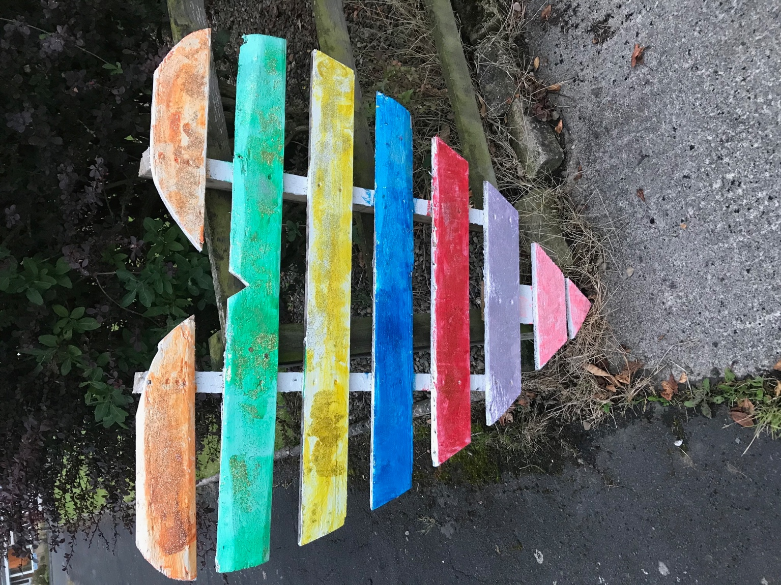

**Introduction**

Hello everyone,

In the Spring of 2020, the Service Users and Carers (SU&Cs) at Edge Hill University in the north of England decided to keep and share logs about their thoughts, feelings and experiences during lockdown.

These lockdown logs exist in a variety of formats, including drawings, prose, poetry, photos and videos. As the collator of these logs, I realised their sheer volume meant they needed to be classified. There was no perfect way of doing this but I have tried my best. One way to use the logs is to look at the contents and then, having found your area of interest, look at the extracts on the page given. If any pique your interest you can find the complete contribution in the raw data attachment. Just look for the author and the date.

As the logs were originally created for internal use at Edge Hill many of the contributions have been anonymised (A1, A2 etc.).

We hope you find our lockdown logs useful.

Best wishes,

George Turner

SU&C at Edge Hill University

**Contents**

**1. Change during lockdown………………………….………………...** p. 3

A. Positive……………………………………………………………..p. 4

B. Negative…………………………………………………………….p. 5

**2. Activities during lockdown ………………………………………….**p. 6

A. Technology and other people………………………………………p. 6

B. More activities……………………………………………………...p. 7

**3. Fears and concerns during lockdown………………………………..**p. 9

A. Mental health……………………………………………………….p. 9

B. Dealing with death………………………………………………….p.10

C. Dealing with birth…………………………………………………..p.11

D. Leaving the house…………………………………………………..p.11

**4. Emerging from lockdown……………………………………………..**p.12

A. Positive………………………………………………………………p.13

i. Getting the vaccine………………………………………………...p.13

B. Negative……………………………………………………………...p.14

i. Concerns about returning to work…………………………………p.14

**5.** **Perception of the Government’s response……………………………**p.15

A. Positive……………………………………………………………….p.15

B. Negative……………………………………………………………....p.15

i. Confusion………………………………………………………….p.15

ii. Lack of trust……………………………………………………….p.16

**1. Change during lockdown**

**Metamorphosis**

We lived a grasshopper life

Of collective fun

That ended

With a breathless kiss

Our fragile frame

Shivered

We lost our wings

And song and

Became ants

Careful for tomorrow

(George Turner – received 18.5.20)

**A. Positive**

The local canal, field footpaths and other people’s gardens began to take on a new importance and enjoyment. Less traffic and I could hear the birds were singing. Ducks, coots and swans nesting and having their young has been a delight as have the flowers with daffodils giving way to lilies, tulips and lilac.

(David Burkey – received 13.5.20)

I have got the people I love around me and that I care about around me.

(A2 18.5.20 *Video* at 1.30)

It has given me time to re-evaluate my life.

(A2 18.5.20 *Video* at 1.53)

Maybe this is a test…that we need to be there for others [and] to think what positive differences we are going to make in the future.

(A2 18.5.20 *Video* at 2.17)

Don’t give up hope-keep going my friend

A vaccine is coming and then it will end

(A3 18.5.20)

I didn't answer to the tyranny of the clock anymore, I had space to think, feel & explore.

(A4 22.7.20)

Doing schoolwork with [my son] has made me realise how behind he is at school. That is all going to be reviewed.

(A5 23.9.20 *Audio* at 4.50)

Absolutely lovely to have the house to ourselves [without carers]…

(A5 23.9.20 *Audio* at 5.26)

**Just Think**

Now, we're locked inside

With many freedoms lost

A golden opportunity to

Think outside the box

(Ad Gridley – received 17. 1.21)

In lockdown, I rediscovered my hobbies and pastimes - a love of carpentry, gardening, music, reading, art and so many other things. Nature was beautiful and clear.

I also found time to enjoy my little family and be the father and husband I wanted to be.

(A6 – received 20.1.21)

A sunny day uplifts the spirits and sitting in a south facing room is cheerful. Breakfast is shared with two blackbirds who bathe in a shallow pool.

**(**Robert G MacDonald – received 3.2.21)

Lockdown meant I could work [lecturing as a service user] at many different universities all across the UK in the same day even working for a couple of

American universities…

(Ad Gridley 14.7. 21 *Video* at 0.38)

**B. Negative**

My full diary of activities and socialising was suddenly empty. No days out walking in the Lakes, no coffees In Costa with friends or the newspaper, no volunteering at a large Christian event in Prestatyn and no working on the BuffetCar at Ffestiniog and Welsh Highland Railway. Gone my Sunday worship and pub lunch with friends and Dobbies Garden Centre firmly closed.

(David Burkey 13.5.20)

Suddenly for life to completely stop. It is very hard on me and extremely isolating.

(A2 18.5.20 *Video* at 0.48)

I cannot go to my caravan in France… I also miss going out for a meal or to a pub once a week and I am missing going to watch my beloved Manchester United

(A3 18.5.20)

So all of us oldies we just stayed inside

No shopping or bingo or a nice long car ride.

No hugs from our loved ones- we stayed in our room

(extract from a poem by A3 18.5.20)

I couldn't access health care, peer support & those without the privilege of an online connection & equipment… I count the days missing celebrations & funerals.

(A4 – received 22. 7.20)

Doing the home schooling has been a bit of a challenge…

(A5 23.9.20 *Audio* at 2.47)

[For my son] Usually have about 15 hours a day care [but now mainly me]

(A5 23.9.20 *Audio* at 3.24)

Pointless which is the right word for life at the moment, Pointless or waiting for Godot .... what are we all waiting for?

**(**Robert G MacDonald – received 3.2.21)

**2. Activities during lockdown**

**A. Technology and others**

Zoom, Skype and Teams have been a steep learning curve but have help connect with family, friends and church. (David Burkey 13.5.20)

Microsoft teams; zoom, Skype meetings all mastered plus face book and What’s app connection with family and a weekly thank you email from my employer. (Toni Bewley 14.5.20)

We learnt how to work a new thing called zoom

Some folks used Skype but don’t ask me why

My little iPad won’t even try

(extract from a poem by A3 18.5.20)

Contact through video chat- feeling happy!

**(**A1 – received 22.7.20)

**B. More activities**

**Haircut**

As steel strokes skin

I watch my body fall about me

Asking if this mirrored alien

Could house

The thoughts within

But as this skilful shaper

Trims my brain

A fresh frame

Appears to civilise my wildness

And when at last

This conjurer

Pulls back my scaly cover

My old body is swept away

And binned

Lest it contaminate another

(George Turner – received 6.1.21)

a daily walk has been therapeutic

(Toni Bewley – received 14.5.20)

During the COVID 19 Pandemic I read, draw and paint besides my study window… I have been keeping a Drawing Journal

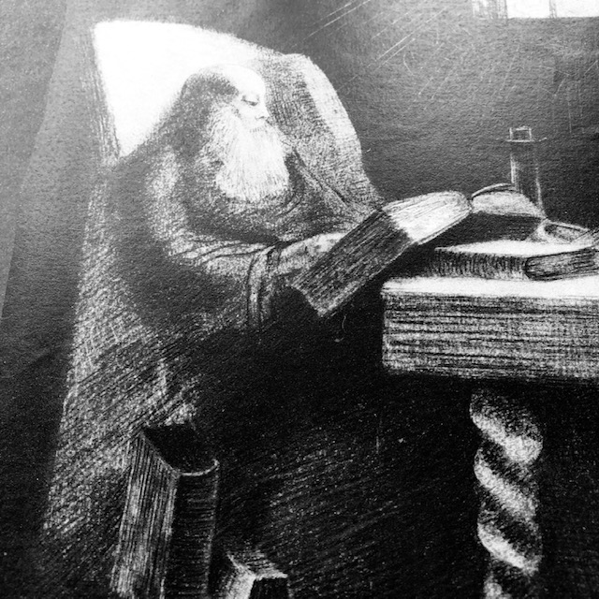

I am working at home and marking the work of First Year Architectural Students [and] developing my Research about Design for Dementia

(Robert MacDonald 15.5.20)

I cleaned the house from top to bottom, made lots of nutritious meals which filled my freezer, went on my exercise bike and had a walk every day

(A3 – received 18.5.20)

Walks…[Using] bikes and scooters…Baking…

Dancing on Zoom…Home learning…Reading…Craft [activities]…

DIY Haircuts…[Enjoying] sunshine…Water fights…

[Lockdown] celebrations…Cuddles…Sleeping late

(A7 *Video* – received 6.6.20)

Walking along the canal bank (A7 – received 7.7.20)

Home learning - making pizza… Getting fresh air - feels great

**(**A1 – received 22.7.20)

…try to get fresh air and vitamin D from the sun when it was sunny and nice warm days.

(A8 – received 22.7.20)

**3. Fears and concerns during lockdown**

**A. Mental health**

**Time out**

Not to the world’s clock

Do I tick

But imprisoned within myself

Loiter in a heaven

And hell

Without restraint

From those who hold

With hugs

Or smother with smiles

A God

Free of mankind

I flirt with madness in

A time out

Of mind (George Turner – received 24.5.20)

A little more anxious at the start if I had any aches or pains … and would I be able to call the doctor but that’s settled now. Motivation is lower than before...The garden helps keep me more or less sane (David Burkley 13.5.20)

My Feelings during lockdown have ranged from loss of control over my daily living, initial fear and anxiety to a sense of acceptance and a feeling of becoming resolute. In fairness, fear was fleeting (Juliet Thomas 11.6.20)

the fact that we cannot have any physical contact and can’t give or receive hugs is soul destroying. It also makes me question my own mortality… I had days where I didn’t want to get out of bed and when I did all I wanted to do was curl up on the settee and read or watch tv. I marked my kitchen calendar green for good days and red for bad. I am just entering my eleventh week and there have been ten really bad days which I feel is ok because good far outweighs bad

(A3 – received 18.5.20)

**B. Dealing with death**

All the world over the virus takes hold

Killing so many- but mostly the old

Too many people are no longer here

Cos the little virus keeps spreading its fear

(extract from a poem by A3 18.5.20)

During lockdown I have unfortunately witnessed the distress of Patients,

their loved ones and Nurses and Medical Staff in the care that has been delivered to and received by dying patients that have been affected by Covid-19. Over the past 8 weeks or so I have been empathising with all parties mentioned above but more particularly with Nursing Staff (having been a Nurse since 1975) and I have been trying to imagine both the emotional and physical impact that the lack of opportunity to deliver care to dying patients as they would want to deliver it might have on Nurses in this situation.

(A9 – received 10.6.20)

The Glove

On a sad note, my twin sister Janet’s husband of 45 years Don had been

suffering from early onset dementia for 5 years and for the last year was in

a residential Nursing Home where he was the youngest resident.

Unfortunately, in May he contracted Covid 19 and very sadly passed away

he was just 68. As was the policy, my sister couldn’t be with her husband

and could only see him through a window near his bed.

When they called her to say he had deteriorated (she had shot home to use

the bathroom and grab some lunch) she went straight back. As she was

getting out of the car she noticed her gloves on the seat and put them on.

When she got to the window she had a revelation and asked the nurse if

she would put one of the gloves in Don’s hand so he could ‘hold her hand’

and the nurse did as asked and Don kept the glove in his grasp. He passed

away not long after and the comfort this small act has brought to my

sister is immeasurable. She firmly believes that she was holding her

beloved Don’s hand till the end.

(Juliet Thomas 16.6.20)

… I was very aware of how these [6] deaths in such strange times were affecting their loved ones and tried to support. I had however failed to take account of how all of this was affecting me.

With the final death, that of my close friend, it all caught up with me and I was rubbed out and drained physically and mentally. My holiday in Scotland was exactly what the doctor ordered!

(David Burkley 30.9.20)

**C. Dealing with birth**

Communities locked down,

Fear of the monster, fear for life.

A kick, a hiccup, a stretch,

Protected and dependent on mummy,

Safe inside.

(extract from a poem by A10 who was pregnant – received 17.1. 21)

**D. Leaving the house**

They [parents whose children have trachys] are scared of their child becoming unwell in case they have to go to hospital and are at risk of catching the virus

(Toni Bewley – received 14.5.20)

the majority of people did try very hard to keep the 2 m distance. But not all of the people did, some just totally ignored it and didn’t bother to try to move to one side so that you could pass at a safe distance… what most people complained about was the cyclists. Some just didn’t have any regard for the pedestrian and would cycle passed in large groups or very fast, what I did notice was that most cycles didn’t have a bell or means of warning so you wouldn’t hear them coming up behind you

(A7 – received 7.7.20)

I snake around people. If someone sneezes, I can see the apoplectic faces of others in the near vicinity.

(Toni Bewley – received 22.7.20)

Worried about going out again…can not be responsible for others…

(A5 23.9.20 *Audio* at 6.10)

**4. Emerging from lockdown**

**Opening the cage**

As wild animals tamed

We hover at the cage’s door

Behind - a world

Predictable and safe

Before - an oyster filled world

Of dangers and delights

From those who kill

And those who cure

Which to choose

Bars that protect or

Boundless uncertainty?

We are wild animals

Born to roam

(George Turner – received 18.5.20)

**A. Positive**

Finally reunited. Cried with emotion   
  
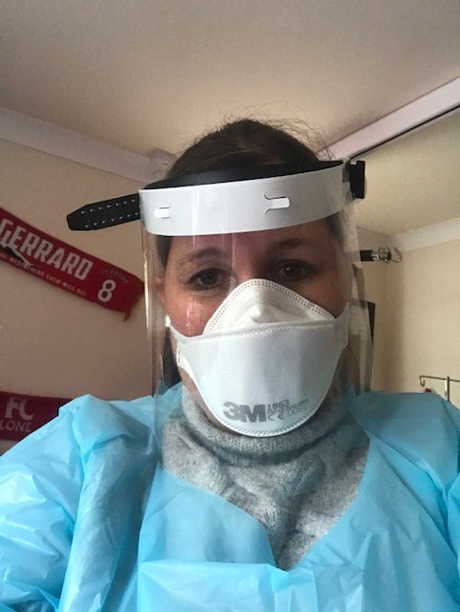

**(**A1 – received 22.7.20)

**i. Getting the vaccine**

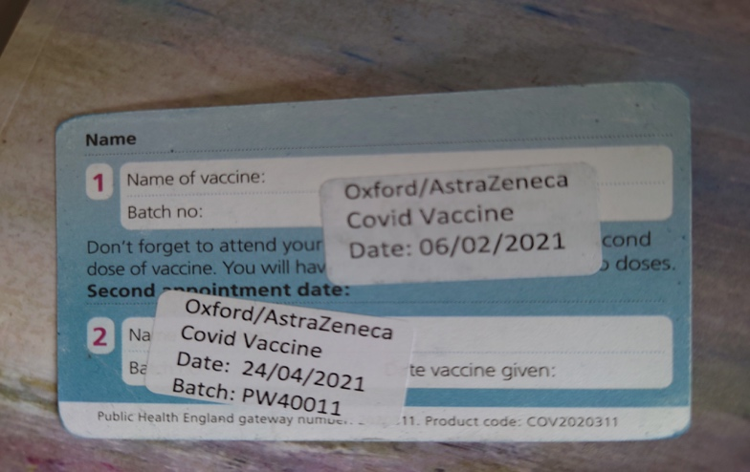

I had my first COVID jab in mid-January and this was a very positive visit to the local Community Centre. Efficiently organised I was in and out in 10 minutes…[People] enjoyed the friendly atmosphere as well as getting their ‘jab’.

(David Burkey – received 12.2.21)

Yesterday I had my first vaccination and I cried, I was so relieved and I thought it would make me feel different somehow. A light at the end of the tunnel. But if I am completely honest, sitting here today, I still feel terrified…

(A11– received 12.2.21)

After the first Astra-Zeneca injection, I couldn't leave my bed the next day. I had regular doses of Lemsip which helped me through. After that one day, I was back on my feet again like nothing had happened. I had my second Astra-Zeneca last Saturday (it's now Wednesday) ready for another day in bed, but I felt fine…

(Ad Gridley 28.4.21)

**B. Negative**

The thoughts of rushing back to normality fills me with dread… Going to selected shops has me presently donning plastic gloves; not face masks yet, but this will be so at the end of this week. I do not like touching anything in shops, not even shopping baskets or trolleys.

(Toni Bewley 22.7.20)

It concerns me this rush to return to normal. It'll be a challenge for many unseen folks to resist.

(A4 – received 22.7.20)

As the lockdown begins to come to an end it’s interesting to see how different people react… I know one person who won’t go on a train or bus, even though the rules now allow him to do so wearing a mask… another person would not go inside [a pub] because he didn’t want to leave his personal details.

(A7– received 18.8.20)

**i. Concerns about returning to work**

I am quite fearful of returning to LJMU [work] and public transport, bus or train (Robert MacDonald 15.5.20)

Come back soon they say, but you must wear a mask, must keep social distance [and] must use hand sanitising stations – but, they insist that it is safe.

(Toni Bewley 30.7.20)

**5.** **Perception of the Government’s response**

**A.** **Positive**

I was ‘touched’ about receiving letters and texts from the government and my local Hospital where I was treated to say that I was considered high risk. It was as though my illness was being validated and made me feel that the anguish and distress that I had experienced had been ‘real’ despite feeling and being very well and nearly three years in remission at this moment in time

(Juliet Thomas 11.6.20).

**B.** **Negative**

**i. Confusion**

The group that I’m involved with of parents of children with trachys are terrified; shielding for 12 weeks and yet many not received letters from the government and so not eligible for a shopping slot for home delivery or a government food box. They are also confused about whether they still had carers in to support them and their child and if they got PPE and most decided to do all the care themselves and so are exhausted… There has been little consultation by the government with any service users - no surprise as co-production is often an after-thought but we need to be consulted. Pressure groups on social media have forced some responses but it’s been piecemeal

(Toni Bewley 14.5.20)

**…**we had the statement by Mr Johnstone last Sunday and since then there seems to be a great deal of confusion… should people go back to work, or is it too soon, how can they keep social distancing on public transport, will it be safe to travel. The biggest concern seems to be should children go back to school… people are very confused by all of these changes. But what doesn’t help is that every time the government says one thing, all of a sudden we have an expert who will challenge it. Who is right it is very confusing for lots of the public, who do we listen to?

Then like most people I thought that we lived in a United Kingdom, but no, Scotland, Ireland and Wales are saying that they will not follow the new government instructions.

(A7 – received 15.5.20)

**ii. Lack of trust**

… health economics has kicked in big time and the elderly and vulnerable have been thrown under a bus.

I don’t any longer believe a word that any of the government representatives say.

(Toni Bewley 14.5.20)

**…**just how “factual” are the published statistics? Do they show what is really happening outside the confines of our incarceration? Or have been manipulated, inflated, fudged and exploited to tell us something else?

Hospitals… were given specific guidance from NHS England on March 7 to ‘urgently’ make available 15,000 beds nationally by discharging anyone who was medically fit to leave. This led to hospitals sending patients into care homes without testing them for the virus, even if staff suspected they had symptoms.

…we must not overlook State permitted “de-prioritisation”. This unilaterally selects people with disabling conditions / syndromes, be they developmental, mental, physical, mobility, brain injury, chronic illnesses, complex needs, addiction, etc., and everyone over a certain age, (irrespective of any known health issues), All, including those that care for people outside of a hospital and / or care home environment are officially classed as “vulnerable and frail”. The picture is very dark indeed as anyone in this sector is now deemed less worthy of hospital treatment than others.

(Allen Bewley 21.5.20)