**RAW DATA**

**LOCKDOWN LOGS**

**EDGE HILL UNIVERSITY**

**SERVICE USERS & CARERS**

*External Version 1*

**Presented in the order they were received:**

From David Burkey – received 13.5.20

I think I was in denial at first and found it hard to see myself as one of the vulnerable. Truth then dawned on me and I began to think about all the things I had lost. My full diary of activities and socialising was suddenly empty. No days out walking in the Lakes, no coffees In Costa with friends or the newspaper, no volunteering at a large christian event in Prestatyn and no working on the BuffetCar at Ffestiniog and Welsh Highland Railway. Gone my Sunday worship and pub lunch with friends and Dobbies Garden Centre firmly closed. It took a little time to adjust!

I then began to look at what I did have and could still do and this change of perspective helped enormously. A different sort of routine, more relaxed but nevertheless a routine ie regular getting up and meal times and exercise. The local canal, field footpaths and other people’s gardens began to take on a new importance and enjoyment. Less traffic and I could hear the birds were singing. Ducks, coots and swans nesting and having their young has been a delight as have the flowers with daffodils giving way to lilies, tulips and lilac. Watch out David for the swoop of the heron! on the canal bank.

Support has been very important indeed. My wife Glenys and I have been married for 50 years later this year and we’ve supported each other well. I’m not sure how well I would cope if I lived on my own. We have a WhatsApp group at church and this has kept people together. It’s also given perspective to the situation in that we’ve heard of some really hard situations, supported people working on the frontline but also rejoiced when babies have been born and when folk have come out of hospital.

Zoom,Skype and Teams have been a steep learning curve but have help connect with family, friends and church.

A big thank to Toni and Sue for getting in touch to see how we were doing and setting up this group. It’s been a support and a chance to catch up, meet new members and try to find the way ahead for the group and to hear about EHU.

Sleep wise. I’ve been ok and more or less as before Covid 19 . A little more anxious at the start if I had any aches or pains etc(I am a man after all) and would I be able to call the doctor but that’s settled now. Motivation is lower than before. I’ve learned new words like ‘Tomorrow’ and even ‘Next week’ but may be that’s a good thing. The garden helps keep me more or less sane. I hope!

From George Turner – received 14.5.20

**Another country**

Where hospitals are morgues

And care homes care to kill

Where friends are fatal

And white van man is king

Where life is made

Of walls and trivia

Where clocks tick death

And carers get the clap

Here we linger

Hold our breath

And shiver

Beneath the sweating sun

**Another distance**

Contact is contagious

Hard to suppress

The pull of flesh on flesh

And love that is skin deep

Bubbles of existence

That pop if touched

By friendly enemies

And those that care

Here we linger

As buried babes

Dying to be caressed

Into life

**Another nature**

Now is the time for Nature

But only some Nature

The caring mother of

The pretty and the cute

Not indifferent Nature

That clothes the earth

With Summer sunshine

And life-giving rancid air

Here we linger

Besieged by Nature

Trying to make a living

Out of death

From Toni Bewley – received 14.5.20

So lockdown and it’s meaning - very difficult as at times it’s seemed like health economics has kicked in big time and the elderly and vulnerable have been thrown under a bus . No mention initially of what would happen to elderly and vulnerable if they got covid 19 ; but general talk seemed to be survival of the fittest and no chance of either group being offered life support. The group that I’m involved with of parents of children with trachys are terrified ; shielding for 12 weeks and yet many not received letters from the government and so not eligible for a shopping slot for home delivery or a government food box. They are also confused about whether they still had carers in to support them and their child and if they got PPE and most decided to do all the care themselves and so are exhausted. They are scared of their child becoming unwell in case they have to go to hospital and are at risk of catching the virus . There has been little consultation by the government with any service users - no surprise as co production is often an after thought but we need to be consulted . Pressure groups on social media have forced some responses but it’s been piecemeal . My work place finally complied with government guidance and closed our workplace which for the first three weeks had been putting staff on Rota’s to come in . So practically lockdown has meant we have accessed two online food deliveries in five weeks - a daily walk has been therapeutic and Microsoft teams ; zoom, Skype meetings all mastered plus face book and What’s app connection with family and a weekly thank you email from my employer. We live in an isolated place so have heard from no one re volunteers etc but I thank goodness that we have a garden to sit in and the sun has been shining - as for the news ; well I don’t any longer believe a word that any of the government representatives say - and as for freedom and no lock down frankly it terrifies me

From A7 – received 15.5.20

Most people seemed as happy as they could be with the lockdown, but then we had the statement by Mr Johnstone last Sunday and since then there seems to be a great deal of confusion.

Lots of people don’t agree with what was said, should people go back to work, or is it too soon, how can they keep social distancing on public transport, will it be safe to travel. The biggest concern seems to be should children go back to school, how will they be able to keep social distancing, young children would not be able to understand, or would they?

Being able to travel is another concern; people are very confused by all of these changes. But what doesn’t help is that every time the government say one thing, all of a sudden we have an expert who will challenge it. Who is right it is very confusing for lots of the public, who do we listen to.

Then as like most people I thought that we lived in a United Kingdom, but no, Scotland, Ireland and Wales are saying that they will not follow the new government instructions. I can fully understand their concerns. Even local councils are now saying that they will not start to send children back to school as they don’t think that it is safe to do so yet.

So with all that is happening and all that is being said, who do we follow? Who do we listen to? It’s all very, very confusing.

From Robert MacDonald – received 15.5.20

During The COVID 19 Pandemic I read, draw and paint besides my study window. I can see an Oak Tree and a Giant Pine Tree which are habitats for many birds including cooing wood doves. I have been keeping a Drawing Journal which includes the architecture of Le Corbusier, Modern Art and Garden Birds.  
In between times I am working at home and marking the work of First Year Architectural Students. I am in a Vunerable Group ( Diabetic Type 1 and Bi Polar ) so my Wife and Partner Mary is my shield, shopper and company. Weekends role into weekends. I am quite fearful of returning to LJMU and public transport, bus or train ? This is my only option.  
Meanwhile, I am developing my Research about Design for Dementia. The news is always bad; the latest is that 1 in 4 of people who die in Care Homes have Dementia or Diabetes....  
Stay safe & well & in the Words of Caroline Flack , Be Kind.

Dr Robert G MacDonald ( self portrait ).

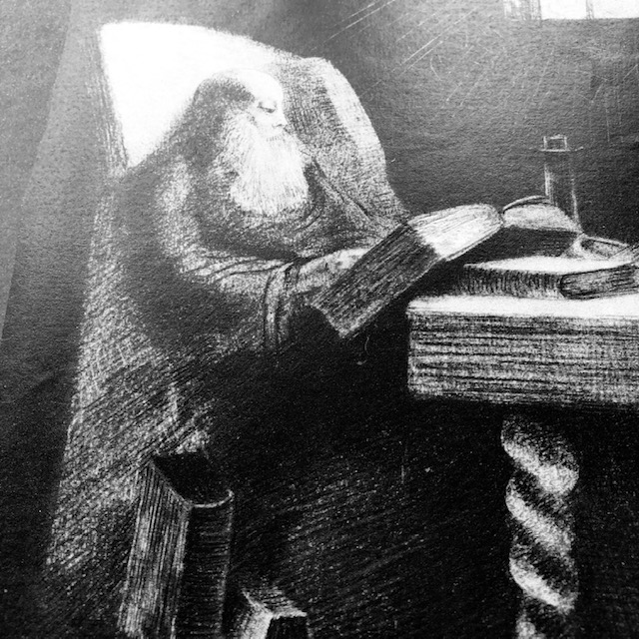

From George Turner - received 18.5.20

**Metamorphosis**

We lived a grasshopper life

Of collective fun

That ended

With a breathless kiss

Our fragile frame

Shivered

We lost our wings

And song and

Became ants

Careful for tomorrow

**Trapped**

We pace our property

As cats in heat

Circling from door to door

Hunting for distraction

Alert to change

Where no change is

Trapped by beckoning glass

Sniffing the stale air and

Brutally aware

Beyond the frozen world

Where we lie and wait

Lies a sun-soaked land of

Enemy and mate

**Opening the cage**

As wild animals tamed

We hover at the cage’s door

Behind - a world

Predictable and safe

Before - an oyster filled world

Of dangers and delights

Of those who hurt and those who cure

Which to choose

Bars that protect or

Boundless uncertainty?

We are wild animals

Born to roam

A3 – received 18.5.20

When we in the Uk first became aware of the pandemic my thoughts were “it won’t come here and even if it does it won’t affect me”. How wrong I was and very soon I became aware that this really was something serious so I went out and did a larger than usual grocery shop and decided to isolate myself for protection. This was almost two weeks before the official lockdown.

I have always looked on age as just a number and it’s how you feel that is the most important. I am a seventy six year old living alone, healthy and reasonably fit so imagine how shocked I was when over 70’s were ordered to isolate for twelve weeks. It came as a shock to realise that because of my age I was indeed considered to be a vulnerable little old lady who needed to be protected.

Rather than sitting around feeling sorry for myself I decided that I needed to keep active. In the the first couple of weeks I cleaned the house from top to bottom, made lots of nutritious meals which filled my freezer, went on my exercise bike and had a walk every day. This was all well and good for a while but gradually I had days where I didn’t want to get out of bed and when I did all I wanted to do was curl up on the settee and read or watch tv. I marked my kitchen calendar green for good days and red for bad. I am just entering my eleventh week and there have been ten really bad days which I feel is ok because good far outweighs bad.

The one thing that has really upset me is the fact that I cannot go to my caravan in France next week, something I do every year for a period of three months. Even if travel restrictions are lifted there is very little prospect of my going this year. I also miss going out for a meal or to a pub once a week and I am missing going to watch my beloved Manchester United.

My family has been very supportive especially my daughter Sally. She, my two sons and two of my granddaughters have been doing my shopping and FaceTiming me but the fact that we cannot have any physical contact and can’t give or receive hugs is soul destroying. It also makes me question my own mortality. I am in the twilight stage of my life and I don’t know how much of it is left. I want to get back to living it to the full as before.

I think life is going to be very different when it gets back to normal, whatever normal will be. I hope it will be better in terms of being more tolerant, helping each other, being less wasteful and less materialistic.

A3 – received 18.5.20

All stay at home -the government said

You could be ill or end up dead.

So all of us oldies we just stayed inside

No shopping or bingo or a nice long car ride.

No hugs from our loved ones- we stayed in our room

We learnt how to work a new thing called zoom

Some folks used Skype but don’t ask me why

My little iPad won’t even try

We stocked up with loo roll and pasta and rice

But a trip to the chippy- now that would be nice

Kept watching the news but that made me sad

Cos this ruddy virus is driving me mad

All the world over the virus takes hold

Killing so many- but mostly the old

Too many people are no longer here

Cos the little virus keeps spreading its fear

Keep ALERT say the people who make up the rules

But the virus is clever, it thinks we’re all fools

Don’t give up hope- keep going my friend

A vaccine is coming and then it will end

**Video from A2 - received 18.5.20**

*(See separate Video attachment))*

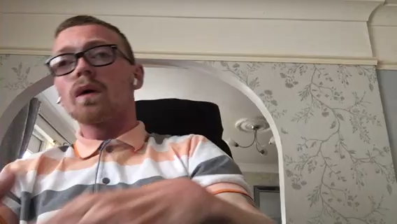

From Allen Bewley – received 21.5.20

"Lies, damned lies, and statistics" is a phrase describing the persuasive power of numbers, particularly the use of statistics to bolster weak arguments. It was popularised in the United States by Mark Twain and others, who mistakenly attributed it to the British prime minister Benjamin Disraeli.

The mortality statistics for COVID19 have been incessantly hammered into our heads by the Government, medical experts, scientists, researchers and mainstream multi-media. Day by day they publish the very hardest of “facts” to justify lockdown - AKA house arrest - and to prove to every single one of us that living in abject fear of COVID19 is the only sensible answer.

Seemingly, only the most secretive, unproven and expensive vaccine ever devised or yet to be devised, linked to a 24/7 personal surveillance tracker, monitored 24/7 by the Government, rigidly and scrupulously enforced by their State Police can possibly save any of us from certain death.

Of course, it goes without saying that anybody classified as “eligible” by the NHS for vaccination will be required to apply to the State for their very own Personal Immunity Passport (PIP) which must be carried on your person at all times and produced on demand to prove to all and sundry that you are indeed a Registered Vaccinated Person (RVP) who is rightfully permitted to live in post-COVID19 society.

The problem is – just how “factual” are the published statistics? Do they show what is really happening outside the confines of our incarceration? Or have been manipulated, inflated, fudged and exploited to tell us something else?

Registered deaths have been recorded in England and Wales since 1837. From 1911 onward the cause of death has been coded in accordance with the International Classification of Diseases (ICD). Maintaining registration records is now the responsibility of the Office of National Statistics (ONS). From a statistical perspective their consistent, verifiable system and inbuilt safeguards has allowed meaningful analysis to inform public health practice and policy for decades, which means the ONS provide some of the most reliable mortality statistics in the world.

In order to register a death in England and Wales, under normal circumstances, a qualified doctor needs to record the cause of death on the Medical Certificate of Cause of Death (MCCD). They must then notify the Medical Examiner for a corroborating opinion. Providing the doctor is clear on the cause of death and no irregularities or suspicions are noted, if the Medical Examiner concurs, there is no need to refer the death to a coroner.

The second opinion of the Medical Examiner (another qualified doctor) was introduced in 2016 following a series of high-profile systemic abuses. The mass murderer Dr Harold Shipman, and doctors at Mid Staffordshire NHS Foundation Trust and Southern Health NHS Trust, covered up crimes and widespread malpractice by improperly completing Death Certificates.

The Coronavirus Act 2020 received Royal assent on March 25th. This had significant implications for the registration of deaths and the accuracy of ONS data in relation to COVID19. Not only did the act indemnify all NHS doctors against any claims of negligence during the lockdown, it also removed the need for a jury led inquest.

The safeguards introduced in 2016 were removed for all cases of COVID19. Doctors do not necessarily need to have examined the deceased prior to signing the Death Certificate. If it is considered impractical for the doctor who last saw the deceased to complete the certificate, providing they report that the deceased “probably” had COVID19, ANY other qualified doctor can sign the death certificate as a COVID19 death. There is no need for the scrutiny by a second Medical Examiner

NHS guidance advises that if no signing doctor has seen the deceased prior to registration of death, a referral to the coroner must be made. However, this is a procedural recommendation, not a legal requirement. A legal requirement is only applicable in cases of unknown or suspicious causes of death. COVID19 is officially deemed a naturally occurring disease and therefore is capable of being a natural cause of death which does not in law require referral to the coroner and “should” be dealt with via the MCCD (Medical Certificate of Cause of Death) process.

This means that, not only is there no need for an examination to pronounce death from COVID19, nor is there any necessity for a positive test or even an indicative CT scan. When mortality statistics are used for research, identifying the underlying cause is considered the most relevant factor. However, current death registration peculiarities proving COVID19 was the de-facto underlying cause of death, now appears extremely doubtful and should be treated with considerable scepticism. Harsh reality, nobody really knows how many people have actually died from COVID19. We are told many people have, but we cannot state with any certainty what the numbers are. Neither can the ONS.

Particularly as the State also instructed the ONS not only to record all registered COVID19 deaths, where positive tests results were known, but also where COVID19 was merely suspected. This prompted a significant increase in the COVID19 fatalities reported by the ONS. Not because more people were dying from it, but because the categorisation of COVID19 deaths has changed. Any mention of COVID19 anywhere on the death certificate, regardless of other comorbidities, such as heart failure or cancer, are now recorded as registered COVID19 deaths.

Hospitals have been under pressure to free up beds since the start of the coronavirus outbreak in anticipation of a surge of extremely sick patients. They were given specific guidance from NHS England on March 7 to ‘urgently’ make available 15,000 beds nationally by discharging anyone who was medically fit to leave.

This led to hospitals sending patients into care homes without testing them for the virus, even if staff suspected they had symptoms. The Department of Health issued separate guidance on April 2 that negative tests were ‘not required’ before discharging people into a care home.

The Care Quality Commission (CQC) is currently investigating “deadly betrayal:” tragically, hospital patients have triggered outbreaks in care homes, claiming the lives of other vulnerable residents. Staff at the care homes have not been told of the condition by the hospital and would have not realised they had the virus so may not have been wearing adequate protective clothing or taken other infection control precautions.

There has been a huge rise in non-Covid related deaths, which may have resulted from residents ‘not getting the medical attention they need’. GPs would normally visit homes if a resident is unwell and some carry out routine check-ups once or twice a month, but there are now a massive number of reported claims that family doctors have refused to attend care homes at all, since the outbreak started.

Of course, we must not overlook State permitted “de-prioritisation”. This unilaterally selects people with disabling conditions / syndromes, be they developmental, mental, physical, mobility, brain injury, chronic illnesses, complex needs, addiction, etc., and everyone over a certain age, (irrespective of any known health issues), All, including those that care for people outside of a hospital and / or care home environment are officially classed as “vulnerable and frail”. The picture is very dark indeed as anyone in this sector is now deemed less worthy of hospital treatment than others.

Should anyone in this group require hospitalisation, you would be at the absolute mercy of strangers. There is a real chance you could meet prejudice in the shape of a doctor or nurse who does not think your right to treatment – or indeed life – is equal to that of a ‘normal’ person. (Whatever a ‘normal’ person is.)

GPs and hospital doctors continue to add Do Not Attempt Resuscitation (DNAR) notices to people’s medical records in violation of legislation and, frankly, people’s right to life. There is a correct procedure when it comes to these things, and it is not being followed. For those that are shocked by this, it’s a human rights issue. For those who deeply love someone within this “classification”, it’s terrifying!

When it comes to the treatment of the old, disabled and disadvantaged, the notion that this virus is a great leveller has been proved a big fat lie. It has shone a light on something that, in better times, was easier to ignore: Some people’s lives simply are not valued as much as others.

Whose idea is it that we dump nine million individual human beings into a box labelled “the elderly” with all that implies. It is both inane and offensive. It's not the same as referring to “teenagers” collectively. Their age group spans six years. The so called “elderly” span 40 years or even a bit longer. It's an attitude that leads to road safety planners portraying older people as bent-over, doddery creatures leaning heavily on a stick.

The age sector includes me. Being over 70, I am de-facto officially classified as “elderly, frail and vulnerable” by decree, banned from any workplace, excluded from socialising with anybody beyond my own front door, forbidden to drive anywhere on any public road, unable to purchase any goods or services that are deemed “non-essential”, even barred from going to any shop to actually collect said goods, by the Government’s demand to “shelter and protect” anyone who has passed the “magic” number.

As far as I know, I do not have any underlying health conditions. I have no symptoms of the wretched virus and no letter from my GP warning me of any reason to feel vulnerable. I don’t feel old, I don’t look old (or so I’m told) and I am sprightly enough to properly fulfil my commitments and responsibilities as Chair of a sport’s National Governing Body (NGB), Chair of a Centre for Independent Living (CIL), a UK Government Growth Advisor, an active member of the Welsh Government Disability Forum and a Council member of the Edge Hill University FoHSUCC.

I have no desire to put anybody in danger or overwhelm the NHS, but as former Head of Risk Management for one of the world’s biggest insurance companies, even at my great age, I do reckon that I’m wise enough to recognise and understand the risks and sensible enough to take precautions to protect anyone else, without that capability being officially removed from me by the State.

Disastrous doomsday projections have now forced this country into a financially crippling lockdown, the worst for 300 years, obliging many of us to remain under house arrest and isolated from those we love Not to mention the creation of a new “ailment” called “Coronaphobia.” A term used to capture the growing number of individuals with excessive anxiety and dread responses caused by the current COVID19 situation, who are now scared witless by the endless sermons about death and disaster and daily mortality rate briefings by the Government and publicised by a hungry mainstream media eager to sensationalise reported deaths.

The ONS will continue to record all deaths and society will eventually have total numbers. However, we might never know the true causes or be able to accurately forecast trends as the statistics directly attributable to COVID19, are now officially vague, unclear and imprecise.

Getting society back to work will be hard. The work ethic propelling us out of bed each morning has been sapped by the vast, sweeping, showy policies of mass house arrest, the unprecedented switching off of an entire advanced 21st Century economy, and a time-limited, not to mention unaffordable, Treasury-funded cost of living subsidy for millions of people.

The adopted “Government Knows Best (GKB)” mantra which declares that “Shutdown, Lockdown, Isolation, Protection and Shielding, (SLIPS)”, is the only viable solution for the future means that months, perhaps years of costly, painful stupidity will follow and even then, it might never fully end.

If, and when, any of us go back to our jobs – assuming, anyone will still have a job – we will all be compelled to abide by ludicrous, impractical rules. Normal life will become virtually impossible. Previously simple actions will be endlessly complicated and immensely expensive. What’s more, all the time this persists, businesses will continue to close, and jobs continue to vanish, visiting misery and sickness on millions, until the whole of society eventually collapses or explodes.

From George Turner – received 24.5.20

**Time out**

Not to the world’s clock

Do I tick

But imprisoned within myself

Loiter in a heaven

And hell

Without restraint

From those who hold

With hugs

Or smother with smiles

A God

Free of mankind

I flirt with madness in

A time out

Of mind

From George Turner – received 28.5.20

**Stay safe**

Boxed up and crammed

With inspiration

We suffocate

In our coughing

Shrouded and loved

Out of existence

Our sleeping corpses

Dream of resurrection

When boxes burst with

New advice to give

Not the deadly stay safe

But the joyous

Go live

**Screens** From George Turner – received 5.6.20

Where actors act

And life is cheap

Bewitchingly full of

Framed faces

You can’t walk round

A cruel trick to offer

The person without the person

Familiars playing

The zombie role

That satisfies

While leaving hungry

Give us the flesh

Give us the soul

**Video from Alanna Bartram (Toni’s daughter) – received 6.6.20**

*(See separate Video attachment))*

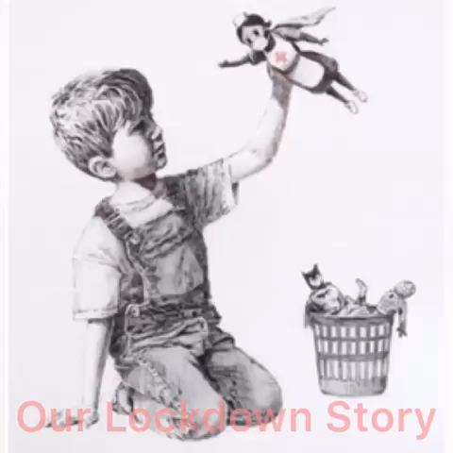

From George Turner – received 9.6.20

**A difficult time**

A difficult time for us

But easy for our enemies

To smuggle through our doors

And make our bodies sweat

We are a meaty dish

That Gods the planet

And when ambulances wail

To save our own

Not every creature shares our strife

We are but one player

In the zero sum

Of life

From A9 – received 10.6.20

Some time ago, (2004) I carried out a number of Semi-Structured interviews in order to investigate Registered Nurses and Student Nurses perceptions of a good death for the Older Adult. During lockdown I have unfortunately witnessed the distress of Patients, their loved ones and Nurses and Medical Staff in the care that has been delivered to and received by dying patients that have been affected by Covid-19. Over the past 8 weeks or so I have been empathising with all parties mentioned above but more particularly with Nursing Staff (having been a Nurse since 1975) and I have been trying to imagine both the emotional and physical impact that the lack of opportunity to deliver care to dying patients as they would want to deliver it might have on Nurses in this situation.

Age Concern (1999) identified twelve principles of a good death, namely:

* To know when death is coming and to understand what is to be expected.
* To be able to retain control over what happens.
* To be afforded privacy and dignity.
* To have control over pain relief and other symptom management.
* To have choice and control over where death occurs (at home or elsewhere.
* To have access to information and expertise of whatever kind is necessary.
* To have access to any spiritual support or emotional support as required.
* To have access to hospice care in any location, not only in hospital.
* To have control over who is present and who shares the end.
* To be able to issue advance directives which ensures wishes are respected.
* To have time to say goodbye and have control over other aspects of timing.
* To be able to leave when it is time to go and not have life prolonged pointlessly.

These were considered to be excellent principles and they should surely have been incorporated into the individuals care plans, professional codes and the aims of the Health Service as a whole.

The semi-structured interviews (2004) with Registered Nurses working in Hospitals and Nursing Homes and Student Nurses working in the same areas produced a set of criteria which they felt were necessary to enable a good death. These were namely:

* Environmental Factors.
* Communication.
* Death of an Older Adult generally.
* The Family/Relatives.
* Spirituality/Dignity/Respect/Culture.
* Issues relating to Staff.
* Knowing the Patient.
* Awareness (of the Dying Process).
* Care of the Older Adult generally.
* Pain.
* Patient independence.

On close examination there is not a great deal of dissimilarity between the two lists and so it could be said that there are useful guidelines available to assist in the delivery of care.

It was acknowledged however, that family played a crucial part in determining whether a good death was achievable, ‘I think it is terribly important that the family continue to care and do some of the basic tasks…after all, they may have been caring for them for years’. Other responses focussed upon the need to allow as much time and privacy for the patient and family in order that goodbyes might be said. Furthermore, others suggested that some patients families may experience guilt and anger as a result of unresolved conflicts.

This leads us to Covid-19 Patients saying goodbye to their loved ones for one last time over a mobile phone held for them by a Nurse due to the restrictions placed on Intensive Care Units and Hospitals on Government and Medical advice. Consider the anguish that must be felt by Nursing and Medical staff during this undertaking and how they mange to cope with the same situation again and again. This is not in keeping with how they would wish to deliver End of Life care and yet this is all they can do! Very few of the above ‘Guidelines/Wishes were able to be implemented.

So Toni , Paola, do you think that there would be any mileage in examining this issue further in terms of exploring individuals thoughts, feelings, emotions whilst delivering End of Life care in this way?

I’m not sure that it might be too intrusive at this moment in time i.e. too early or that it may be too raw at this stage for people to revisit. I would be grateful to hear either of your thoughts and thank you both for taking the time to read this offering.

Juliet Thomas – received 11.6.20

My Feelings during lockdown have ranged from loss of control over my daily living, initial fear and anxiety to a sense of acceptance and a feeling of becoming resolute. In fairness, fear was fleeting and mainly focused on my families well being as I took the magnitude of the pandemic on board. I quickly became galvanized as to our safety and the measures we would take to ensure we were following the Governments advice to the letter.

I found the hand washing and distancing routine straightforward and my health professional background and an understanding of cross infection really helped. Although, I have noticed that the majority of people in my community and certainly my immediate family have embraced the hand washing and distancing measures with gusto.

Without a doubt my illness of three years ago had prepared me well for “lockdown” as having been diagnosed with Non-Hodgkin’s Lymphoma a type of blood cancer I was used to distancing myself from anyone with a cold, a cough or sore throat as I underwent a 19-week course of chemotherapy. As the treatment was at times debilitating I spent a lot of time at home so I had experienced a sort of ‘Lockdown’ before and became adept at avoiding potentially dangerous situations.

It might sound strange but I was ‘touched’ about receiving letters and texts from the government and my local Hospital where I was treated to say that I was considered high risk. It was as though my illness was being validated and made me feel that the anguish and distress that I had experienced had been ‘real’ despite feeling and being very well and nearly three years in remission at this moment in time.

However, I had a sense of once again being labeled: Sick, potentially Covid sick, cancer recovering patient and ‘victim’ and the fact I was ‘being shielded’ made me feel rather helpless. However, I understand these feelings are possibly to be expected (or not) and that many of my fears and anxieties of being ill and receiving a potentially life threatening diagnosis came back because of Covid 19 but the tragedy of large numbers of people dying makes my grateful that I have survived so far and intend in keeping it that way.

The Glove

On a sad note, my twin sister Janet’s husband of 45 years Don had been suffering from early onset dementia for 5 years and for the last year was in a residential Nursing Home where he was the youngest resident. Unfortunately in May he contracted Covid 19 and very sadly passed away he was just 68. As was the policy, my sister couldn’t be with her husband and could only see him through a window near his bed.

When they called her to say he had deteriorated (she had shot home to use the bathroom and grab some lunch) she went straight back. As she was getting out of the car she noticed her gloves on the seat and put them on. When she got to the window she had a revelation and asked the nurse if she would put one of the gloves in Don’s hand so he could ‘hold her hand’ and the nurse did as asked and Don kept the glove in his grasp. He passed away not long after and the comfort this small act has brought to my sister is immeasurable. She firmly believes that she was holding her beloved Don’s hand till the end.

From George Turner – received 15.6.20

**Fear**

From nearest to dearest

Sweat spreads

Through the dumb air

Until all

All are infected

With a gasping disease

That saves the body but kills the soul

But such timid fear can be fought

Fought with bold hope

With a coloured crayon

And a friendly word

For there is a cause and cure of

All our woes

The herd

**Close encounters**

The warmth

The skin

The beating heart

Serve

The primal urge

For contact

But this gathering up

This smothering by hugs

Can bring a soothing death

To both

Both are repelled by their attraction

Both imprisoned by walls of air

Each tortured flesh

Needs flesh to feed on

There is horror in feeling this much

What is love

Without touch?

From George Turner – received 19.6.20

**Life’s ups and downs** *(statue toppling)*

Raised by our peers

Who knew what they were doing

We lord the land

Beneath us

A still centre of a shifting world

‘Til thanks to those

Who know what they are doing

On our plinth

We begin to sway

Like those who pull us down

We have hearts of steel

And feet of clay

From George Turner – received 2.7.20

**Bonsai**

Now I can go out

To quicken the heart

And hear the wild trees blow

I view my stay-at-home plant afresh

Lovely in its limitation

Pampered

Into sterile perfection

A living ornament

Confined and protected

From rough skies above

Not the only thing

To be imprisoned

By love

From George Turner – received 3.7.20

**Unprecedented**

Well-known to history

Fire, war and plague

Give panic a precedent and

Suffering a standard

But those without memory live

Where all

All is unprecedented

They are lost

In a forest of fear

Starting each day anew

With baby minds

In a knowing world

Inventing all they do

The amnesiac

The demented

And perhaps one day

You

From A7 – received 7.7.20

**Social distancing**

Over the last few months it has been interesting to see how different people acutely did this. In fairness I found that the majority of people did try very hard to keep the 2 m distance. But not all of the people did, some just totally ignored it and didn’t bother to try to move to one side so that you could pass at a safe distance. Others really went overboard and would cross to the other side of the road to make sure that there was a good distance between you and them. But most people would move to one side as you approached them, this is what I did when out walking. What I did find was that some people would get very angry if people made no effort to social distance. I can remember when walking along the Ormskirk road in Aintree I was crossing the road which was the entrance to Aintree race course, there was a lady stood on the splitter island and she was very angry, I stood to one side to let her pass, she thanked me and then went on to complain very loudly how some people just didn’t try to move. She said that because of the lockdown she couldn’t visit her friends and walking was her only way to see people. After a couple of minutes I said have you enjoyed having a complain? She said yes thanked me and went on her way.

Walking along the canal bank what most people complained about was the cyclists. Some just didn’t have any regard for the pedestrian and would cycle passed in large groups or very fast, what I did notice was that most cycles didn’t have a bell or means of warning so you wouldn’t hear them coming up behind you. I remember when out walking one day I saw a man who was about 30m ahead of me, two cyclists approached him from behind, one shouted that he was coming through, so the man stood to one side. He didn’t know that there were two bikes and he stood in front of the other and was knocked down. Fortunately neither he nor the cyclist was hurt, but the cyclist did give him some grief. But again thankfully most people on their bikes were very polite as they passed.

From A8 – received 22.7.20

My personal experience for preventing corona virus -Covid 19  was to stay at home , observe socila distance ( 2 meters) wear face mask ,  self isolate from others and follow the health and safety regulations : wash my hand frequently  , use liquid sanitizer to clean hand and services to prevent catching any corona virus through spreading. Also try to get fresh air and vitamin D from the sun when it was sunny and nice warm days.

General comments / remarks:

There will be continous public health awareness to prevent getting corona virus and to follow all the health and safety regulations at work , home and in the community with regular update  from central & local authorities to stay well and safe and apply social distancing all the time.

A4 – received 22.7.20

On reading our lockdown log:

A lot of what was written reflects my experience. I didn't answer to the tyranny of the clock anymore, I had space to think, feel & explore but I couldn't access health care, peer support & those without the privilege of an online connection & equipment.  
> Actions about me continued without me.  
> I feel very much in limbo not being able to come out of isolation while the world rushes to return to it's normal, I count the days missing celebrations & funerals.  
> It concerns me this rush to return to normal. It'll be a challenge for many unseen folks to resist.

A1 – received 22.07.20

We love you NHS!

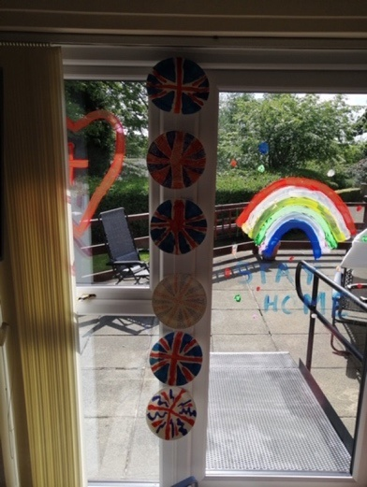

Further contact through video chat- feeling happy!

! 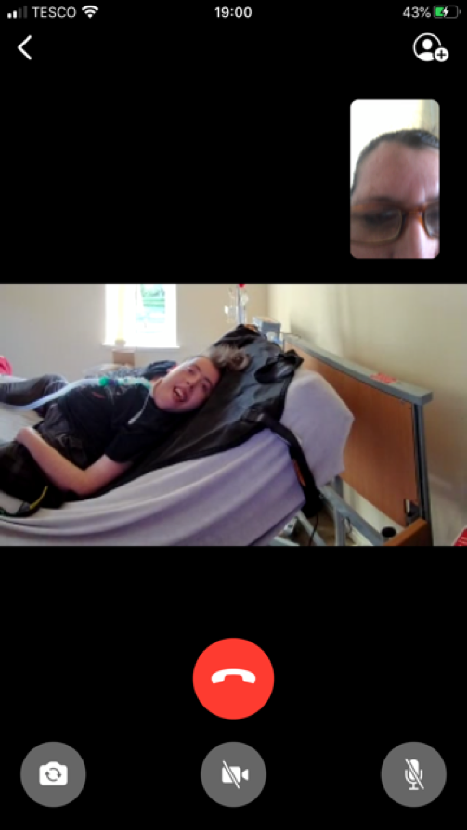

Home learning - making pizza . Good fun   
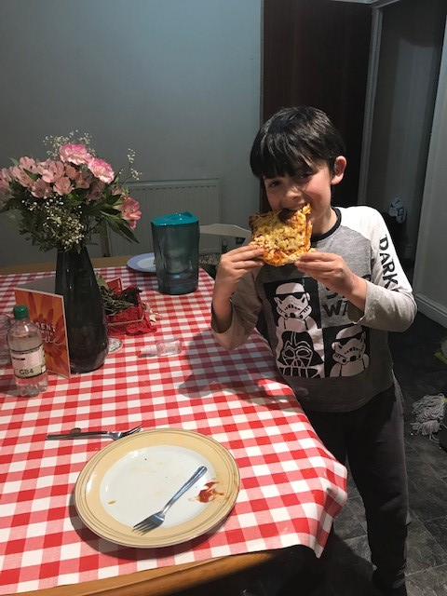

Getting fresh air - feels great

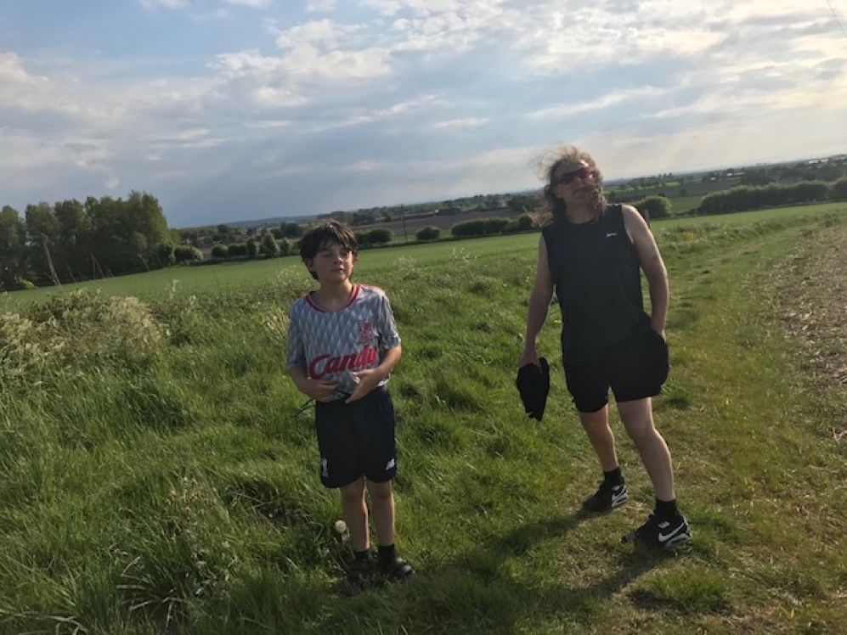

Finally reunited . Cried with emotion   
  
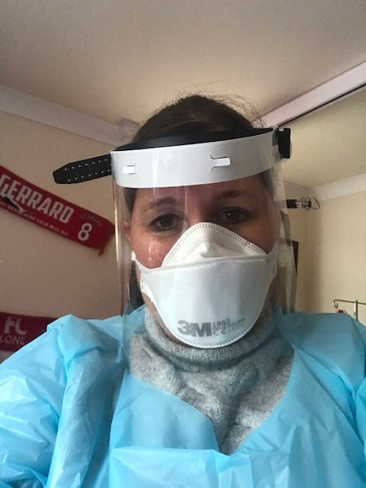

Venturing out of lockdown - anxious , excited !!

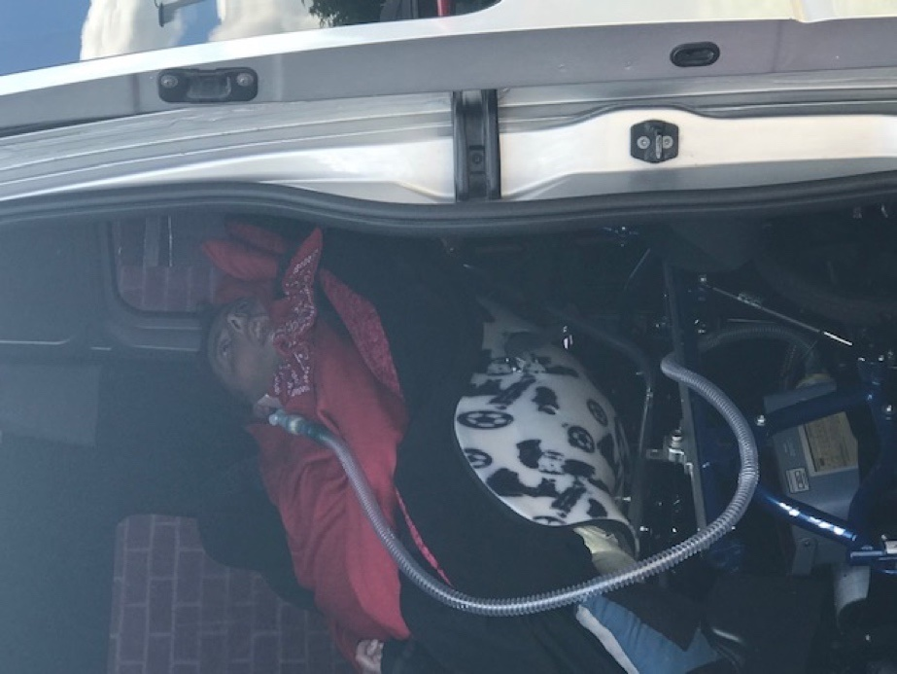

Four way video chat - getting clever !

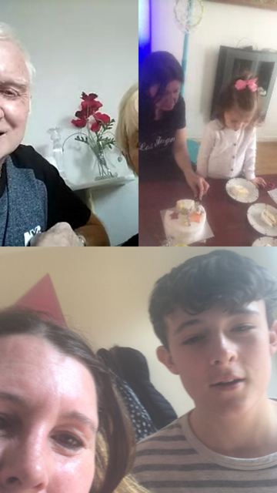

Keeping in contact !

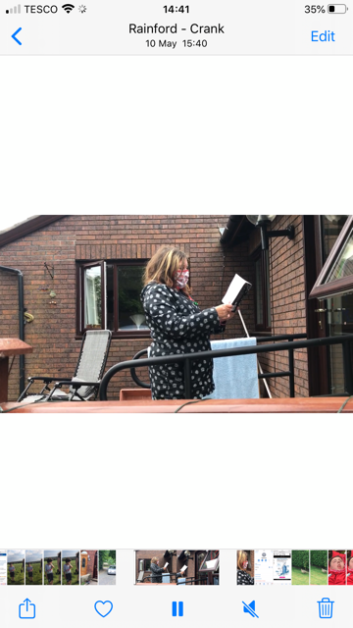

A1

Toni Bewley – received 22.7.20

**Brave new world**

Well, I am not feeling brave and I do not like this new world. The thoughts of rushing back to normality fills me with dread. This isn’t going to be normal and the mention of it being so is like something from Disney. Going to selected shops has me presently donning plastic gloves; not face masks yet, but this will be so at the end of this week. I do not like touching anything in shops, not even shopping baskets or trolleys.

Somehow, it seems like going into the lion’s den from now on. My employer gives out conflicting advice, like the UK government, day by day. It oscillates from come into work as all is safe, to stay at home because it is not. I have students starting a course in September; what do I really tell them? Is it safe to come onto the university campus with others? probably not, but I am only allowed to give them the corporate message. Do my employers care about me? certainly not, and they show it with reminders constantly about the worth of the students to the establishment, but not with equal value of the worth of the staff.

I go out for a daily long walk; currently, I snake around people. If someone sneezes, I can see the apoplectic faces of others in the near vicinity. I am happy to be healthy, happy to have survived the apocalypse to date, but mourn for the lost freedom of the past, and do not relish the prospects of living life on a precipice from now on.

Toni Bewley – received 30.7.20

So, they tell me that I can have two free corporate face masks. Rather than excitement at the thought of this, my blood runs cold. It equates to me with being thrown into the lion’s den. Its safe they say (my employers) so safe that you will have to make sure that you clean the classroom before you leave. So safe that I cannot enter my office that normally holds four people without consulting a rota. My office maybe safe for just two, but even then, I am not sure. You can do your online safety advice checks, they say; but I don’t want to have to do that really because the mere thought of having to do this emphasises that there is risk. Come back soon they say, but you must wear a mask, must keep social distance, must use hand sanitising stations – but, they insist that it is safe.

No one has asked me how I feel, but do you know Mr Employer that I’m feeling rather safe in my bubble, without a mask, without doing online health and safety sessions and without having to clean surfaces before I leave the room. I feel safe in my own little bubble and regardless of what I am hearing about how safe my workplace is, I’m not sure that I want this bubble to burst.

Toni Bewley

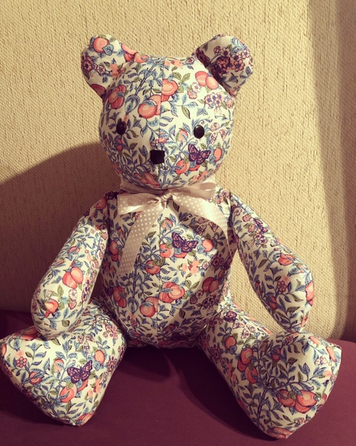

A12 made this in Lockdown – received 6.01.2021

**Haircut**

As steel strokes skin

I watch my body fall about me

Asking if this mirrored alien

Could house

The thoughts within

But as this skilful shaper

Trims my brain

A fresh frame

Appears to civilise my wildness

And when at last

This conjurer

Pulls back my scaly cover

My old body is swept away

And binned

Lest it contaminate another

George Turner – received 6.01.2021

**Poem for a baby born during lockdown**

Communities locked down,

Fear of the monster, fear for life.

A kick, a hiccup, a stretch,

Protected and dependent on mummy,

Safe inside.

Pans banging, hands clapping,

Your heart beating,

Thanking frontline warriors,

Saving lives

Whilst we remain,

Safe inside.

Births, graduations, funerals, weddings,

Celebrations of love stolen.

Now we mourn the lives lost,

And rejoice the recovery.

A celebration of lives,

Safe inside.

A gush of water,

Nine months your home,

Soon you will arrive,

No longer

Safe inside.

The wave of pain,

Bearing down,

Your head will emerge,

Guided by midwives,

Encouraged, supported, protected, born into a pandemic,

Safe inside.

Silky hair crowning a head that bears no fear,

Unaware of the enemy.

Innocent, no judgement, perceptions.

No media, no poison.

A new life has emerged.

From safe inside.

No visitors, no celebrations.

Hearts filled with love

From a distance.

Faces bathed in sun smiling,

As we wave

Safe inside.

Two tiny feet uncurl,

Never worn, untouched by the earth.

Adventure awaits, a journey to hold.

Life, possibilities, joy,

When the time comes,

Safe outside.

A10 – received 17. 01. 21

Nine poems from Ad Gridley – received 17.01.21

**First World**

A handful of cables deep under the sea

Full of hellos & goodbyes

Satellites bounce our good & bad news

Across our most beckoning skies

**Just Think**

Now, we're locked inside

With many freedoms lost

A golden opportunity to

Think outside the box

**Grandiose Delusions**

Is Corona my fault?

Now, I know it's not

In the past I'd run away &

Pray I don't get caught

**Ambitions...**

When Lockdown is over

I'll get a big apartment

Vacation in Bermuda

And spend at Aston Martin

**Before & After**

As we stay in Lockdown

Waves still beat the shore

Let's hope the world emerges

Better than before

**Wipe Everything**

An Englishman's home

Is ever his castle

Careful to maintain

Two metres from parcels

**Airborne Division**

Infinitesimal squadrons glide on hapless gusts

Breed on unwashed fingers and seatbacks of the bus

If trying to vanquish a deadly foe this small

Sit tight & outlive it (as sanctioned by the law)

**Three Hands Circling**

Stay at home and wait

The future's on its way

Now will become history

There'll be hugs again

**Post-Corona**

European twilight

Good folk throng the street

Summertime heat hangs heavy in the air

Laid back in bare feet

March 23rd 2020: I never, ever had time to think or pause before. Deadlines, pressures, performance evaluation, appraisals were all consuming, I did them constantly.

Then, all of a sudden, I had to stop and shield. The equivalent of being sent out of the class in school, without the shame.

 Before this, my wife Cathy was concerned, my youngest daughter Lucy upset: their mantras varied between "you should be able to just go off work" and "I'm really worried Dad, you're in the highest risk group". My own feeling was that I could not just disappear, I had obligations, a sense of duty and purpose, but it was becoming apparent that circumstances were overtaking any feelings I had.

In lockdown, I rediscovered my hobbies and pastimes - a love of carpentry, gardening, music, reading, art and so many other things. Nature was beautiful and clear. I also found time to enjoy my little family and be the father and husband I wanted to be.

 Lockdown was a pause, but not an end.

A6 – received 20.01.21

**Pointless**

Each day and night turns into another. What day is it anyhow? A sunny day uplifts the spirits and sitting in a south facing room is cheerful. Breakfast is shared with two blackbirds who bathe in a shallow pool. With ageing so comes more medical tests, blood, urine, ultrasound. It’s even a risk going to a surgery, hospital and clinic. Waiting for a cataract to be removed or having a dental appointment are all risky. Waiting for the vaccine? Now there is another variation. In Southport and Liverpool. Try not to watch the TV news and find some comedy shows instead. Evening meal is off a tray whilst watching Pointless which is the right word for life at the moment, Pointless or waiting for Godot .... what are we all waiting for? Lots of Time to ponder on the Meaning of Life?

Robert G MacDonald – received 3.02.21

Lockdown 3 began in January 2021 following a raft of restrictions of one kind or another from mid October 2020. It’s likely to last until at least 8th March 2021.

My wife and I had letters advising us to shield so basically we could leave the house to exercise like everyone else but not go into the essential shops which were open. We were fortunate as we had a supermarket priority slot and groceries came regularly each week to the front door. Other extras, treats and any emergency supplies were picked up by kind neighbours and friends. We are so privileged.

I manage to get out most days for a walk but on really cold days I need to stay indoors. If I get fresh air and exercise and see other people even just to say hello then I feel much better both physically and mentally. January is a hard month for most people and I sense many people have found it even more of a struggle in 2021.

Earlier lockdowns seemed to engender a good community spirt and folk wanted to smile, say hello or chat. Not so much this time as most people are well wrapped up, wearing face masks and want to keep their heads down and keep any contact to a minimum.

I’ve missed being able to work in the garden but that is changing now as we move into February with Spring bulbs showing signs of new life and some potted in the garage ready to come indoors. Spring is on the way. Hurray!

I had my first COVID jab in mid January and this was a very positive visit to the local Community Centre. Efficiently organised I was in and out in 10 minutes and no queuing outside. Community volunteers were on hand and this was good especially for those brought by car who perhaps with shielding or living alone had seen few people for months and were really feeling alone and very isolated. They enjoyed the friendly atmosphere as well as getting their ‘jab’. My heart does go out to those on their own who are not able physically to get outdoors especially in the cold weather. I count my blessings every day. Zoom for church services, lunches and quizzes have provided social interaction and support. It’s been good to have the challenge of work to do for EHU Service User/Carers group and the weekly Drop In- it seems like a gathering of old friends now. Lovely

What about other people who live nearby?

I guess for most people they are weary of it all and just wondering when it will end. Those who home school are finding it harder than in the heady days of last Spring as families are cooped up indoors all day in Winter. That said there’s more traffic on the roads and more children are attending school than in the earlier lockdowns.

Those who just loved the novelty of working from home and enjoying their garden and neighbourhood seem also to have grown weary and long to get back to office life. They miss the social interaction and stimulation of friends and colleagues. This is especially so if they work in Liverpool city centre as we have a train every 15mins and a commute of just 20 minutes.

I have a friend who lives alone and really misses being able to get to the gym to see other people as well as exercise. As someone else put it to me for many life is just ‘same old, same old,’

People do seem to be out for their daily permitted walk but not is a great numbers. A new coffee shop has opened up just before we went from Tier 2 to Tier 3 and they had to close except for takeaway. They have seized the day and now have a roaring trade in coffee and chocolate brownies (scrumpy). Many walking along the road have a drink and goody bag in hand. They’ve found a way to brighten up life and reward themselves for exercising.

Those who help in Food Banks say how much they have been needed during this pandemic. So we have those who can work from home or are retired on steady incomes managing pretty well financially but those on furlough or have lost their job or had hours cut finding life has the added pressure of shortage of cash and all the mental stress this has brought. Similarly people have struggled because non COVID health issues have not had attention or appointments for treatment have been delayed. Again for such people there is increased mental stress and anxiety. From what I observe most folk are keeping to the mantra to ‘Stay at home,Help the NHS and Save lives’ despite being weary and fed up with it all. One or two bend the rules slightly but generally people are complying with what’s been asked of them.

Life is really tough for children at school and students and I think for us all as we adapt to a new normal and face a different sort of future when we come out the other side of Lockdown 3.

David Burkey – received 12.02.21

When I think about the pandemic the word that comes to mind every single time is terror.

Early on I was sent a (totally unexpected) letter, instructing me to shield and as we speak I have had three such letters now. Telling me to shield, not only from the outside world, but those I live with too. ‘If you can’t keep 2 metres apart wear a mask indoors’. In the early months of the pandemic it was hard to control how terrified I felt of catching the virus. Terrified not just for myself but for my family too, especially my youngest who has Down Syndrome and Autism. I have rarely ventured out, even when my shielding was paused, because that kind of terror doesn’t just disappear, it has become my default now.

Yesterday I had my first vaccination and I cried, I was so relieved and I thought it would make me feel different somehow. A light at the end of the tunnel. But if I am completely honest, sitting here today, I still feel terrified of the outside world, of people, of covid, of new variants and ventilators and grief. I am not sure how I will ever feel normal again.

A11 – received 12.02.21

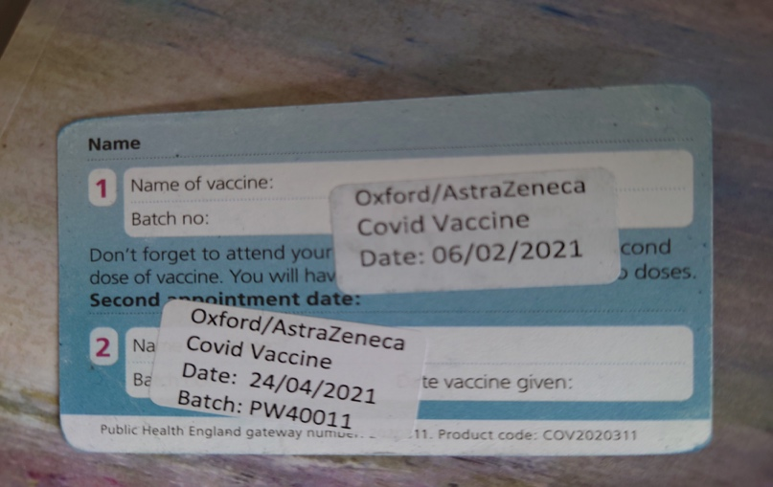

After the first Astra-Zeneca injection, I couldn't leave my bed the next day. I had regular doses of Lemsip which helped me through.

After that one day, I was back on my feet again like nothing had happened. I had my second Astra-Zeneca last Saturday (it's now Wednesday) ready for another day in bed, but I felt fine, except for a dull ache in the arm they used. The first was said to mean I'd be 70% protected, after the second, this figure apparently increases to 90%. I was given a card (please find attached) which said I'd had my jabs.

Ad Gridley – received 28.04.21

Extra: Some comments on Lockdown Logs from Robert MacDonald, a member of the Service User and Carer Group – received 21.3.21

*As we have all experienced Lockdown is a restrictive policy for people or a community neighbourhood to “stay where they are”, usually due to specific risks to themselves or to others when they can normally move and interact freely. The term “stay at home” or “shelter in place” is often used for lockdowns that affect an area, rather than specific locations. Lockdown is an emergency measure for mass safety measure in a disease outbreak. These Lockdown Logs clearly reveal the physical, mental and psychological effects and implications of the restrictive policy. The Lockdowns will have short term medical effects but at the post Covid stage we, do not know the long-term implications and psychological effects. Long Term Covid is already recognised as an additional medical condition that we are learning about including fatigue, shortness of breath, cough, joint pain and chest pain. There are many additional psychological symptoms including deep depression and anxiety.*

*At the most extreme the term Lockdown can also be used for a prison protocol that usually means the prisoner being in Lockdown for 24hrs per day with lack of day light, limited food and exercise. All the prisons in the UK are recording high numbers of prisoner Lockdowns. In contrast, for some people and creative artists, Lockdown has been a time for great creativity and an opportunity for self-discovery. When Vincent Van Gogh was in a seclusion suite in an asylum, he painted some of his most beautiful paintings. He painted the works of others and he admired his own paintings. Vincent did not own a garden but many of his paintings were about green places, colourful flowers and natural landscapes. Vincent gave us significant messages about the therapeutic value of views of green.*

***Lockdown Gardens: A prose.***

*When Vincent was in the Asylum.*

*He painted passionately,*

*Wheat fields with Cypress Trees,*

*In his room in 1888 Arles.*

*Vincent never owned a garden,*

*But he knew of many.*

*He reminded us of the value of Green gardens and places,*

*He painted Sunflowers, trees and Starry Skys.*

*He painted trees in the Provincial Sun,*

*Transfigured memories of his native Holland,*

*He wanted to Paint*

*As if everybody understood him.*

*Gardens by the Sea*

*Intense yellows,*

*Sea Blues*

*The Earth, sky and Sun.*

*Harvest Yellows,*

*Fields of Corn,*

*Canal Side Walks*

*And Sunsets.*

*Boats on Sandy Beaches,*

*Blue Mediterranean Seas*

*With steps*

*Across Stone Bridges.*

*Peach Trees in Bloom and White Roses,*

*More Cypress Trees*

*In the Garden*

*Where Vincent sat on a Stone Bench.*

*Most of all he painted Sunflowers…*

*Robert MacDonald*

*Many of the positive aspects noted in the Lockdown logs concern therapeutic nature of gardens, canal sidewalks, field footpaths, wild flowers and plants. Many individuals have discovered watching bird life such as magpies, swans,* *geese, doves and coots. Taking the dog for a walk in a park or green space became a simple part of daily exercise and has encouraged conversations (at a safe distance) about dogs. There is probably nothing more therapeutic than stroking and feeling the precipice response and tactile quality of a dogs or cat fur. Certainly, The Lockdown Logs record our pleasure of walking in the fresh air during Spring Time when the crocuses and daffodils amazingly appeared.*

A stone bench after Vincent, in the Asylum, between two trees.

(Robert MacDonald – received 7.7.21)

