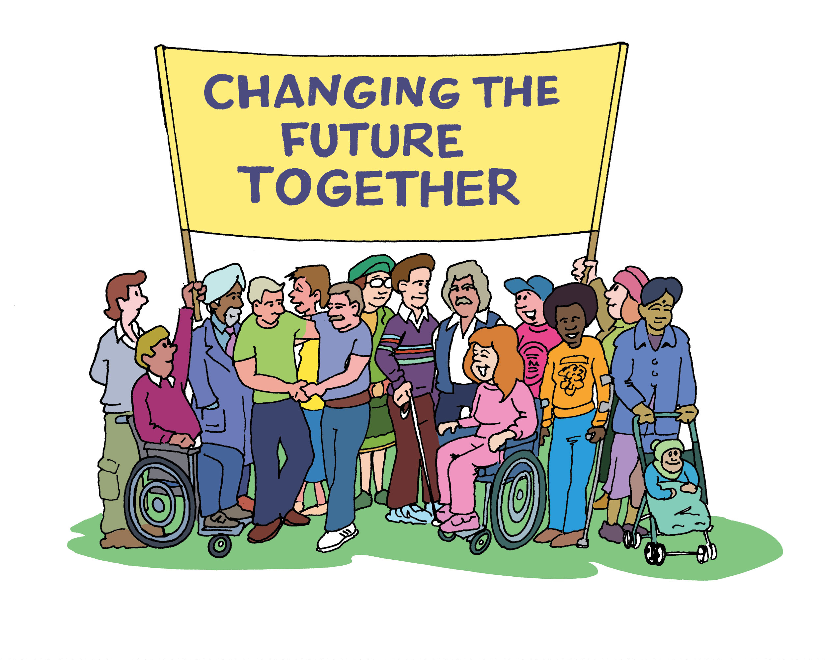

Peter Beresford and Frances Hasler

Transforming Social Care

Transforming Social Care

Changing the future together

Peter Beresford and Frances Hasler

Report of the findings from an event bringing together service users and policymakers to feed into the Government’s Green Paper Consultation

ISBN 978-1-902316-62-8

Copyright: Centre for Citizen Participation

2009

Brunel University Press

Contents

Summary 7

Illustrated Main Points 15

Acknowledgements 27

Forewords 29

Part One: Background

Introduction 36

1. The government policy context: David Behan 43

2. An alternative service user view: Peter Beresford 51

Part Two: Findings

3. Strategies for improving social care 62

4. The services and support people want 79

Part Three: Conclusion 99

References 105

Appendices

1. Event Programme 109

2. Organisations supporting the Event 110

3. Easy read evaluation form 111

DVD of Main Speakers 115

Summary

Introduction

The Report sets out the findings from a national event jointly organised by Brunel University and the Commission for Social Care Inspection bringing together a wide range of service users and policymakers to explore what kind of social care they want for the future and how it can be achieved. The event received wide support from a total of 18 social care organisations, including statutory, independent, third sector, professional, trade union, university and service user organisations. They also provided financial support which made it possible to ensure access for a wide range of service users to take part.

1. The government policy context

Social care is being given more political priority. The government is working to improve social care. It wants social care to promote people’s independence and citizenship. The present system is too complicated and needs reform. More attention needs to be paid to quality and outcomes rather than money and quantity.

The government believes that social care services need to be based on a model of personalisation, tailored to people’s individual needs and making more use of direct payments and individual budgets. Four big changes are needed. First, services must listen more to service users. Local authorities are responsible for all their citizens needing support, not only those the state pays for. Second, there need to be improvements in how services are bought – or commissioned, involving service users. Third, there needs to be better checking of the performance of services. Fourth, workers need good training to have the skills they need.

There are five key policies for improving social care. These are:
- Personalisation
- Early intervention, to prevent problems getting worse
- Improving services for dementia, which is a large and growing problem
- Ensuring people are treated with dignity in services
- Improving help and support for unpaid carers

Discussions and large scale public consultations are being organised to inform these big policy changes.

2. An alternative service user view
The transformation of social care through the philosophy of independent living is a major innovation with revolutionary potential. Groups of people who have long been devalued have themselves developed new approaches to services and support which enable them to live and contribute on equal terms with other people.

Social care now has the potential to transform millions of people’s lives for the better,. Yet still many people live in institutions and have inadequate, unreliable and sometimes inappropriate support. Service users and their organisations have shown that it is possible for people to live lives of previously unimagined quality and value. Yet this is still not widely known or recognised and social care as a policy is still not well understood or valued.

This raises big questions for the future.

- Now that we know, particularly from the efforts of service users themselves, how to make it possible for service users to live fuller more equal lives, why is it still the case that many people do not - and many still face massive barriers, prejudice, insecurity, isolation and want?

- How can we what can we do to make it possible for many more people who are service users, to be able to get the support they need and the broader changes that are required in society to live the lives with real choice and control that they are capable of living and should have a right to?

3. Strategies for improving social care
Service users and policymakers don’t just have views about what better social care should look like. They also have ideas about how to help make this happen. In their discussions, service users and policymakers identify six main ways in which they think better support can be achieved for people in future. In order of priority these are:

- Changing the nature of social care
People think it is important for social care to change and to be seen to be better in a number of ways if it is to gain more support. This includes through social care developing a broader more holistic approach to people and by bringing about culture change in social care; through strengthening its evidence base, raising its status and profile, making it more attractive; by improving terminology, introducing new legislation and improving the benefits system.

- Campaigning and lobbying
Campaigning, lobbying, direct action, forming alliances and developing dialogue are the methods most commonly mentioned as ways of getting improved social care, by bringing pressure to bear to achieve it. Service users are seen as having a central part to play in making this happen.

- Education
Educating a wide range of groups is seen as a valuable way of gaining support for social care. This included service users and potential service users and service user organisations. Through education, service providers would offer better support and by educating the general public and children from an early age at school, social care would come to be better understood and supported for the future.

- The media
The media are also seen as having a vital role to play in raising both the profile of and public interest in social care. They can challenge negative stereotypes and help advance positive values like those of independent living, both through their news reporting and by featuring issues positively in ‘soaps’.

Challenging the stigma and prejudice attached to those associated with social care
While the media are seen as an important means of highlighting social care, they are also seen as playing a part in encouraging the stigma and prejudice which people see as a major problem facing service users and social care. Ways of counter-acting such negative stereotyping are seen as a valuable means of improving the status of both social care and service users.

- A stronger voice for service user organisations
The increased involvement of service users is also identified as a key way of improving social care support. There are calls for increased support, including funding support for service users’ own organisations, capacity building for such organisations and greater use of support services provided by service user organisations.

4. The services and support people want
Service users and policymakers have many suggestions to make about what better social care would look like. Eight main ways to improve social care are identified. In order of priority, these are:

- Greater user involvement
Greater user involvement emerges as people’s top priority for improving social care. Included under this heading are increased involvement for people who use services, more support for service user organisations, more service user training and more user-controlled services. The importance of building service user capacity and developing self-assessment are also highlighted.

- An improved workforce
Three key areas for improvement of the workforce are identified. These are improving the role, status, pay and conditions of workers; better training for workers and positive changes in the social work role. People want social work that is less bureaucratic and where practitioners are less gatekeepers and more supporters.

- Better, more appropriate services
People see improvement in services as meaning better access to support and services (including early access to and preventative support), more self-directed support and deinstitutionalisation. Not all comments are supportive of individual budgets and some people stress the need for them to be supported by an adequate infrastructure. Other issues that are highlighted included ensuring good standards, having a positive approach to risk taking and the importance of equity and reliability in service provision.

- Improved funding
At the heart of this concern is the need for more funding for social care and the damaging effects of inadequate funding. People also stress the need for existing funding to be used better and differently.

- Changing from a restricted to an
accessible universal service
Related to the last issue, is the call that social care should change from being a means-tested to a universalist service. Participants call for the removal of narrow eligibility criteria and for social care to be available to all as of right.

- Policy and provision based on rights
and independent living
Another priority is for social care to be based on values of independent living and human rights, with service users supported to live their lives on as equal terms as possible, as an entitlement.

- Policy and provision based on an holistic
approach to people
People call for policy and provision which are more locally based, which treat the individual as a whole person, instead of being based on a narrow idea of ‘social care’ needs and which are connected with the wide range of other policies that affect their lives, like housing, health, benefits, education, planning, justice and so on.

- Improved social care organisations
Finally people want better social care organisations, particularly organisations which are less bureaucratic and hierarchical, less concerned with profit-making and more accessible.

5. Conclusions
There is considerable agreement between what government says it wants for the future of social care and what service users and policymakers call for. Both highlight the importance of user involvement, improving the quality of the workforce, developing more preventative services and ensuring people have choice and control and treating them with dignity and respect. However there is a difference in emphasis between the two. While the government is now committing itself to a policy of personalisation, based on self-directed support and individual budgets, participants highlight a much broader range of changes they want to see in social care.

There is a more explicit commitment to the need for more funding as well as better use of funding. They offer a vision of social care that is participatory, rights-based and holistic in approach. Their vision is strongly value-based and there are many calls for a rights based, universalist approach to social care, along similar lines to the traditional principles of the NHS (National Health Service). Their ideas for the future of social care are much closer to the broader picture offered by the government’s own Independent Living Strategy, than its specific approach to social care. Their ideas for how it is to be achieved rest heavily on the need for more service user and public involvement, campaigning and lobbying, education and positive use of the media. They also emphasis the need for social care to show rapid signs of improvement if it is to gain greater public and political support and understanding and additional funding for the future.

Transforming Social Care

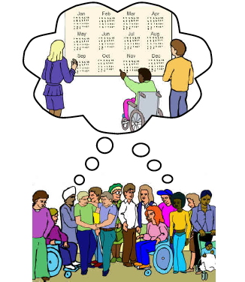

Illustrated Main Points


The Commission for Social Care Inspection and Brunel University organised a meeting about social care.


At the meeting, there were:
- people who use services
- people who write plans and policies for Government
- people from social care organisations.

They talked about the kind of social care they want for the future and how to make it happen.

You can get more information about the meeting on the Shaping Our Lives website: www.shapingourlives.org.uk
Government plans and policies
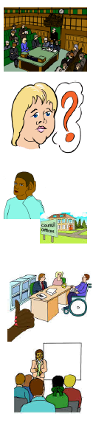

The Government is talking a lot about social care. They are asking people what they think.

Social care is difficult to use and understand at the moment.

Social care should make people’s lives better.
- Services need to listen more to people who use their services. Councils need to listen to everyone in their area.
- There needs to be better ways of planning, buying and checking services.
- Workers need to have good training.
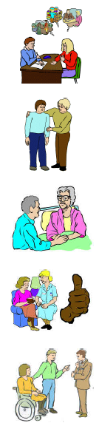
The Government has 5 main plans for making social care better:

- Making services fit people’s needs.

- Giving people support when they first need it and not just waiting until things get worse.

- Making support better for people with dementia, which affects the way people remember and do things

- Making sure that people are treated well in services.

- Better help and support for unpaid carers.

Making social care better
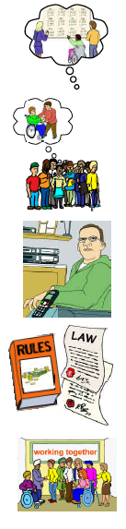

The people at the meeting came up with 6 main ways to make support better in the future:

1. Changing the way social care works.
People need to know about social care and want to work in it and use it.

Services need to look at the support that people need to live the lives they want to.

Laws and benefits rules need to be changed.

2. Speaking up about social care.

People need to speak up and work together to make social care better.
3. Learning and giving people information.
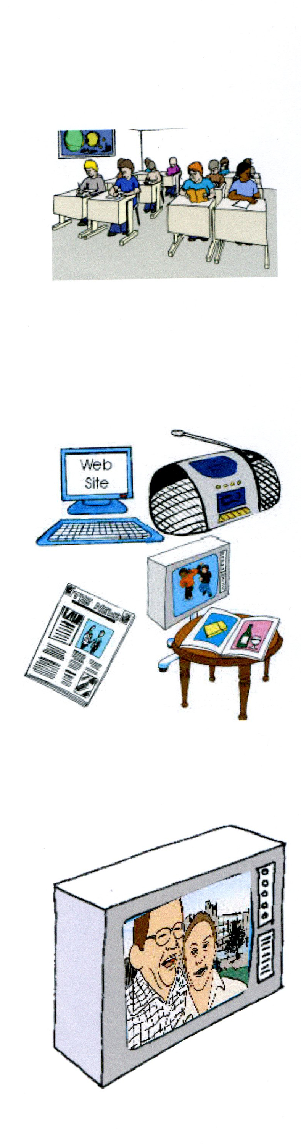
Telling people about social care was seen as a good way to get support for social care. People said it was important to talk to children in schools about social care.

4. Newspapers, television, radio and the internet.

People said that newspapers, television, radio and the internet are important ways of getting people interested in social care issues.

The news and soaps could tell people about good things in social care, like people having choice and control.

5. Trying to change the bad ways people think about social care and the people who use services.


The ways people think about social care and people who use services can be a problem.

People said that newspapers, television, radio and the internet often make this worse.

6. A bigger voice for user-led organisations.

People said that involving the people who use services is an important part of making social care better.

People said there should be more money for organisations run by people who use services.
The services and support people want


People talked about 8 ways to make social care better:

1. Involve people who use services more.

People said that this was the most important part of making social care better.

Organisations of people who use services should do training and run services. People should be given support to say what their needs are.

2. Better workers.

People said that social care workers needed better pay, training and working conditions. People said that there are too many forms to fill in in social work.
3. Better services that fit people’s needs.


People want to be able to get the support they need when they need it. This means supporting people early and not waiting until things get worse.

Most people said that individual budgets and living in the community are important.

Some people had worries about individual budgets.

4. More money.

People said that there needs to be more money for social care. Money could also be spent in different ways.

5. Support for everybody.

People said that everybody should have the right to get social care support when they need it. The rules should not stop people who need support from getting it.
6. Support based on rights and independent living.


Social care should be based on human rights and independent living. People who use services should have the right to choice and control in their lives.

7. Support based on the whole of a person’s life and their needs.

People said support should be local and support a person to live the life they want to.

Housing, health, benefits, learning and planning should work together.

8. Better social care organisations.

Organisations and services should be easy to use and not be about making money.

Final points


Government and people who use services want many of the same things in social care.

Government is working on making sure services fit people’s needs. But people who use services would also like to see other changes, like more rights, more money for services and choice and control.

Social care needs to get better so that people support in it in the future.

Credits



This report has been designed and produced for the CSCI by the ‘EasyRead’ service at Inspired Services Publishing Ltd. Ref ISL025/08

Artwork is from the Valuing People Clipart collection and cannot be used anywhere else without written permission from Inspired Services.


To contact Inspired Services: www.inspiredservices.org.uk

Acknowledgements

We have many people to thank for making possible this report and the event it is based upon.

We want to thank Tanya Hosch, Alice Terry, Aileen Hamdan, Michelle, De Araujo and Cathy Brown of the Commission for Social Care Inspection for all their help in organising the event. Also Fran Branfield and Jenny Willis of Shaping Our Lives for all their help in enabling a wide range of service users to take part and for their access needs to be met as well as they were. Thanks also to Ruth Beresford and Suzy Croft for all their help on the day meeting and supporting participants and to Independent Living Alternatives for providing high quality personal assistance.

We would particularly like to thank the speakers for contributing to the event whose findings this publication reports, including Dame Denise Platt, Professor Chris Jenks and David Behan.

Thanks also to Terence Tiernan of Brunel University for his help beyond the call of duty in recording the event and subsequently helping in producing material for this report. Also Richard Mitchell and Andrew Hill of Brunel University Press for help in producing the report and to Michael Atiaya and Barbara Goodhew for their organisational skills and support. We would like to thank the Easyread service at Inspired Services for creating the illustrated main points for this report as well earlier accessible information.

We owe a special debt to the eighteen organisations who sponsored the event and provided financial and other support which made it possible to ensure as good access as possible for service users to participate. Most of all we want to say thanks to all the service users and policymakers who took part and whose views, experience and ideas provide the basis for this report. They brought together a valuable and inclusive range of perspectives to inform future discussion and development of support and social care.

Foreword
Dame Denise Platt. DBE,
Chair, Commission for Social Care Inspection
In my job, I frequently visit councils and usually I ask them if they will make an opportunity for me to meet people who use social care services during my day. Not the usual line-up of policy makers, but the people for whom social care is meant to make a real difference in their lives. How councils do this, tells me a lot about their attitudes towards people who use services. Some councils sit me in the town hall all day and bus people in. I once asked a person ‘How long have you known this social worker who brought you in today?’ they replied ‘Oh I’ve never met them before’.
One council I visited arranged for people who use services to organise the whole day. They took me round the council and they told me about the services. And not only that, they told me about how they had taken the opportunity to have a real influence on what those services looked like and the type of services that were provided.
That’s what the real opportunity is for our agenda. Putting people that need these services right back in the centre so they can have a say in what those services do.
And let’s think about personalised care. Can we really have personalised care if the person who helping to support someone else to live independently does not know who they are? Doesn’t know what they fear? Doesn’t know what they want to achieve and doesn’t know what their aspirations are? On my visits I often say ‘Tell me about the person I am about to meet’ and what I get is, ‘This is Mrs So and. She has home care four times a week. She has had a stroke, she’s got her medication at the side in a special box and people come in and help her to do these things during the day’. What I really want to hear is: ‘This is Mrs Jones. This is how she likes to live her life. She is in touch with her daughter. We help her to go out and go to her local club. She loves visiting an art gallery. We keep her in touch. She tells us the things that she wants to do and we help her to do them’.
These are really fantastic times for people working in social care. The new agenda of personalised care and support is what many people who came into social care came into it to do. They came in to help people make a difference to their own lives and in doing that, give a satisfying job, by seeing other people succeed. And that is what this Report and the views it offers are about.

Foreword

Professor Chris Jenks,

Vice Chancellor, Brunel University

I am pleased to provide a foreword for this report, as I was to be involved in the event jointly organised by Brunel University and the Commission for Social Care Inspection that contributed to its content. I would also like to extend my thanks to my colleague Professor Peter Beresford for his leadership in this area.

As a Vice Chancellor of a UK University I am concerned to ensure that higher education is delivered to a range of people across the population; I am committed to the two national agendas of freedom of access and broadening participation – this is where our interest in social care comes in.

The two core priorities of contemporary universities are to contribute to the nation’s economy and to improve the quality of life of its people. Social care is precisely the area where these two priorities overlap. That people who use social care services should be enabled to contribute to the economy will also ensure an improvement in the quality of their lives – investment in this area will ensure an upward spiral of improvement, neglect will ensure the opposite.

Perhaps because the UK has an early history of industrialisation it also established a long tradition of social care. The industrial revolution, the increased division of labour and the rapid development of a capitalist economy created whole strata of casualties and Victorian philanthropy was aimed at either retaining these people within the workforce or managing their exit. Such ‘care’ was not, then, as benevolent as it at first appeared and indeed, we established charities for the care of sick or injured animals before those to care for poor or unhealthy children or adults.

Such charities were also organised from the top down, they operated through patronage and thus the care was sporadic, isolated and in no sense part of a mind set that permeated the whole society. Later developments like the Beveridge Report of 1942 led to the establishment of the welfare state where there was an official recognition that central government had a statutory obligation and a fiscal commitment to the care of its people. This was a great step forward in provision. The next major transition in thinking came with the Warnock Report on Special Needs Education in 1971 (which contained no financial clauses). Here it was recognised publicly that disability is not simply a characteristic of individuals, but rather the outcome of the collision between individual needs and social structures. If the world is organised in terms of staircases and some of us cannot get up and down staircases, then we are disabled, if a child is put in a classroom where they cannot access the medium of communication, be it oral or visual then they too become disabled.

Universities today have a central place in advancing the knowledge base for social care. We can build links between policy makers and professionals to improve both our understanding of needs and the delivery of support. It is also our political role to keep such issues high up on the national political agenda. This is an issue close to Brunel University’s heart, with its commitment to widening participation and to including service user groups in both our staff and student bodies. As far as possible we attempt to equalise the higher educational experience for all stakeholders. Universities have a continuing critical and historical role in changing attitudes and altering national priorities through raising awareness.

Part One

Background
Introduction
A time of change

Big changes are currently taking place in social care. The government is introducing new approaches to policy and practice which will affect who gets support, how people get support, the kind of support that is available, how it is organised and funded and the roles of service users, paid workers and unpaid ‘carers’. The aim is to develop social care fit for the twenty first century (Dh, 2005, 2006, 2008; HM Government, 2007; DH and Department for Education and Skills, 2006). The rhetoric is of giving people ‘choice and control’. As part of this process, the government is consulting with a wide range of people, including service users, carers, workers and others.

The aim of this report is to bring together the views of just such a wide range of people who have a special interest in social care to be part of this consultation, to help inform it with their experience, knowledge, views and ideas.

This report draws on a unique event, Recasting the Future of Social Care Together: From existence to living, which brought together key policy makers and also a diverse range of service users. While the scene was set by government policymakers and a service user presentation, the main aim was to enable these two key groups, service users and policymakers together to develop their own focused discussion on social care. There aren’t many opportunities for the two groups to meet face to face and have shared discussions, each learning from the other. The goal was to pull together their views and ideas about two major issues: how can we achieve better social care and what will it look like.

Background to the Report
There was something else that made this event unusual. It began as the occasion for a ‘professorial lecture’. The usual purpose of these is for senior academics when they are appointed or later in their career to give a lecture in their area of expertise, to share their knowledge, particularly with other academics. Because this academic was a service user, with a special interest in social care and service users being involved to improve policy, practice and their lives, the aim here was to do something different. This was first to highlight and explore the gap there seems to be between what we now know social care can offer and service users’ common day to day experience of it. Second, it was to involve policymakers and service users in thinking through how the current situation could be improved. So the aim was for a participative event and one which could help be part of a positive process of change and reform.

Almost a hundred people in all took part in the event. Service users made up the largest group, but policy makers were also strongly represented. Representatives from many social care organisations were present. The chief executives of two of the four large social care organisations (Social Care Institute for Excellence, Commission for Social Care Inspection, General Social Care Council and Skills for Care) took part and the chair of a third opened the event.

The event was widely supported. It was jointly organised by Brunel University and the Commission for Social Care Inspection. However it also received support from 18 other social care organisations, from the state, voluntary, user-led and commercial sectors, including policy, practice and research organisations and social care journals. The generous financial support that these organisations offered made it possible to meet all the travel and support costs of participating service users and make the event a truly free one for them. Every effort was made to meet the different access needs of the wide range of participating service users and much thanks go to Shaping Our Lives, the national service user network, for all the help they offered here in supporting the involvement of a diverse range of service users.

How the event was organised
The event was held over an afternoon, so that it was possible for people to come for the day from all over the country and it wouldn’t be too tiring for anyone. A quiet room was also made available. When people arrived they were able to have lunch and meet others. Frances Hasler chaired the Event. Dame Denise Platt, Chair of the Commission for Social Care Inspection introduced the afternoon and David Behan, Director General for Social Care at the Department of Health explained government plans for the future of social care, followed by an opportunity for comment and questions. Peter Beresford from the Centre for Citizen Participation at Brunel University set the scene for the afternoon’s discussion, focussing on the realities and potential of social care. Then participants, first in small groups and then coming back together, discussed how social care could be improved and what they wanted it to look like. Such open discussion sessions made up the greater part of the event, which was then closed by Chris Jenks, the Vice Chancellor of Brunel University and followed by tea.
The findings of this Report
The main part of this report is made up of what participants at the event had to say about improving social care. Service users, patients and other members of the public are often encouraged at consultations to produce ‘wish lists’ of what they would like to see from public policy. In the real world of funding limits, preset policy and party politics, these often cut little ice. The aim here was very different. It was to look at both how improvement might be achieved – what workable strategies could achieve what people wanted – and what that change would actually need to look like. There was also a commitment, both on our part and on the part of the Department of Health to ensure that what people had to say would be included in the government consultation on the future of social care. This Report will be formally offered as evidence to that consultation.

The aim was to bring together a wide range of service users and policymakers, to enable them to exchange their views and understandings, learn from each other and share this more broadly. We are not claiming that this is in any way a report on a representative sample of people. What it is though is a view of what a wide range of service user and policymakers see as key issues for social care reform.
What it is based on are the views of key policymakers and others involved in the production of social care and a wide range of service users with interest and experience in the development of social care and with strong links with other service users.

This is not a quantitative study. It is not intended to provide statistics or percentages. But it does highlight the range of issues people see as important and how they prioritise them. Significantly what people have to say does not always coincide with conventional views of what needs to happen. Some different priorities emerge here.

We have put together what people have to say about the future of social care by collating the comments that they made at the event through the different opportunities that were available. These include:

- Their written group feedback at the event
- What people wrote on their individual feedback/evaluation forms
- Additional individual written feedback received after the event
- The main issues (up to three) from their group discussions that people fed back verbally about how to get improvement and change in social care
- Additional miscellaneous comments made at the event in plenary sessions and recorded by the palintypist when participants had opportunities to raise questions and make comments.

We have then organised people’s comments, identifying headings emerging from the issues people identified, grouping them together where appropriate and scoring the number of mentions that they made of them under the five headings listed above. So what we are able to do is report what issues were raised and rank these according to how often they were identified. Again we do not claim that this offers a precise picture of what matters most to people, but it does provide some strong indications of their ideas and the collective importance attached to them. Again it needs to be said that there are very rarely opportunities for such a wide range of service users to come together to offer their views in this way and even fewer when they and policymakers can do this together.

How this Report is organised

This Report is organised into five sections, presented in three parts. After this Introduction, the first section by David Behan, Director General of Social Care at the Department of Health, sets out government plans for major change in social care. The second section by Peter Beresford argues that social care in recent times has been the location of some of the most innovative thinking and practice developed by human beings, but that most people’s ordinary experience of social care is still often not good. He raises the big questions of why this is and what can be done to get the social care support people want. The third and fourth sections report people’s answers to these two questions, looking at their strategies for improving social care and the kind of services and support that they want. A final section looks at the conclusions to be drawn from what people say.

Three appendices provide details of the event on which this Report is based, details of the organisations supporting the event and the easy-read evaluation form we used to gather people’s feedback. A pocket at the back of this Report includes a DVD with the main presentations offered on the day.

1. The government policy context
David Behan,
Director General for Social Care,
Department of Health

I believe social care is rising up the political agenda. The Prime Minister now talks about it, about direct payments and individual budgets in his speeches. He frequently mentions ‘personalisation’.

But far fewer people use social care than health services and therefore are less aware of it. Four per cent of us are using social care and 40 per cent of us have someone we know or close to us who is using it, compared with 96 per cent of us who will see our GP (doctor) this year. Less than half of people are even familiar with the term ‘social care’. The level of public recognition about social care is very low. So how can we have a debate about the future of social care when many people do not understand what is meant by the term?

This is the definition of social care which is used in the White Paper, Our Health, Our Care, Our Say (DH, 2006), which is concerned with the future of social care. It was produced following discussion with more than 2,000 people using social care services.

The wide range of services designed to support people to maintain their independence; enable them to play a fuller part in society; protect them in vulnerable situations and manage complex relationships.

This is important for discussing the future of social care. There are three big issues in this definition. It means:

- Services are about promoting and maintaining people’s independence. The underpinning model is one of supporting people’s active citizenship, rather than them being dependent as ‘clients’;
- It is not people themselves who are vulnerable, but the situations they may find themselves in which can make them vulnerable;
- The system that exists in this country for accessing support services is huge and complicated and getting around it isn’t easy.

Current services are also focused on those with most need rather than early intervention and standards across the country vary from one place and from one provider to another dramatically. Services are means tested and people can find they pay more in one authority than another.

So the current system is one that needs some reform, the way services are commissioned focuses more on quantity and cost than on outcomes and quality. The result is that the responsibilities falling on families and people providing unpaid care are ever increasing.

Many things are changing. With demographic pressures, particularly increases in the numbers of older people, with rising expectations, people are used to living 24/7, using the internet to access information and to do other things. We have a twentieth century system for delivering help and support in this country, but we have got twenty first century demand and expectations. We need to look to a system that provides twenty first century responses to twenty first century needs. The system for care and support must change. Those services must change in quite a radical and dramatic way.

So my second point is that the current system of social care needs to be transformed, to a new set of arrangements. This is what we are setting out in our vision. It is a transformation in the way that services are commissioned, developed and delivered. This needs to be based on services being ‘personalised’ around individual needs, so they are tailored to people’s particular circumstances and requirements. They will be based on the model of citizenship I talked about to build on what people are able to do, rather than what they can’t do.

These are easy words. The real challenge for us is how we change the system we have currently got and what the basis is for the change we make in the system. I want to argue that there are four things we need to change if we are going to develop better care and support for people.

First, we need to do much more about listening to people who use services about how services and support can help individuals and groups live the lives that people want to see. This critical issue is not really about whether the services are in councils or primary care trusts (PCTs) or with providers like the voluntary sector. It applies to everyone. It is not just do you listen to people who use services? Do you have a system to engage with them? It is what are you doing differently as a result of what people are telling you? We need to push beyond saying have you got a system to listen, to what are you doing about what you hear? There are some really important issues here.

Local councils need to take a broader view than just the people they provide funding support for to access their services. They are responsible for all their local population and that includes people with money of their own who might be self-funding their own support. Eighty per cent of the population somewhere like West Sussex receiving care services are paying for them themselves. Only 20 per cent are publicly funded. In other places, it can be the opposite way round. My argument is that councils need to listen to the whole of their population and not only those people who are being publicly funded.

Second, we really need to improve the way we commission services. There are some key challenges relating to how people who use services can actually influence the commissioning plans of local councils. This is not just about people funded to use services being involved with those who provide them, but also people who use services more generally being involved with those who plan and commission services.

Third, we need to look at how we manage the performance of organisations. This doesn’t only involve the inspectorates. We also need to use the new performance framework in local government because that can drive changes in the way that services are provided. Do councils and independent organisations know exactly what people think of the quality of services – that’s important in any performance framework. It’s not just about knowing the numbers. Yes, equality impact assessments can be part of checking performance – and surveys – there’s probably no one way of doing this.

Fourth, it is essential that the social care and health workforce have good quality training and development to ensure they have the skills to carry out the work they do. It is a paradox to me that if you work in a care home, providing support for people with dementia, you do not need a formal qualification. We need to push beyond this and ensure that the social care workforce has the skills, ability and imagination to provide the support it needs to.

I think it is important to develop a vision for the future which does not distinguish between those people who can pay for social care themselves and those who can be publicly supported by the state. To sum up, If we are going to change the system, we need to:

- listen to people who use it;
- improve the way we commission services;
- improve performance management;
- ensure that staff have the skills needed to do the job asked of them.

If we do not attend to these four areas, we will not get the system changing. If we just attend to one and not the others, change will not happen. If we are really serious about driving forward a reform programme, we need to attend to all four of these.

What are going to be the next priorities? First, is personalisation. I use the term broadly to mean increasing the take up of direct payments and of individual budgets. These are absolutely at the heart of the strategic shift we need to make in the reform of the present social care system we are operating. They are essential to ensuring that people who use services are in control of the support and assistance they receive. They are essential in shifting the balance of power from professionals to people who use services.

So you will see the social care Minister, Ivan Lewis and other ministers talking a lot about the take up of direct payments and the expansion of individual budgets. We are highlighting how to do this and not whether we are going to do it. Personalisation is here. The only issue is what is the best way to do it?

Personalisation is not just achieved through individual budgets and direct payments. It is as much about the way that you can tailor care to people in group living settings. I have had discussions about personalisation for people in secure [psychiatric] hospitals where their liberty has been restricted and I have been told how individual budgets can help people who are long term drug users.

We need to think broadly about how this personalisation agenda can drive and reform systems. There are some difficult questions about people’s personal capacity and where people’s rights are restricted, but I think you will see the personalisation agenda featuring heavily.

The second policy is about early intervention. We have done some work on prevention in pilots with older people. The evidence from this, where people are at risk of having to go into hospital is that if money is invested in targeted prevention, it can result in quite dramatic saving, preventing people having unnecessarily going into hospital and making possible a better outcome for individuals and better use of money.

The third issue we are driving forward relates to dementia. We have some 600,000 people with dementia in this country and by 2020 it is likely to rise to over a million. We know that the quality of services is not good enough and we need to prioritise improvements.

Fourth, we need to look at the way people are treated in services to ensure that they are treated with dignity.

Fifth and finally, we are developing our thinking in relation to the support and help that we give to unpaid carers, launching a review of the Prime Minister’s Carers’ Strategy in spring 2008. We are speaking to people who are caring about their experience so we can build on that for the future.

So the key policies are about:
- Personalisation
- Early intervention
- Dementia
- Dignity
- Carers

From the beginning of 2008 we launched discussion on the reform of the care and support system. This is a nationwide discussion because we think it needs to take place across society – and not just across professional groups – about the future of the care system and its funding. The outcome of that discussion is to produce a Green Paper on the future funding of social care. So there are some real opportunities, moving forward, to look at how we change the current system and base it on personalisation.

2. An alternative
service user view

Peter Beresford,
Professor of Social Policy,
Brunel University,
Chair of Shaping Our Lives

I want to focus here on a wonderful human invention. It is perhaps the greatest invention of our age. Yet no one ever talks about it like that. In fact it doesn’t get talked about much at all!

In 2007 a large group of important people got together to identify humanity’s greatest innovations. They talked about DNA technology, the world wide web and rockets (Randerson, 2007). It’s not surprising that they highlighted achievements like these. When people talk about important new ideas and discoveries, they tend to talk about science, rockets, outer space and sometimes the internet. But what is so special about rocket science – it’s just a matter of making something go fast and far and in the right direction? And most rockets are made to destroy things.

Independent living – a truly revolutionary idea
What I want to look at isn’t rocket science. It is much more complex than that. That’s because it is concerned with us as human beings, our lives and how we live – and that’s much more complicated and exciting than any space rocket. What I want to look at is what people have called social care or independent living or supported living. Something new has been growing. I think it is the greatest discovery of the late twentieth and early twenty first century. We are part of this discovery and living through it now. I want to argue that this represents the most pioneering human development of modern times.

People who talk about important inventions and discoveries often don’t think of social care or supported living. I think that may be because they mostly think of scientific discoveries which men have been concerned with and interested in, while what I am talking about has often been ignored because it has been thought of as women’s work and treated as if it is unimportant. But I think that in recent years we have developed new approaches to what people have called social care that are truly revolutionary, radical and groundbreaking – not just in public policy – but also in human development more broadly.

Why independent living is so important
So why do I think independent/supported living is important?
- Because it is radically different. It can transform millions of people’s lives and make it possible for them to live much better, more equal lives, where they can contribute and have rights and responsibilities. There are many groups of people, who are often now called ‘service users’ that this is true of. It includes disabled people, older people, mental health service users/survivors, Deaf people, people with learning difficulties, with life limiting illnesses and conditions, and many more. They make up a large proportion and number of the population.
- Because it makes it possible for us to include the strengths and contribution of everybody in society and to understand and value our diversity as human beings.

And why do I think what has been happening in recent years in social care or supported living is an important discovery and innovatory?
- Because in many societies, particularly in the west, many of these groups have been treated as inferior, abnormal, defective and useless. This new approach provides evidence to show that this is wrong and not true. It gives the lie to this discriminatory way of thinking. It shows that people have things to offer instead of needing to be treated as ‘dependent’.
- Because as the evidence shows, this idea works much better than old ones, like charity which did things to people ‘for their own good’ or to be ‘kind’. Or the state, which did things to control people, or kept them separate, often in bad conditions. Or the market or private sector, which did things mainly to make a profit out of people.
- Because this idea came from service users themselves, people who have often been written off as incapable and inadequate. Service users, their organisations and movements created these new ideas and new ways of doing things, which see people as equal, able to speak and act for themselves and with rights to live alongside and on equal terms with other people. Service users have got together in their own organisations and movements to do this, organising in new and inclusive ways. They have got together with progressive workers to do so. They have developed new democratic and participatory ways of supporting people.

At the heart of this new development are two important ideas. First, that if people have the kind of support that they want, which they are in control of, then it can become possible for them to find out what they might truly be capable of doing and then be able to do it. They can live their life much more like they want to; for example, get more education and training, have relationships, families and children, get decent paid work if they want to, be active citizens in society, learn different things (Office for Disability Issues, 2008).

Second, is the important idea that for people to be able to live their lives on equal terms, then barriers: physical, cultural, in attitudes and communication, must be removed; discriminatory and oppressive attitudes and structures must be challenged, people’s human and civil rights must be valued and safeguarded.

This is a revolution that has crept up on us and because people mainly think of discovery as meaning rockets, science, new medical drugs, surgery and electronics, it hasn’t got much public attention. People are much less likely to understand something truly new when it is about changed understandings of each other, new evidence of what previously excluded groups can really do and the major contributions that they have made to this and to society more generally, than when the newspapers have headlines about an expedition, the breaking of a record, the activities of celebrities or some new scientific invention, even though these may have little importance in, or impact on their lives.

Important new developments
Yet we have seen revolutionary developments making it possible for people to take control of their lives and lead lives that until very recently it was felt that they were incapable of - by people seen as experts. Let me give some key examples:
- Service users designing and running their own schemes of support through direct payments and individual budget schemes;
- Service user organisations providing the infrastructure to enable a wide range of service users to access such self-directed-support schemes;
- Service users creating new forms of support, for example, peer support schemes, non-medicalised crisis houses for mental health service users, self-advocacy schemes, advice and information services, self-management schemes, user-led help lines to meet people’s needs as they want;
- Recognition of the importance of addressing diversity in relation to age, gender, culture, class, sexuality, ethnicity, belief, disability and so on, and the development of ways of doing so;
- Service user organisations providing new forms of collective services which are particularly valued by service users who receive them;
- The development of new theories like the social model of disability and the philosophy of independent living developed by service users themselves;
- The systematic involvement of service users in all aspects of professional education and training (social work);
- New research approaches developed by service users, the development of research projects by and involving service users; user controlled research, including such research undertaken by people with learning difficulties.

So we really do know how to do things different and better. This has been a real break with the past. It is based not on state, or market, or charity, not on paternalism or doing things for profit, but making things democratic, involving people; being reciprocal – two-way - under people’s individual and collective control. How much of this is known in the wider world? Probably not much. Yet it highlights a coherent, far-reaching and probably unprecedented human development with global implications.

And we shouldn’t forget that these are important, ground-breaking developments by groups of people who historically, in the west at least, have been written off as inferior, less able, pathological and defective.

The continuing barriers and oppressions
These are also groups who internationally over time have been subjected to:
- Programmes of enforced sterilisation
- Restrictions on having sexual relationships
- The removal of their children
- Routine institutionalisation and segregation
- Programmes of euthanasia
- Involuntary medical interventions and ‘treatments’
- Restrictions on their human and civil rights

Many of these things are continuing to happen. But there are also much more general problems, despite all that we now know about how people included in these groups as service users; mental health service users/survivors, older people, disabled and Deaf people, people with learning difficulties and so on, can be supported to live full and valuable lives in mainstream society (Shaping Our Lives, 2008; Shaping Our Lives and others, 2003, 2007).

This is because the reality still is that despite the groundbreaking revolution in support that I have described, many people, perhaps the majority of service users, still face problems, exclusions and disadvantages that we might associate more with the nineteenth century than with the twenty first century. Many – most people, perhaps – who use services, still experience the same old problems that limit their lives. Despite the revolutionary progress that has been made in understanding and provision in this field, social care remains a marginal policy in many societies, given low political, economic and public priority. People whose horizons and possibilities might be limitless, still live in large numbers on the edge of things (CSCI, 2008 and 2009).

So, for example:
- While here only a relatively small number of service users access direct payments or individual budgets that can offer them much more control over their lives, nearly 500,000, mostly older people are estimated still to be living in institutions. Yet we know that this is far from what most people want. One in four of us can expect to end our days in such an institution.
- Examples of the most appalling neglect and abuse continue to be reported regularly and routinely in Britain. In 2007, for example, appalling examples were reported against people with learning difficulties in Cornwall.
- Service users repeatedly report the inadequacy of the support offered them in their homes through domiciliary support. They talk of an under-skilled, under-funded workforce frequently lacking in respect and understanding.
- Wider attitudes in society to service users still often oppressive and destructive. In 2007 there were murder trials relating to two men with learning difficulties who were bullied and killed and a woman with a disabled daughter was reported as so terrorised and bullied by teenagers that she set fire to her car burning the two of them to death. People still face the most terrible stigma, hostility and prejudice.
- Perhaps the most common problem is that service users are denied reliable, adequate, appropriate, good quality, affordable support, frequently either receiving none or not enough to live their life to their proper potential. Many are still frequently left poor and deprived.

Perhaps there are things about social care itself; how it is organised, its culture and how it has been led, that may result in these problems. But it also makes us think about broader problems that there may be in society. What might these tell us about the value that is attached to people who use social care services, or indeed who work with them, and to social care generally? What does this tell us about a society, where this still is what can and frequently does happen?

Big questions for the future
All this raises two big questions. First, when we now know, particularly from the efforts of service users themselves, how to make it possible for service users to live fuller more equal lives, why is it still the case that many people do not - and many still face massive barriers, prejudice, insecurity, isolation and want? Why is this? (PMSU, 2005; Glynn, Beresford, and others, 2008) Are we really less interested in our own and other people’s wellbeing than we are in buying and consuming things; in military hardware, space rockets and celebrities? Who is getting it wrong: the state, the market, or the rest of us?

What might all this say, for example, about:
- How people generally think about themselves?
- How people and policymakers see service users?
- What is seen as important in our society?

Second and most important, what can we do to make it possible for many more people who are service users, to be able to get the support they need and the broader changes that are required in society to live the lives with real choice and control that they are capable of living and should have a right to? How do we get this big and important change? How can we ensure that the blueprint for change we now have in our hand, which I described here, becomes the day to day reality for the many thousands of people who can be helped by supported living?

- What would challenge the limited priority this now seems to have?
- What new evidence might help change things for the better?
- How can we get more money than before for independent living and social care?
- What different ways of campaigning might help?
- Are there new alliances that need to be developed?
- Are there new ways of influencing policymakers and politicians?
- Are there new and better ways of highlighting these issues?

Time is long overdue for a wake-up call to make things different. That’s what this report and the event it is based on are concerned with. By raising these issues and giving a wide range of people the chance to offer and share their views about them, hopefully we will all be able to make better progress for the future.

Part Two

Findings
3. Strategies For Improving Social Care

How would we know that what we have put forward will actually have an effect or actually influence anything?

Move beyond the rhetoric into practical approaches to the implementation of ‘real’ needs. Real choices, that are based on self-assessment, that you don’t have to wait a lifetime to be met, which causes more suffering and pain, which is inhuman and degrading and a violation of basic human rights.

No quick fix. It needs to be right.

Introduction
A key aim in organising this consultation and get-together was to enable a wide range of policymakers and service users to think through together how change can be achieved in social care. For example:
- What will raise its profile and priority?
- How can we get improved support and services?
- What would be effective strategies to achieve these aims?
- Who would need to be involved?

Much of the discussion about improving social care has been about what it would need to look like to make it better – for it to provide better support for service users. But this has tended to overlook how this is ever to be achieved. Meanwhile governments have often moved on with their own proposals. In the end such discussions can end up just producing wish lists. The real point has to be to work out possible and effective ways to achieve positive reform and improvement in the real world. That was one of the key purposes of this initiative.

Participants generally seem quite capable of identifying ways forward to improve social care and distinguishing this from what kind of improvements they would like to see in social care. But there is some overlap between the two of these concerns. it is important to be aware that the distinction between the two can be blurred.

Thus people noticeably talk about some issues which could clearly be seen as representing an improvement in social care, when why they mention them is because they also see them as a means of bringing about such change. This is particularly true, for example of calls for:
- More user involvement
- More funding
- Making social care a universal service

But there are other examples of seeing what some might regard as an end, also as a means. Sometimes it is not clear which, as it were, comes first and which is chicken and which egg. Sometimes routes to improving social care and what a changed social care would need to look like can be the same.

We have tried in organising material to reflect people’s own understandings of whether they see things as means or ends (or sometimes both).

Taken together participants suggestions for how to get improvement in social care can be grouped in six main headings. In our view their proposals for achieving change are not necessarily what might have been expected and do not reflect conventional approaches to improving the role and status of social care. We have ordered these in accordance with the priority people attached to them as was reflected in the number of comments that they made about them. Changing the nature of social care emerged as the most important for people, with more than twice the number of comments of any other issue.

- Changing the nature of social care
- Campaigning and lobbying
- Education
- The media
- Challenging the stigma and prejudice attached to those associated with social care
- A stronger voice for service user organisations

Some comments are very broad, suggesting that to achieve any real change in social care will require a broad strategic approach. For example:

True involvement, better funding, respect.

Roll out individualised budgets. Funding of groups such as self-advocacy [groups] to support people to develop skills and knowledge. Improve value based training for support…

Recognition that the transformation required demands real resources and is not cost neutral.

1. Changing the nature of social care
In descending order of priority, these are the ways in which people see it as possible to get the social care that they want.
- Through a broader, more holistic understanding of social care
- Through culture and attitude change in social care
- Strengthening social care’s evidence base
- Raising social care’s status and profile
- Highlighting social care’s political nature
- Improving terminology
- Through new legislation
- Improving the benefits system to make it fairer
- Make social care more attractive
- Through better planning

The first point accounted for nearly a third of all comments; the first four almost three quarters of all suggestions people raise.

Through a broader, more holistic understanding of social care
Three concerns emerge under this heading. These are first to break down unhelpful barriers between social care and other helping services like health. Second, to be sensitive to the social care elements in all policies and services. At a time when we are seeing local post offices, shops, pubs and other amenities closing and the increasing centralisation of life in urban and out of town shopping centres only accessible by car, this has particular importance. Third, to see the individual in a holistic sense and not only as a bundle of needs. In some cases people relate this to the philosophy of ‘independent living’.

We thought that social care was perhaps too narrow a place to have a debate about independent living.

I want to remove the distinction between nursing and social care.

Scrap health and social care needs and have life needs.

Focus funding on local communities so you have a whole life approach and communities can explore local solutions and develop appropriate services.

Social care, health and housing are all joined.

Instead of talking about ‘social care’, look for solutions from a broader context. Independent living is about housing, transport, education and removing barriers to all the things non-disabled people take for granted.

Through a wider and more inclusive definition of social care, as all our business, an approach to others, not simply a profession or special interest area.

Rethinking social care to include ‘social services’ that are not delivered under that banner and creating universal access to a particular standard of living.

Labels are used to justify [separate] funding streams and cause the disabled people’s movement to be pitted against each other for limited resources.

Society must realise the quality of people’s lives.

A wider view of what social care is would help.

To have life support, forget the artificial divide between health and social care. Independent living (should be the reason) for all interventions.

Social care needs to be tied up with the rights of people to participate in society and make choices. Funding needs to be in a form that honestly supports this agenda.

The concept of social care needs to be widened to embrace all aspects of life. I want to be seen as a human being who needs certain levels of support. Not just a medical label, not in terms of what I can’t do, but as what I can contribute to other people and society. The system will need to change to help us all to become more human.

A holistic view of a healthy society needs to be taken, for example, the Danish or Swedish model of social care.

Through culture and attitude change
in social care
What links all these comments is that people want to highlight the importance of different philosophical models and more supportive, service user-centred attitudes to underpin social care if it is to become more mainstream for the future. People highlight models and values like independent living, the social model of disability and universalism as crucial if social care is to achieve more priority. They emphasise the importance they attach to a value-based system of social care. As can be seen with an idea like individual budgets, there is not necessarily consensus among stakeholders.

A universal service raises the agenda. Everybody [can] need personal assistance.

We thought that the social model of disability should be promoted throughout society especially in the NHS and that requires some sort of big culture change.

Don’t change what works!

More funding for the voluntary sector and direct payments.
Promote the social model [of disability] throughout society, especially in the NHS – culture change.

Changing social care model from care management.

Personalisation won’t help as it means more assessment for all elements of your service.

Social model of disability should be used by government departments and local authorities. Don’t talk about ‘people with disability’.

Informal carers are supported for economic reasons and this does not promote independent living.

Get rid of some of the people involved in our lives. I get 11 professionals!

Move towards a user centred approach.

Better training [for workers]. Better pay.

Through national alignment of entitlement for all.

Introduce individual budgets for all!

A cultural shift to encourage the valuing of social care and the benefits it affords people.

Strengthening social care’s evidence base
Strengthening the evidence base of social care significantly is the next most common concern. While this might not be expected, it again highlights the central importance for social care, if it is to be taken seriously, of building policy and practice, change and reform on a strong basis of research, evaluation and direct experience.

Commission research on not providing social care support.

Through disabled people’s organisations linking with universities for research.

Raising social care’s status and profile
Some participants not only feel that raising social care’s status and profile are key goals. They also feel that these have to be reflected in any effective strategies for change that are developed at local and particularly central level. Thus, for example, they say:

Re-introduce wage councils for social care setting high minimum standards of pay and training.

Raise the status of social care. Start from raising pay to workers to attract people who want to provide care to others.

Higher status and profile, more training and research for and by social care workers from social care assistants to social workers.

Promote positive social care.

Making care a professional body to be proud of.

Other suggestions
In other comments, participants highlight a range of additional issues which they think could help bring about improvement in social care. These include:

Through legislative change - through the Independent Living Bill

Social care to be called something else and find an alternative term for ‘service users’.

Look at terminology around social care. It can confuse rather than inform.

Politicise social care in the way we have seen with health.

Making it a public issue.

Change the image. Social care looks like a place people go to as a last resort.

Make social care ‘sexy’ so everybody wants it. Changing structures does not change experience.

Reform the benefits system.

Identify small improvement steps.

Implement ideas, learn what works, use that, discard things that don’t work.

2. Campaigning and lobbying
This category includes the second largest group of comments service users and policymakers have to make about routes to reforming social care. Here they highlight the important role they see to be played by:
- Campaigning, lobbying and direct action
- Forming alliances and developing dialogue

Campaigning, lobbying and direct action
Participants stress the importance of collective action and service users campaigning if they are to achieve change.
Through service users campaigning for more individual budgets.

Service users need information to campaign.

Join DAN [the disabled people’s’ Direct Action Network] if you want to see REAL change happen.

Concerted campaigning around elder care nationally and locally.

Join our Our Lives Our Choices (Independent Living Bill) campaign.

Combine events like this with direct action.

Cut MPs’ salaries by 75%!

Participants also see the importance of forming alliances and linking up with other groups to strengthen their impact in bringing about change.

Strengthening lobbying. Joint working between different stakeholders to make the political and economic case for more funding.

Support based on need not labels. We are all human beings. We want to get away from pity and blame and unit among disability movements and allies (maybe social care staff) to campaign for civil liberties.

Policymakers spending more time with service users.

‘Nobble’ local councillors.

MPs to be involved.

They talk about the need to develop dialogue and a more interactive and active form of consultation.

We need to change the kind of conversation in consultation. Listen to what we have been saying for years.

A continuing dialogue system needs to be put in place and user-led organisations need to be involved.

3. Education
Educating people about social care is seen as an important way of improving understanding and extending support for it. This is highlighted as valuable for different groups and in different contexts. Educating service users and potential service users is seen as key to highlighting the true scale of demand for it and ensuring that people got the support they need:

Raising expectations. Not everyone, particularly older people, know what they are entitled to or how to get it or want to ask for it.

People don’t know what choice and independence are until they have experienced them.

More raised expectations. Why just expect to be consulted, when I could get the money (directly for support)?

It is seen as essential for service users’ organisations if they are to achieve their demands:

Education and training for the disabled people’s movement to include the development of political and lobbying skills, the planning and development of policy.

Service providers need more education if they are to deliver the kind of support that service users want:

Try and change attitudes (education).

Make people that make the decisions spend time at grass roots.

Education to those providing service to service users. There’s a reluctance to embrace new schemes. I am part of an individual budget scheme. Even now when I attend events to tell my journey, they don’t seem to be able to understand and I find it hard to relate to their working practices.

Educating children from an early age about social care is also seen as essential.

Mainstream education.

As is public education, if there is to be better public understanding and support for social care for the future.

Need to educate the public and media about what social care is.

Through education of general public about the need for social care. We might all need it.

4. The media
The media are seen as another way of bringing social care to public attention and helping improve public understanding of it and its public image.

There needs to be an increased awareness of how social care improves people’s lives.

Improve the media portrayal of social care. It might increase recruitment.

Start as a quick win by having someone on East Enders being struck down by an accident and becoming disabled.

‘Real life’ stories in the media.

Using the media is also seen as a way of challenging stereotypes and advancing positive philosophies, like that of independent living and to:

Challenge stereotypes of disabled people, for example, EastEnders.

Running publicity campaigns in the media about the importance of independent living.

Increase media attention to focus on benefits of social care for independent living.

However, there is also a concern that the media should be used appropriately.

Need media to persuade general public that social care is for everybody and can be used by them. Positive stories are needed. Use of celebrities should be treated with caution. Not ‘triumph over tragedy’ stories, nor denying the need for help.

Advertising in the media is seen as a means both to raise social care’s profile positively and to increase people’s understanding of what it can offer.

Public relations about social care, the end result being that people are helped to be independent, not help to cook dinners.

Better public relations in all forms of the media.

5. Challenging the stigma and prejudice attached to those associated with social care
Stigma and discrimination are widely recognised as key problems facing social care service users. Some participants also see them as key problems limiting the support and priority given to social care services and argue that they need to be challenged if social care support is to improve. The role of the media is also highlighted here.

Stop the media breaking their legal duties under the Disability Discrimination Act, the Human Rights Act in how and the language they use to report disability.

People are objectified. They need to be seen as citizens, as part of society.

Challenge prejudice against disabled people.

Tackling the negative image of service users either through advertising, education in school or so that people/taxpayers are willing to pay more.

6. A stronger voice for service user organisations
For some participants a key route to improving social care is to increase the involvement of service users. To achieve this they call for increased support, including funding support for service users’ own organisations, capacity building for such organisations and greater use of user led support services.

How are you going to consult widely when there are a lot of organisations of disabled people who do not have the resources to be able to really effectively consult their members?

That charities basically are hundred percent representative of (service users’) voice and ‘nothing about us without us’.

Creating user controlled organisations and creating a hundred thousand jobs for disabled people that way (that’s how many people are employed by these charities).

Service users as the managers and trainers of the support we get. Don’t professionalise this without us.

Give priority to user led organisations.

Only fund hundred percent user led disabled people’s organisations.

The encouragement, involvement and reliable funding of genuine local user-led support organisations who have a say in policy as well as service delivery.

Provide more funding to service users.

4. The services and support people want

Introduction
If the first focus of what people talked about at the event was how better social care was to be achieved – ways to get better services - the second was what it would look like. Participants also have a lot to say about this.

They identify a range of principles and improvements that they feel are needed to get the kind of services and support that people want. Their comments fall into eight overall categories. While all the issues that they highlight are common issues of concern, they have not necessarily been the issues most often raised in other discussions when social care reform is discussed – and certainly not with the particular pattern of ranking that service users and policy makers give them on this occasion. There is wide support for all of these issues. In descending order of the number of mentions they receive, they are:
- Greater user involvement
- An improved workforce
- Better, more appropriate services
- Improved funding
- Changing from a restricted to an accessible universal service
- Policy and provision based on rights and independent living
- Policy and provision based on an holistic approach to people
- Improved social care organisations

1. Greater user involvement
Increased user involvement emerges as the most important single issue for improved social care provision. Service users repeatedly emphasise the importance they attach to user involvement, but it is important to remember that these responses came from a wide range of high level policymakers as well as service users.

Comments included in this category (again in descending order of how often they were mentioned) include:
- Increased user involvement
- More support for service user organisations
- More service user training
- More service user-led services
- Build service user capacity
- Develop self-assessment

Increased user involvement
This include general comments about the current problems from a lack of effective user involvement and the importance of improving it. For example:

My home care was took over by the private sector recently…I was not informed until the week it was going to change and I was not consulted any weeks before…Another neighbour more vulnerable than me was not consulted. It was only when I put pressure on and range somebody at county hall that I actually got a reply.

I am keen to find a way of involving young people to enter this debate. It’s not just a debate for older people. It’s got to be younger people too. It’s the younger people that are going to be paying the taxes that go into the system.

We need to transfer ownership of the processes as well as of the services to service users.

More input from service users at all levels.

More opportunities for people who use services to decide.

Real involvement of disabled people needs four to six months consultation.

More support for service user organisations
Participants highlight the continuing lack of adequate funding for service user controlled organisations and the need for this to change if they are to provide an effective basis for involvement and collective action.

Self advocacy groups offer many people life changing opportunities, but have to fight to survive. Needs some money to run, but not seen by some people as providing a measurable achievement.

Funding to advocacy groups to provide peer support.

More service user training
Service user training has long been identified as an effective means of changing the culture of services and supporting them to become more appropriate and user-centred.
Service users [should be] involved in training. This change needs to be supported by managers.

Involve service users in training of staff.
Disability (equality) training to be delivered by disabled people.

People should not be forced to get an NVQ (National Vocational Qualification) before they work for us (service user). We should decide what training our employees need. Training we provide should be recognised.

More service user-led services
There is already strong evidence that service users particularly value services and support provided by other service users and this is reflected in comments made at the event.

User-led organisations to be funded to provide more services.

More resources to service user organisations to provide services.

2. An improved workforce
Comments included under this heading fall into three broad headings. These (in descending order of frequency) are concerned with improving:
- The role, status and conditions of workers
- Training for workers
- The social work role.

Improving the role, status and conditions of workers
Participants place a big emphasis on upgrading the jobs of social care practitioners so that they can be seen as having more skills, worth and value. The aim is clearly to improve both perceptions of what they do and the roles themselves.

Improve conditions of work (including pay)

Raise wages.

Pay above minimum wage

Attract more young support workers as a profession. Better training.

Provide continuity for both the service user’s needs and worker development.

Raise standards of frontline workers.

Change social care model from care management.

Improve workers status

Let service users take informed risks.

Change social care staff roles to enable and empower.

Improving training for workers
Levels and standards of training among the face to face social care workforce are currently low, particularly in the private sector. Participants identify this as a major problem which needs to be addressed to achieve a good quality workforce.

Many employers are not providing enough training, including in direct payments.

Better training for social care workers and paid accordingly.

Training.

Training, enforce minimum standards.

Develop skills for staff employed in delivery of direct care.

Increase training for people working as carers in the community and in institutional care.

Enough budget for training and enforce it.

Improving the social work role
Finally people talk specifically about the need to improve the social work role. Social workers are the key professional group in social care. There have been growing concerns that their role has been undermined both by its bureaucratisation and by them increasingly being put in the position of being rationers or ‘gatekeepers’ of services, restricting access, rather than providing support to service users.
Free up professionals from paper work. They need to do they job they want to.

Good social workers end up doing managerial roles and not carrying cases.

Social workers moving from a gate keeping to an advocacy role.

From a social work perspective, go back to long term social work instead of short term interventions, so the social worker can build better relationships with people.

More professional care that gives people real choice and supporters with the right attitudes without red tap and extra admin[istration].

Listen to service users. Social workers making decisions with service users not implementing them without consultation as I feel happens [now].

3. Better, more appropriate services
A wide range of changes are identified by participants to provide better services. However, their comments mainly focus on the need for;
- Improved access to support and services
- Self-directed support
- Deinstitutionalisation

Improved access to support and services
This generated by far the greatest number of comments. People raise concerns about the need to be able to go to one place to sort out their support needs, the need for flexibility in services and for services to be preventive in philosophy, not waiting until things get worse or go wrong and also for access for particular groups facing marginalisation and exclusion.

We need a one stop shop.

Local authority to provide 24 hour care at home – not care homes.

There should be free phone contact. Most of the people that need to contact (social services) can’t afford to worry about the cost of the call.

Simplify the system.

Implement the Disability Rights Commission Neurodiversity and Autism Action Group Majority Report which includes a charter of essential needs to be met.

You save by getting neurodiverse people out of prison by screening people at point of arrest. Neurodiversity includes mental health, head injury, brain injury an strokes, degenerative neurological conditions.

One stop shop with free phone.

There is insufficient attention paid to all the anomalies and inconsistencies in systems for supporting social care service users through direct payments, self-directed support, individual budgets and so on compared with other funding systems, for example for parents and unemployed people.

Money on preventative work will save money on acute needs.

Early intervention with support if requested. Compulsion is against citizens’ human rights.

Self-directed support
The next most common focus for people’s comments is self-directed support; that is direct payments and individual budgets. Their aim is to put the individual service user in charge of the state funding to which they are eligible (which may come from a range of streams) to work out their own package of support.
The government is now placing an enormous emphasis on such self-directed support or personalisation, as we saw earlier from the comments of David Behan, the Director General of Social Care. The aim is for all social care to be based on a model of personalisation. However, what is interesting about the feedback from this event, is that personalisation was not identified as a key route to bringing about change in social care and was certainly not seen as a key means to improving it. Indeed, in their comments about individual budgets, reservations were raised. There wasn’t unanimous support for self-directed support and some mention made about the importance of ensuring an adequate infrastructure. Thus:

Money to service users will save money on institutions.

Opposed to people being pressurised and bullied into individual budgets.

Change through individual budgets.

Individual budgets for everyone.

Deinstitutionalisation
Getting people out of institutions is the third issue that commanded a number of comments from participants. Nearly half a million adults, mostly older people still live in residential homes in Britain. But participants also express concern about the way that social care service users are also ending up in other kinds of institutions, notably prisons.

Moving people out of institutions.

No to all institutionalised care as a basic human right.

A lot of people are locked up in the prison system. I have been arrested many times for being autistic. They take me in and I know they will not meet my needs.

There was one case where there was an ASBO for a lady committing suicide and other people with Aspergers and ADHD and especially Tourettes. What kind of society does that make us if we are criminalising some of the most vulnerable people in society?

Other improvements to services
People also comment on the need for other kinds of improvement in services, notably the establishment of minimum standards, greater reliability in services, better management of risk and the need for more advocacy support.

Who will set the minimum standards for support? Would we get a Rolls Royce, a Ford or a Mini kind of service?

Equity/equality

My home care is up and down. Sometimes I get it but other weeks it seems to be late.
Stability in services. Not change for change’s sake.

Make the auditing commensurate with the risk. If there is loads of risk, then check. If not then don’t.

We need creative ways to look at keeping people safe. Regulation as it stands doesn’t do this.

Advocacy by independent people and access to free legal advice.

4. Improved funding
Improved funding ranks next in people’s concerns. People’s main concern is the need for more funding for social care. Issues are also raised about where the money should go and the costs of not spending enough on social care. Thus:

There aren’t enough resources for all budgets.

More money to local social services.

A larger budget allocation from the government to take the pressure off social services cut-backs.

More money!

How much does it cost not to provide appropriate social care support?

Participative budgets. Give money to affect change to people affected.

More money for social services.

Some people feel that there need to be separate funding streams for some disadvantaged groups, but others disagree.

There must be money spent on people included as having Autistic Spectrum Disorder.

Nearly a quarter of comments, however, also stress the need to make better use of existing funding.

Restructuring in terms of how funding is spent.

Better use of present resources. This would free up funds to provide support to others.

5. Changing from a restricted to an accessible universal service
While the NHS is a universalist service, largely available free at the point of delivery to everyone, social care is a means tested service and in recent years narrowing eligibility criteria have increasingly limited access to it and increased cost.

Close behind participants’ calls for more and better funding for social care, is their view that it should change from being a means-tested to a universalist service. Participants call for the removal of narrow eligibility criteria and the ending of means testing. Thus, for example, they say:

No means testing!

Get rid of panels and eligibility criteria and provide an individualised service

community care charges work unfairly – needs change!

Remove narrow entitlement criteria – use common national criteria.

People talk instead of the need for social care to be available as of right.

Having a rights based system which is appropriately resourced; more money and better use of the investment.

Funding support through a national rights-based system rather than a more discretionary, inconsistent local authority system.

Rights based entitlement

Most of the comments included under this heading emphasise the need for a universal service available for all.

Non-disabled people depend on care. We all need it. Acknowledge the universal need.

Include people who are self-funded.

Care and health service should be available to all.

Meaningful universal access, include, for example, parenting skills (development) for all parents.

Acknowledge that personal assistance should be a universal service.

It should be equal across the country. How can we do this when local authorities can make their own decisions?

Universal entitlement, factoring in possible risks of freeing up resources to enable it, as with health and education. Social workers supporting people not (being just part of) bureaucratic systems.

Everyone gets an equal and adequate support service.

A universal service with the same social and financial status given to other necessary services like health, education, etc.

Always told there isn’t enough money.

Government has begun to talk about making a ‘universal offer’ in social care, for example, providing information and advice to all people who may need social care support, including self-funders and not just those paid for by the state. But it is clear that where participants talk about universalism they mean entitlement to social care support overall, not only to information about it.

6. Policy and provision based on rights and independent living
The next two issues people highlight are both concerned with the values which they think social care should be based on. The first of these stresses the importance of social care being based on a rights based approach and the philosophy of independent living. Independent living is the philosophy developed by the disabled people’s movement which seeks to replace traditional understandings of them as dependant, with an emphasis on them to have control over the support they receive and equal access to mainstream life and services.

The philosophy of independent living is based on the social model of disability, which draws a distinction between the individual’s perceived impairment and the discriminatory reactions they encounter in a disabling society. It does not mean standing on your own two feet, but rather to have the support to live on as equal terms as possible with other (non-disabled) people.

Make the duties of various statutory and non-statutory bodies to respect and meet the legal rights of individuals pro-active, not reactive and rights-based, not powers and duties-based system.

When people are enabled to be independent they become better citizens. They might employ people (who pay tax) Because they are out and about, they have spending power and they are active citizens, working, volunteering, etc.

For people’s requirements to be listened to and acted upon in the framework of independent living. Better funding and training.

Promote independence and listen to what people want.

7. Policy and provision based on an holistic approach to people
Two sets of comments are included in this category. First, those relating to people’s sense that services and support need to be more locally and community based, reflecting the natural arenas that people live in and the links with other services and aspects of their life. Second, and related to this, that services need to see the individual as a whole person and seek to address the whole of their identity, rather than be based on narrow notions of particular ‘social care’ needs. This also highlights the need to address the improved integration of services. While this is most often talked about in policy discussions in terms of the integration of health and social care, in their comments people tend to go much further. Thus they say:

Focus funding on local community with identified needs, with the community to explore local solutions and develop appropriate services.

Very local, street or neighbourhood based social care workers available 24/7 that everybody could take their concerns to.

We need to use planning legislation to have fully accessible environments.

We need to link health care and housing.

Link social care to health (more).

Link social care to health, housing, benefits, justice.

Remove the distinction between nursing care and personal care.

Change the perspective of social care to stop focussing on services and ‘need’, really listening to people’s views and focussing on how people want change to their lives and how their decisions can be maintained.

More team working between other organisations.
I agree with the comments that it is ‘life needs’ not ‘health’ or ‘social care’ needs that we should be focusing on. Individual solutions for individuals.

8. Improved social care organisations
While participants mainly focus on improving policy, practice and funding in their comments, the final issue they identify is concerned with the need for organisational change in social care. There is a sense that social care’s organisational structure needs to be improved. Both the statutory and for profit sectors are mentioned:

The problem of agencies trying to make a profit

Change the organisations

Simplify the system.

Getting the location of policy and financial control right. Where should social care are be located [what kind of organisations]?

The comments most often made in relation to organisations are concerned with reducing what people experience as their increasing bureaucracy. This is of particular interest, given that social care is a policy area that was one of the earliest to be subjected to structural change under Mrs Thatcher’s governments under the mantra of cutting state bureaucracy.

Take bureaucracy away.

Less bureaucratisation – especially in local authorities – reduce how many resources are taken up by running the system.

Cut red tape.

Shift the emphasis from performance indicators back to social care.

Part Three

Conclusion
Conclusion
The need for social care reform

There is now broad agreement, including from government, that social care policy and provision require reform. The government is now advancing radical proposals for such reform. What is interesting when we look at what everyone has to say about reforming social care is how similar their suggestions are. So much of what people seem to want, is the same as what government says it wants to do. The government prioritises the need to improve the training of the workforce, to make services more preventative, to increase user involvement and to treat people who use social care services with dignity and respect. The same concerns were highlighted at the event which we are now reporting. Of course the big issue will be how to convert the rhetoric into reality.

A rich and complex picture of the changes that are needed in social care and how to achieve them emerges from what service users and policymakers say. It can no longer honestly be argued that all people are asking for is more money or more of the same – even though these may have a part to play. Service users are now able to formulate sophisticated proposals for reform and how to achieve it. They make clear, as they have long done, that they want things that are genuinely different from the past.

How to achieve change: the importance of involvement
It is the issue of how to achieve real change (rather than just what that change should look like) that is often forgotten. However, it was a central concern of this event. Here we see that participants have a lot to say about how change really can be made possible. Their key proposals for achieving change are for:
- More campaigning and lobbying
- More education
- More positive media involvement
- The building of alliances
- Challenging stigma
- More say for service user organisations
- And at the same time, crucially, social care services that can show themselves as worthy of more investment and priority

Thus they don’t see it as something that is likely to happen just through the conventional top down processes of social policy. External pressure from service users and others is seen as essential. If social care is to change, then a whole set of attitudes among a wide range of people, including general public, professionals, services and service users, must change. At the heart of all these strategies is the message that there needs to be greater and more effective user involvement. If change is to be meaningful and not diluted during the processes of implementation, then it has to owned by and fully involve service users. It is not enough for government to put together what it sees as a positive programme and then try and set it up for service users and public. It has to be much more of a joint enterprise. So far the evidence is that national government is coming to understand the importance of effective user involvement, but such involvement is far from being a reality on the ground.

The support people want: a participatory, rights-based and holistic vision
When it comes to the kind of social care people want, there are also some differences in emphasis between what government is currently saying and what we heard from participants at this event. The government has placed an enormous emphasis on the ideas of ‘personalisation’, self-directed support and individual budgets. These do crop up among people’s priorities, but much less centrally than in government policy statements and there is no consensus about them. There is a strong reminder in what people say that developments like individual budgets are means not ends. What crucially needs to happen is that people’s life chances are greatly improved and extended.

Again what is given greatest priority is service user involvement. For most people this is key to real improvement. A much broader conception of improving social care services emerges, which includes better access to support, de-institutionalisation, better quality provision, a greater concern with equity and a positive approach to risk taking. More funding for social care emerges as a taken for granted requirement, not least if the quality of the workforce is truly to be improved.

The importance of values
A particular emphasis also emerges on the value base of social care. People have much to say about the need for social care to be a universalist service with an end to means testing and eligibility criteria. There are strong calls for it to be rights based, based on a philosophy of independent living and holistic in approach, truly connected with other public policies, including health, but also extending far beyond it. Such an holistic approach is consistent with the values embodied in the government’s new Independent Living Strategy, but as yet far from a reality in both social care and public policy more generally. Here we can see a gap between government and broader views. There seems little political enthusiasm to extend the NHS’s universalist philosophy to social care, where notions of ‘co-funding’, between state and individual, instead seem to be gaining ground. Yet universalism and entitlement to social care by right were highlighted by many at this event.

References

CSCI (2008) State of social care in England 2006–2007, London, Commission for Social Care Inspection.

CSCI (2009) State of social care in England 2007–2008, London, Commission for Social Care Inspection.

DH (2005) Independence, well-being and choice: Our vision for the future of social care for adults in England, Green Paper, Department of Health, London, The Stationery Office.

DH, (2006), Our Health, Our Care, Our Say: A new direction for community services, White Paper, Department of Health, London, The Stationery Office.

DH (2008) Local authority circular LAC (DH)(2008)1: Transforming social care, London. Department of Health.

DH and Department for Education and Skills (2006), Options For Excellence: Building the social care workforce of the future, London, Department of Health.

Glynn, M. Beresford, P. and others (2008) Person-centred Support: What service users and practitioners Say, York, Joseph Rowntree Foundation.

HM Government, (2007), Putting People First: A shared vision and commitment to the transformation of adult social care, London, The Stationery Office.

Office for Disability Issues, (2008), Independent Living: A cross-government strategy about independent living for disabled people, London, The Stationery Office.

Prime Minister’s Strategy Unit, Cabinet Office, (2005), Improving the Life Chances of Disabled People, London, The Stationery Office.

Randerson, J. (2007), Scientists Hail The Web, Rockets And Radio In List Of Innovations, The Guardian, April 30, p5.

Shaping Our Lives, (2008), in, General Social Care Council Social
work at its best: A statement of social work roles and tasks for the
21st century, London: General Social Care Council.

Shaping Our Lives National User Network and others, (2003), Shaping our lives – from outset to outcome, York, Joseph Rowntree Foundation.

Shaping Our Lives, National Centre for Independent Living and University of Leeds Centre for Disability Studies (2007) People Management Knowledge Review 17: Developing social care: Service users driving culture change, London, Social Care Institute for Excellence.

Appendices



Recasting the Future of Social Care Together:

From existence to living

14 November 2007
The Resource Centre, 356 Holloway Road London

A national event, jointly organised by the CSCI
and Brunel University

Agenda

Time | Item
12:00 | Sign in and lunch
13:15 | Welcome:  from the Chair, Frances Hasler, CSCI
Setting The Scene:
Dame Denise Platt, DBE Chair, CSCI
Aims for the Future:
David Behan, Director General for Social Care, Department of Health
 | Opportunity for comments and questions
14.00 | Visions for the Future:  Peter Beresford OBE, Brunel University
14:30 | Small group discussion:  Developing positive futures
15:30 | Pulling things together and next steps
15:50 | Closing comments:  Chris Jenks, Vice Chancellor, Brunel University
16.00 | Event close, goodbyes and tea

This event is supported by the following organizations
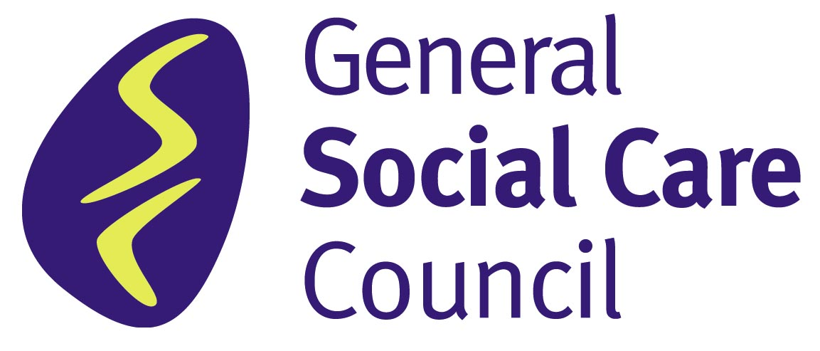

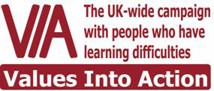
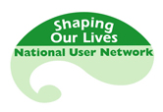


- Local Government Association
- Research in Practice for Adults
- London Borough of Lambeth
- Care & Health
- Community Care Magazine

Recasting The Future of Social Care Together

14 November 2007
Evaluation Form

Please complete and hand to Tanja Hosch or Alice Terry. Or send this form to them at this address: 33 Greycoat Street, London, SW1 2QF

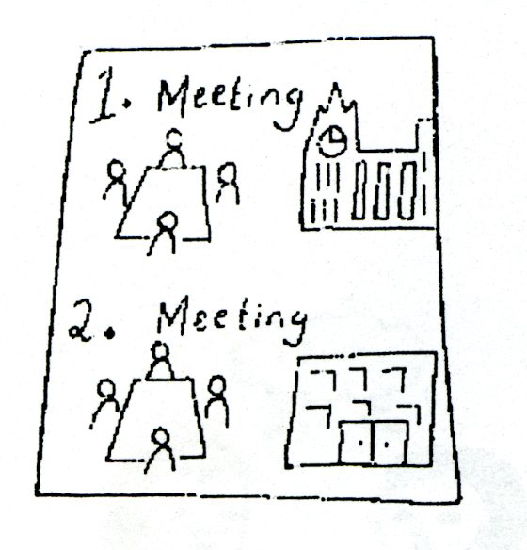


1. Do you think you are a service user?

Yes No


2. What did you find most helpful about the event?


3. What did you find least helpful about the event?


4. What do you think is the most important thing that needs to happen to get better social care support?

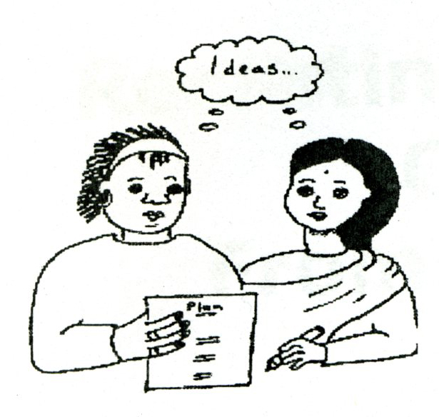

5. Do you have any other general points you would like to pass on from being at the Event?

